ACIL ALLEN CONSULTING
Report to
Australian Department of Health
September 2020
REVIEW OF THE SECOND NATIONAL PARTNERSHIP OF ESSENTIAL VACCINES
Final report

ACIL ALLEN CONSULTING PTY LTD
ABN 68 102 652 148
Level Nine
60 Collins Street
Melbourne Vic 3000
Australia
T+61 3 8650 6000
Level Nine
50 Pitt Street
Sydney NSW 2000
Australia
T+61 2 8272 5100
Level Fifteen
127 Creek Street
Brisbane Qld 4000
Australia
T+61 7 3009 8700
Level Six
54 Marcus Clarke Street
Canberra ACT 2601
Australia
T+61 2 6103 8200
Level Twelve
28 The Esplanade
Perth WA 6000
Australia
T+61 8 9449 9600
167 Flinders Street
Adelaide SA 5000
Australia
t +61 8 8122 4965
acilallen.com.au

ACKNOWLEDGEMENT:
The review team would like to acknowledge the generous contribution to this review of the Review Steering Committee members and officials from the Commonwealth Department of Health (Immunisation Branch), the Department of the Prime Minister and Cabinet, the Treasury and the Australian Institute of Health and Welfare.
© ACIL ALLEN CONSULTING 2020

          - Glossary of terms and abbreviations i
- Executive Summary vi
    - 1 INTRODUCTION
1.1 This engagement 1
1.2 Background to the NPEV 2
1.3 Approach to the Review 17
1.4 This report 22
    - 2 PERFORMANCE OF THE SECOND NPEV
2.1 To what extent is the NPEV appropriately facilitating the cost-effective and efficient delivery of immunisation programs under the NIP? 23
2.2 To what extent has the NPEV increased activity levels in the areas of immunisation and
immunisation coverage? 38
    - 3 rOLES AND RESPONSIBILITIES OF INVOLVED PARTIES
3.1 How well have the parties performed in delivering the NIP in accordance with the terms of the agreement? 40
    - 4 PERFORMANCE MONITORING AND REPORTING ARRANGements
4.1 Are the NPEV’s performance monitoring and reporting processes effective and appropriate in measuring the agreement’s achievements and outputs? 43
    - 5 financial arrangements and contributions
5.1 To what extent is the NPEV appropriately facilitating the cost- effective and efficient delivery of immunisation programs under the NIP? 52
5.2 How appropriate are the financial contributions and the structure of the performance and
milestone payments? 57
    - 6 APPROPRIATENESS OF AN NPA FOR IMPLEMENTING THE NIP
6.1 To what extent does the NPEV remain appropriate in facilitating the policy objectives of the NPEV? 67
6.2 To what extent may further funding beyond the expiry of the Agreement be required if any
increased levels are to be maintained? 70
6.3 What other lessons have been learned that could improve future NPEVs? 71
    - 7 high level findings and future developments
7.1 High level findings 74
7.2 Potential developments to the second NPEV 78
7.3 Recommendations 79
    - A terms of reference A-1
    - B EVALUATION FRAMEWORK b-1
    - C nip schedule c-1
    - D outcomes and outputs of the first npev d-1
    - E DISEASE TRENDS e-1
    - F VACCINE PREVENTABLE DISEASES COVERED BY VACCINES UNDER NIP f-1
    - G second npev definition of 'fully immunised' G-1
    - H additional data H-1
H.1 Vaccination coverage rates H–1
H.2 Vaccine supplier delays H–9

            - Figures

FIGURE 1.1 TIMELINE OF THE IMMUNISATION PROGRAM IN AUSTRALIA 4
FIGURE 1.2 KEY PARTIES INVOLVED IN THE SECOND NPEV 8
FIGURE 1.3 AIR PAYMENTS 13
Figure 1.4 Disease trends for Chickenpox and shingles 16
FIGURE 2.1 VACCINATION COVERAGE RATES FOR 60 ≤ 63 MONTH OLDS, BY STATE, 2005-2019 28
FIGURE 2.2 VACCINATION COVERAGE RATES FOR ABORIGINAL AND TORRES STRAIT ISLANDER
CHILDREN 12 ≤ 15 MONTH OLDS, 2003-2019 29
FIGURE 2.3 VACCINATION COVERAGE RATES FOR ABORIGINAL AND TORRES STRAIT ISLANDER
CHILDREN 24 ≤ 27 MONTH OLDS, 2003-2019 30
FIGURE 2.4 VACCINATION COVERAGE RATES FOR ABORIGINAL AND TORRES STRAIT ISLANDER
CHILDREN 60 ≤ 63 MONTH OLDS, 2003-2019 32
FIGURE 5.1 AVERAGE NUMBER OF DAYS DELAY IN VACCINE ORDERS, BY STATE, 2019 55

FIGURE E.1 NUMBER OF NOTIFICATIONS OF HEPATITIS A, 1991-2019 E–1
FIGURE E.2 NUMBER OF NOTIFICATIONS OF HEPATITIS B (NEWLY ACQUIRED), 1993-2019 E–2
FIGURE E.3 NUMBER OF NOTIFICATIONS OF HAEMOPHILUS INFLUENZAE TYPE B, 1991-2019 E–2
FIGURE E.4 NUMBER OF NOTIFICATIONS OF INFLUENZA (LABORATORY CONFIRMED), 2001-2019 E–3
FIGURE E.5 NUMBER OF NOTIFICATIONS OF INVASIVE MENINGOCOCCAL, 1991-2019 E–3
FIGURE E.6 NUMBER OF NOTIFICATIONS OF PNEUMOCOCCAL DISEASE (0-4 YEARS), 2001-2016 E–4
FIGURE E.7 CRUDE HOSPITALISATION RATES (HOSPITALISATIONS PER MILLION POPULATION)
OF ROTAVIRUS (0-4 YEARS), 1994-2016 E–4
Figure H.1 HPV VACCINATION COVERAGE RATES: ADOLESCENT females (2012-17) and males
(2014-2017 H–2
FIGURE H.2 VACCINATION COVERAGE RATES FOR 60 ≤ 63 MONTH OLDS IN FOUR LOW-COVERAGE SA3 GEOGRAPHICAL AREAS IN ACT, 2014-2019 H–3
FIGURE H.3 VACCINATION COVERAGE RATES FOR 60–<63 MONTH OLDS IN FOUR LOW-COVERAGE SA3 GEOGRAPHICAL AREAS IN NSW, 2014-2019 H–4
FIGURE H.4 VACCINATION COVERAGE RATES FOR 60–<63 MONTH OLDS IN FOUR LOW-COVERAGE SA3 GEOGRAPHICAL AREAS IN NT, 2014-2019 H–4
FIGURE H.5 VACCINATION COVERAGE RATES FOR 60–<63 MONTH OLDS IN FOUR LOW-COVERAGE SA3 GEOGRAPHICAL AREAS IN QUEENSLAND, 2014-2019 H–5
FIGURE H.6 VACCINATION COVERAGE RATES FOR 60–<63 MONTH OLDS IN FOUR LOW-COVERAGE SA3 GEOGRAPHICAL AREAS IN SA, 2014-2019 H–6
FIGURE H.7 VACCINATION COVERAGE RATES FOR 60–<63 MONTH OLDS IN FOUR LOW-COVERAGE SA3 GEOGRAPHICAL AREAS IN TASMANIA, 2014-2019 H–6
FIGURE H.8 VACCINATION COVERAGE RATES FOR 60–<63 MONTH OLDS IN FOUR LOW-COVERAGE SA3 GEOGRAPHICAL AREAS IN VICTORIA, 2014-19 H–7
FIGURE H.9 VACCINATION COVERAGE RATES FOR 60–<63 MONTH OLDS IN FOUR LOW-COVERAGE SA3 GEOGRAPHICAL AREAS IN WA, 2014-19 H–8
FIGURE H.10 AVERAGE NUMBER OF DAYS PLANNED LAG IN VACCINE ORDERS, BY STATE, 2019 H–9
FIGURE H.11 DELAY BY SUPPLIER, 2019 H–10
FIGURE H.12 DELAY BY DELAY PERIOD, 2019 H–10

            - Tables

Table 2.1 Summary of assessment against the perfoRmance benchmarks for states and territories 2017-18 to 2018-19 27
Table 2.2 Summary of performance for Performance benchmark 2 29
Table 2.3 HPV vaccination coverage rates for adolescent females and males, 2018-19 32
Table 2.4 Summary of performance for Performance benchmark 5 36
Table 5.1 leading practice principles Assessment of the NPEV funding model 58
Table 5.2 NPEV payments received ($), by state or territory and payment type, 2018-19 63
Table 5.3 Schedule B: contributions to the AIR for vaccination provider payments for notifications to the AIR 66

Table B.1 EVALUATION FRAMEWORK B–2
Table C.1 NATIONAL IMMUNISATION PROGRAM SCHEDULE C–1
Table F.1 Incidence of vaccine-preventable Disease for vaccines covered UNder
the NIP (child and ADOLESCENT) F–2
Table G.1 Definition of ‘fully immunised’ by age cohort G–1
Table H.1 number and proportion of Aboriginal and Torres Strait Islander
60-<63 month olds, by jurisdiction, 2017-18 H–1
Table H.2 WASTAGE AND LEAKAGE RATE FOR AGREED VACCINES, 2013-14 to 2018-19 H–8

            - Boxes

Box 1.1 Outcomes and outputs of the second NPEV 7
Box 1.2 Commonwealth and state and territory roles under the second NPEV 10
Box 1.3 Funding allocations and payments 15

Box D.1 outcomes and outputs of the first npev D–1

Glossary of terms and abbreviations
  - Glossary
Aboriginal and Torres Strait Islander / Indigenous | A person of Aboriginal and / or Torres Strait Islander descent who identifies as Aboriginal or Torres Strait Islander and is accepted as such by the community in which they live.
Age-specific rate | The rate for a specific age group. The numerator and denominator for calculating the rate relate to the same age group.
At-risk groups | Certain groups of people who are at greater risk of contracting a certain disease and / or are at most risk of severe infection, for example, Aboriginal and Torres Strait Islander peoples and pregnant women.
Australian Immunisation Register (AIR) | A national register that records all vaccines given to people of all ages in Australia. This was previously the Australian Childhood Immunisation Register, which focused on childhood vaccines.
Catch-up payments | Catch-up payments are made to vaccination providers who administer a completed schedule to children who are more than two months overdue.
Cold chain | A system for transporting and storing vaccines within the safe temperature range (2-8ºC). This needs to be maintained from the time the vaccine is manufactured through to administration.
Cold chain breach | Occurs when the vaccine has been stored outside the safe temperature range. The vaccine may temporarily be stored up to 12ºC for a maximum of 15 minutes.
Coverage rate | The percentage of the population or of a specific age group or at-risk group who have received a particular vaccination or combination of vaccines.
COVID-19 pandemic | A worldwide pandemic of the coronavirus disease 2019 (COVID-19) caused by severe acute respiratory syndrome coronavirus 2 (SARS-CoV-2).
Fully immunised | ‘Fully immunised’ means that an individual has received a pre-determined group of vaccines appropriate for their age, as defined by the Australian Immunisation Register. This definition may change over time along with changes to the National Immunisation Program Schedule. As of July 2020, the definitions for ‘fully immunised’ are outlined in Appendix G.
Immunisation | Immunisation is the process of both receiving a vaccine and becoming immune to the disease as a result.
Incidence | The rate of new (or newly diagnosed) cases of the disease.
Jurisdictional Immunisation Coordinator | The Jurisdictional Immunisation Coordinator is part of state and territory immunisation teams that distribute vaccines and work with vaccination providers to deliver vaccination programs.
National Immunisation Program (NIP) | A collaborative initiative involving all levels of government, healthcare providers, administrators and researchers. The NIP provides vaccines free of charge to eligible individuals, including infants, children, adolescents, older people and those of any age who are at higher risk from certain diseases, according to the NIP Schedule.
National Immunisation Program Schedule | A series of vaccinations under the NIP given at specific times throughout life, ranging from birth through to adulthood. The list of vaccinations, as of July 2020, are outlined in Appendix C.
National Partnership Agreements | National Partnership Agreements outline the shared responsibilities between the Commonwealth and state and territory governments in the delivery of a range of services across Australia.
Notification Payments | Notification Payments are made to vaccines providers who notify the AIR they have completed a vaccination schedule for a child up to the age of seven years.
Recognised vaccination provider | Medical practitioners, midwives and nurse practitioners with a Medicare provider number are automatically recognised as vaccination providers and authorised to record or get immunisation data from the AIR.  Only reports from recognised vaccination providers in Australia are accepted by the AIR. Other eligible health professionals and organisations can apply to become recognised vaccination providers
SA3 geographical areas | Statistical Areas Level 3 (SA3) are geographical areas for the output of regional data, and have a population of between 30,000 to 130,000. There are 351 SA3s in Australia.
Schedule | The NIP Schedule is a series of immunisations given at specific times throughout an individual’s life.
Special Account | A special treasury account titled Australian Immunisation Register Special Account allows Services Australia to make payments to recognised vaccination providers once they notify the AIR of completed immunisation schedules for children up to the age of seven years.
Vaccination | Vaccination is the process of receiving a vaccine from a needle or drops in the mouth by a healthcare professional.
Vaccination provider | Vaccine providers are authorised to administer vaccines. These include medical practitioners and general practitioners (GPs), appropriately certified nurses or nurses under a doctor’s order (without requiring additional immunisation training in delivering vaccinations), and pharmacists (in some states).
Vaccination provider support organisation | Provide support to vaccination providers and include GP clinics, state and territory or local council community health centres, Aboriginal Health/Medical Services, schools, Primary Health Networks, Public Health Units, local councils, pharmacies and hospitals.
Vaccine leakage | Vaccine leakage occurs when a vaccine that is purchased for administration to eligible cohorts under the NIP is administered to a person who is not eligible to receive the government-funded vaccine.
Vaccine wastage | Vaccine wastage is caused by cold chain breaches, expiry, missing inventory or other damage, such as breakages to the vaccine vial syringe or packaging.
  - Abbreviations
ABS Australian Bureau of Statistics
ACIL Allen ACIL Allen Consulting
ACIR Australian Childhood Immunisation Register
ACT Australian Capital Territory
AIHW Australia Institute of Health Welfare
AIR Australian Immunisation Register
ANAO Australian National Audit Office
ATAGI Australian Technical Advisory Group on Immunisation
COAG Council of Australian Governments
COPE Commonwealth Own-Purpose Expenses
COVID-19 Coronavirus disease 2019
Department Commonwealth Department of Health
GP General Practitioner
HPV Human papillomavirus
HPV Register National HPV Vaccination Program Register
IGA FFR Intergovernmental Agreement on Federal Financial Relations
JIC Jurisdictional Immunisation Coordinator
NHR National Health Reform
NIP National Immunisation Program
NNDSS National Notifiable Diseases Surveillance System
NPA National Partnership Agreement
NPEV National Partnership on Essential Vaccines
NSW New South Wales
NT Northern Territory
PBAC Pharmaceutical Benefits Advisory Committee
QLD Queensland
SA South Australia
SPP Specific Purpose Payments
TAS Tasmania
The Handbook Australian Immunisation Handbook
VIC Victoria
WA Western Australia

Executive Summary
ACIL Allen Consulting (ACIL Allen) was engaged by the Commonwealth Department of Health (the Department) to conduct a review of the second National Partnership on Essential Vaccines (NPEV). The review has been led by ACIL Allen with oversight from a Review Steering Committee comprised of representatives from the Commonwealth and each state and territory government, and support of the Immunisation Strategies section in the Department.
This Final Report presents the assessment of the second NPEV according to the Terms of Reference and evaluation framework (Appendices A-B).
  - Context
In Australia, responsibility for health care is shared by Commonwealth, state, and local governments and is delivered through a combination of the public and private health systems. Immunisation is one of the most impactful public health interventions of the past century, and the establishment of the National Immunisation Program (NIP) is one of Australia’s most significant health success stories.
Immunisation in Australia is delivered through the NIP under the National Immunisation Strategy, as well as through a range of state and territory immunisation programs and private market services, such as immunisation for travellers and people working in certain occupations and industries. The NIP is a collaborative initiative involving all levels of government (Commonwealth, state, and local – although not all local governments are involved), healthcare providers, administrators and researchers. The NIP consists of a schedule (the NIP Schedule) of recommended vaccines for specific age groups and/or medically at-risk groups, made available free of charge to citizens and residents eligible to receive Medicare benefits. The vaccinations cover the whole of life from birth through to old age.
Vaccinations are administered by medical practitioners and general practitioners (GPs), appropriately certified nurses or nurses under a doctor’s order (without requiring additional immunisation training in delivering vaccinations), pharmacists (in some states and territories) and Aboriginal Health Practitioners with appropriate qualifications depending on jurisdictional requirements. These are delivered through GPs’ clinics, state and territory or local council community health centres, Aboriginal Health/Medical Services and school-based programs.
The NIP is jointly funded by the Commonwealth and state and territory governments and implemented by state and territory departments of health. Funding for vaccine purchasing and services to support immunisation uptake has increased from $10 million per year in the mid-1970s to more than $460 million in 2017-18.
  - The National Partnership on Essential Vaccines
The first NPEV introduced arrangements for the funding and delivery of a national, coordinated and integrated approach to maintaining and improving effective immunisation coverage for vaccine-preventable diseases covered by the NIP. It delineated the roles and responsibilities of the Commonwealth and states and territories, and provided for incentive payments to the states and territories for achieving performance benchmarks. The first NPEV focused on addressing the issue of social inclusion, including responding to the lower vaccination rates experienced by some Aboriginal and Torres Strait Islander peoples.
The second NPEV is an agreement between the Commonwealth and state and territory governments running from June 2017 to 30 June 2021. The second NPEV aims to cost-effectively and efficiently deliver immunisation programs under the NIP and provides an estimated $74.3 million in financial contributions to the states and territories over the life of the agreement. The second NPEV recognises all parties’ mutual interest in improving vaccination outcomes and reducing vaccine-preventable diseases through coordinated effort.
Under the second NPEV, the Commonwealth is responsible for contributing funding, supplying vaccines and providing leadership to support implementation of the second NPEV, monitoring and assessing performance, and coordinating national monitoring and surveillance of adverse events following immunisation.
The states and territories are responsible for delivering outputs and outcomes assigned to them under the second NPEV, delivering the NIP, assisting the Commonwealth with procuring vaccines to be supplied under the NIP, supporting access to immunisation and provision of quality data to the Australian Immunisation Register, and reporting on performance, vaccine wastage and leakage and adverse events.
  - Review findings
The review addressed a series of questions relating to the performance of the second NPEV and the parties to it. The findings are presented below.
      - To what extent is the NPEV appropriately facilitating the cost-effective and efficient delivery of immunisation programs under the NIP?
Key Finding ES 1
The second NPEV provides a clear, focused and nationally consistent framework for delivering state and territory-based immunisation programs. The second NPEV’s objectives and outcomes are consistent with those of the NIP.
The outputs specified in the second NPEV focus on a limited range of activities undertaken by states and territories to achieve the abovementioned objectives and outcomes. It is unclear if these outputs reflect areas of reform and while they are important, it is not clear if they represent the areas most likely to drive reductions in the spread of vaccine-preventable diseases or improve vaccination coverage rates.
Over the two assessment periods, the states and territories were assessed as meeting 92 per cent of performance benchmarks and the milestone, and as such, are contributing towards delivering the objectives and outcomes of the NIP.
      - To what extent has the NPEV increased activity levels in the areas of immunisation and immunisation coverage?
Key Finding ES 2
The second NPEV focuses states’ and territories’ efforts and resources on immunisation and improving immunisation coverage rates for the performance benchmarks. However, some immunisation areas not covered by the second NPEV may receive less focus than may be needed to improve vaccination coverage rates.
While the second NPEV has likely contributed to increased vaccination coverage rates, this has been supported by other Commonwealth and state and territory immunisation policies and improved data quality. It is not possible to determine the extent to which increases in vaccination coverage rates are attributed to the second NPEV.
The second NPEV has encouraged states and territories to devote additional resources to improving the quality of data relevant to the performance benchmarks.
      - How well have the parties performed in delivering the NIP in accordance with the terms of the agreement?
Key Finding ES 3
The Commonwealth has performed its roles and responsibilities well in reducing the price and securing the supply of vaccines and engaging more with the states and territories, particularly during challenging circumstances. However, there have been delays in providing data and reports to the states and territories, which is not monitored through the NPEV.
The states and territories have performed well in meeting the vast majority of performance benchmarks and the milestone and in meeting their responsibilities outlined in the second NPEV.
      - Are the NPEV’s performance monitoring and reporting processes effective and appropriate in measuring the agreement’s achievements and outputs?
Key Finding ES 4
The second NPEV’s performance monitoring is linked to the outputs specified in the second NPEV. The performance monitoring and reporting processes provide a nationally consistent approach to assessment.
Consistent with the outputs, the performance indicators are narrow in focus and do not capture all the achievements or activities performed.
The performance monitoring approach drives a focus on improving data quality to ensure the states and territories meet the performance benchmarks and qualify for the associated payments.
Measurement of the outputs of the second NPEV is complicated and lacks clarity. States and territories are not well placed to influence wastage and leakage, other than by constraining delivery of vaccines to vaccination providers.
States and territories do not have access to real-time, accurate data on immunisation coverage and wastage and leakage and are therefore unable to make adjustments to improve their performance.
While reporting is often delayed, it is not overly onerous.
It is appropriate that an independent agency, the AIHW, compiles performance reports.

      - To what extent is the NPEV appropriately facilitating the cost-effective and efficient delivery of immunisation programs under the NIP?
Key Finding ES 5
Administrative cost data is not routinely collected and there is no consistent or agreed approach to doing so. This prevents quantitative assessment of cost-effectiveness. The agreement is relatively easy to administer, although states and territories are devoting significant administrative effort to cleansing data. Cost-effectiveness could be strengthened through streamlined performance assessment and payment processes.
The second NPEV has achieved cost-efficiencies, by centralising procurement, undertaking competitive tendering, bundling pricing offers and streamlining the purchasing workload. This has resulted in approximately $5 million in savings.
The states and territories benefit from these cost-efficiencies by being able to order vaccines at the nationally negotiated vaccine prices.
      - How appropriate are the financial contributions and the structure of the performance and milestone payments?
Key Finding ES 6
The second NPEV aligns with some leading practice principles more than others, including Outcomes-focussed, Choice and control and Efficient. The second NPEV does not meet the principle of Transparent and simple.
The second NPEV’s Financial Arrangements provide a clear policy intention linked to performance indicators. The second NPEV does not cover the breadth of immunisation activities conducted by the states and territories.
While the second NPEV has reduced the administrative burden on the states and territories due to centralised procurement (also reduced the overall size of the payments), the states and territories need to allocate significant resources to monitoring, performance reporting and data cleaning. The financial contributions aim to improve state and territory performance, and do not reflect state and territory activities or fund service delivery.
Performance assessment is complex, varies across years and is often delayed.
The structure of the performance benchmark is equitable yet unreliable and non-recurrent. In contrast, the structure of the milestone payment is reliable yet inequitable. The state’s contributions to the AIR are inequitable.

      - To what extent does the NPEV remain appropriate in facilitating the policy objectives of the NPEV?
Key Finding ES 7
An NPA remains an appropriate mechanism for Commonwealth funding to flow to states and territories to facilitate objectives of the NPEV. The NPEV fulfils the requirements of an NPA in terms of value and national significance, and provides targets and financial incentives. Related policy initiatives do not appear to duplicate the NPEV.
However, the NPEV does not adequately account for state and territory differences and is not comprehensive of the policy objectives of the NIP. The states and territories lack real-time visibility (and thus control) of their performance against the objectives.
      - To what extent may further funding beyond the expiry of the Agreement be required if any increased levels are to be maintained?
Key Finding ES 8
Further funding is required beyond the expiry of the second NPEV to maintain immunisation coverage rates. This is needed to support the supply of safe and free vaccines, ensure public access to evidence-based immunisation information, and incentivise vaccination providers to report data.
Changes to regulation and governance and the addition of performance indicators that are not linked to funding may also support maintenance of immunisation coverage rates.
      - What other lessons have been learned that could improve future NPEVs?
Key Finding ES 9
The NPEV has been effective in raising the profile of immunisation in some states and territories and can be leveraged to improve state and territory performance.
Lessons have emerged from the unintended outcomes of the second NPEV, including a reduced overall spend on vaccines and reduced value of performance payments, lack of specificity or flexibility for different elements of the agreement, and the punitive nature of the performance indicators. In particular, the requirement for increasing coverage rates to 95 per cent may not be fair or achievable over time. There is a lack of focus on state and territory-specific issues and emerging disease trends.
The assessment measures and process and performance monitoring are complex and do not enable real-time monitoring.
  - Potential developments to the second NPEV
A number of potential developments to the second NPEV were identified during the course of the Review. These include:
- Streamlining the assessment measures and process to improve their clarity, effectiveness, and appropriateness. This includes:
  - ensuring that the performance benchmarks are fair, achievable, and attractive for states and territories as NIP implementation partners; that is, reconsidering the current 95 per cent immunisation coverage target
  - retaining the language from the first NPEV regarding ‘maintaining or increasing’, instead of ‘increasing’
  - removing the three-month lag from the performance assessment
  - focusing on performance measures within the control of the states and territories
  - accounting for activity undertaken to increase immunisation coverage, including communication and collaboration across the involved parties
  - increasing flexibility for unanticipated circumstances, including changes to the NIP schedule, emerging vaccines research, or the impact of COVID-19
  - broadening the coverage of the NPEV to include additional vaccines and / or cohorts covered under the NIP
  - selecting targets with each state or territory each year that will address the specific gaps in that state
- Shifting the funding approach to:
  - readjust the proportion of funding that is considered secure
  - consider proportionate rewards for partially meeting the performance benchmarks
  - change the language to specify that states and territories spend the funding on immunisation activities
  - allow for a large-scale upgrade in infrastructure to ensure vaccines continue to be distributed effectively
  - allow for innovation and research to develop Australia’s vaccine distribution model in line with best practice
- Improving performance monitoring, including:
  - providing for real-time data accessibility for all vaccines and cohorts
  - developing performance measures for the Commonwealth
  - developing performance indicators not linked to funding
  - ensuring that every administered vaccine is viable, safe and of high quality, and reported to the AIR.
Sufficient time should be allowed to develop a new NPEV (or alternative approach). This would support each party to negotiate and modify the NPEV to secure the flexibility required to achieve better outcomes, including relationships between the parties and future management and implementation of the agreement. This could also incorporate feedback from Aboriginal and Torres Strait Islander communities and immunisation specialists in Primary Health Networks.
  - Recommendations
The findings of the Review inform the following recommendations.
        - A National Partnership is an appropriate mechanism for improving outcomes under the NIP.
Implementing the NIP requires a focus on ensuring target populations receive the recommended vaccinations safely, in a timely manner and with minimal wastage and leakage. This involves activities focused on maintaining current immunisation rates for some cohorts and vaccines, and increasing immunisation rates for others. Assuming immunisation remains a national priority and it is agreed that the Commonwealth and states and territories share responsibility for achieving the outcomes of the NIP, a National Partnership is an appropriate mechanism for driving improvements in immunisation coverage rates, as National Partnerships are intended to focus on specific projects or areas of reform.
It is feasible to continue to use the National Partnership as one mechanism through which the Commonwealth assists states and territories to implement the NIP, both through purchasing of vaccines and through funding. However, there would be benefit in clarifying the extent to which the Commonwealth will fund activities required to maintain immunisation coverage rates and the mechanism through which this funding will flow, given many states and territories have reached or nearly reached the stretch target levels. To ensure equity between the states and territories, considerations should take into account the different approaches taken across the states and territories to administer vaccinations, and the associated funding arrangements including through the Medicare Benefits Scheme. Where immunisation services are primarily delivered by local councils, states and territories contribute a higher proportion of funding to deliver immunisation services than when delivery is primarily by GPs.
        - NPEV should focus on areas of most need.
Many of the outputs and associated benchmarks contained in the second NPEV are reaching the point where the cost of achieving further improvement is open to question. The selection of outputs and associated benchmarks should be based on disease prevalence and gaps in vaccination coverage rates, which may differ across states and territories. It is not appropriate from a policy perspective to withhold payments based on small movements in already high vaccination coverage rates. Considering a broader range of outcomes and outputs would realign the focus of the NPEV on reforming areas of most need.
        - Data limitations necessitate an alternate approach.
State and territory criticisms of the second NPEV include the lack of recognition given to the full spectrum of activities that the states and territories perform in implementing the NIP. While this is addressed in part in the recommendations above, it is also relevant to consider the impact of data limitations on the selection of NPEV outputs and associated performance benchmarks. The AIR moved to a whole of life register in 2016, and there is currently limited data to report on adult immunisations, which constitute a significant and important part of states’ and territories’ activities. A different approach is needed to drive vaccination coverage in areas where data is poor during this data building phase. Further, there is currently limited capacity for states and territories to monitor real-time performance. This will improve over time, particularly if this becomes a focus of the Commonwealth and states and territories.
During this data building phase, a suitable approach used for the National Partnership on Universal Access to Early Childhood Education 2018-2020 is to require states and territories to develop, and agree with the Commonwealth, an annual Implementation Plan. This Plan outlines targets that reflect each state’s individual needs and circumstances. If a similar approach is incorporated in the next NPEV, plans could target areas and cohorts where improvements in vaccination coverage is desired (and feasible). This approach could be used to drive activity on currently difficult to measure vaccines and cohorts.
The Plan is linked to a 30 per cent funding payment, and as such, would provide additional certainty to the states and territories to enable better planning and budgeting for activities most likely to improve vaccination coverage rates.
The requirement for an Implementation Plan would provide national consistency (a requirement of a National Partnership), but enable flexibility to nuance some outputs and activities based on state and territory-specific areas of greatest need. This would also provide for a focus on immunisation-related activities required to increase vaccination coverage rates.
        - States and territories should be able to influence outputs.
Outputs should be tied to factors the states and territories can influence and control. The states and territories have control over ordering and delivery of vaccines, yet not over other factors influencing wastage and leakage. The Commonwealth is better placed to influence this output, including through mandating that vaccination providers report all vaccinations to the AIR.
States and territories have invested considerable effort in data cleansing in order to meet the performance benchmarks. However, they have limited influence on the quality, timeliness and accuracy of reporting to the AIR. The Commonwealth is better placed to influence data quality, through mandating of vaccination providers to report to the AIR and developing a broader strategy in collaboration with the Royal Australian College of General Practitioners, the Australian Health Practitioner Regulation Agency, and local government. This would provide an opportunity for states and territories to make better use of the resources they have available to implement the NIP.
        - AIHW should inform the benchmarks.
While the Commonwealth and states and territories should discuss and agree upon the outputs required under future agreements, the AIHW is best placed to inform on vaccination coverage data and benchmark calculations, compared with good practice. This should focus on streamlining the calculations to improve clarity.

Introduction | 1
 | Introduction

This engagement
The Commonwealth Department of Health (the Department) engaged ACIL Allen Consulting (ACIL Allen) to review the second National Partnership on Essential Vaccines (NPEV).
The aim of the review of the second NPEV (the Review) was to evaluate the performance of the second NPEV and identify achievements and limitations. The Review will inform decisions regarding the treatment of the second NPEV upon its expiry and consider whether policy objectives and outcomes and/or outputs of the second NPEV have been achieved, and whether they have been delivered in an effective, efficient and appropriate manner.
The Review was conducted in accordance with Paragraphs 36-38 of Part 6 of the relevant second NPEV, considering guidance provided in the Intergovernmental Agreement on Federal Financial Relation’s (IGA FFR) A Short Guide to Reviewing National Partnerships.

Specific requirements
The Review considered:
- the appropriateness of the second NPEV to facilitate the cost-effective and efficient delivery of immunisation programs under the National Immunisation Program (NIP)
- a review of the performance benchmarks and milestone in measuring the achievement of outcomes
- the quality, timeliness, accuracy and appropriateness of performance monitoring processes and reporting
- appropriateness of financial contributions and the structure of performance and milestone payments
- whether the second NPEV as an Agreement has increased activity levels in the areas of immunisation and immunisation coverage in such a way that further funding beyond the expiry of the Agreement may be required if those levels are to be maintained.
The Review also considered:
- any ‘lessons learned’ to ensure that performance and the monitoring framework can be improved for any future agreements
- whether, based on the evidence considered as part of the review, the policy or program remains appropriate, including whether related policy initiatives or any aspects of the second NPEV are being pursued through other agreements.
The Terms of Reference for the Review are outlined in Appendix A and the evaluation framework is detailed in Appendix B.

Background to the NPEV
National Partnership Agreements (NPAs) provide a mechanism for coordinating specific services and were established by the Council of Australian Governments (COAG) under the IGA FFR. NPAs outline the shared responsibilities between the Commonwealth and state and territory governments in the delivery of a range of services across Australia, for example, legal assistance, health, skills, and housing.
On 29 May 2020, the Prime Minister announced that a National Cabinet established to coordinate Australia’s response to coronavirus disease 2019 (COVID-19) would continue, that a new National Federation Reform Council would be formed and that the COAG would cease. The National Cabinet has announced the formation of six National Cabinet Reform Committees, which includes a health committee.
Health care is a significant cost to the Commonwealth Government, amounting to nearly $181 billion in 2016-17. Responsibility for health care is shared by Commonwealth, state, and local governments and is delivered through a combination of the public and private health systems.
Immunisation in Australia is delivered through the NIP under the National Immunisation Strategy, as well as through a range of state and territory immunisation programs and private market services, such as immunisation for travellers and people working in certain occupations and industries.
Immunisation is one of the most impactful public health interventions of the past century, and the establishment of the NIP is one of Australia’s most significant health success stories. An effective vaccine protects an individual against a specific infectious disease and its various complications. The efficacy of a vaccine is measured by its capacity to reduce the overall frequency of new infections and to reduce major complications. All vaccines currently in use in Australia confer high levels of protection that are sufficient to prevent disease in most vaccinated individuals, and for the broader community.
Funding for vaccine purchasing and services to support immunisation uptake has increased from $10 million per year in the mid-1970s to more than $460 million in 2017-18.

National Immunisation Program
The NIP is at the core of Australia’s National Immunisation Strategy. The NIP was established in 1997 with the aim of reducing the incidence of vaccine-preventable diseases through increased national immunisation coverage. The NIP makes numerous vaccines available free of charge to eligible individuals, including infants, children, adolescents, older people and those of any age who are at higher risk from certain diseases.
The NIP is a collaborative initiative involving all levels of government (Commonwealth, state, and local – although not all local governments are involved), healthcare providers, administrators and researchers. The program positively affects the health of all Australians at some point in their lives, either directly through vaccination or indirectly through community immunity.
Immunisation policy, governance and regulation for the NIP are managed by the Commonwealth Government, with support from numerous stakeholders, advisory bodies, and related agencies, including the Office of Health Protection in the Department, the Australian Technical Advisory Group on Immunisation (ATAGI), Services Australia, the Therapeutic Goods Administration, the Advisory Committee on Vaccines, and the National Health and Medical Research Council. States and territories provide authority through state or territory-based legislation for certain groups to administer vaccines without a medical order (e.g. pharmacists, nurse practitioners, and midwives), and implement immunisation programs to deliver on Commonwealth and state and territory policy objectives.

National Immunisation Program Schedule
The NIP consists of a schedule (the NIP Schedule) of recommended vaccines for specific age groups and/or medically at-risk groups, made available free of charge to citizens and residents eligible to receive Medicare benefits. The vaccinations range from birth through to adulthood. The current complete list of vaccinations on the NIP Schedule is shown in Appendix C.
The NIP Schedule was established in 1997, although routine immunisations in Australia for specific adult cohorts date back to 1917 when the tetanus vaccine was introduced for the armed forces. Originally focused on nine childhood diseases, the NIP has since become more complex, taking a whole of life approach to immunisation. The NIP now covers 17 diseases for infants, children, young adults, vulnerable adults (such as Aboriginal and Torres Strait Islander peoples, people who are immunocompromised, and pregnant women) and older people. The NIP covers multiple vaccine schedule points and doses for certain vaccine-preventable diseases. The vaccines listed on the NIP, and their year of introduction to the NIP (or predecessor arrangements), are provided in Figure 1.1.
Drawing on the advice of clinical experts, the NIP schedule is changed periodically to account for the development of vaccines against diseases for which vaccines were previously unavailable, improvements in vaccine efficacy, quality or safety, the development of new combination vaccines that reduce the number of vaccinations needed to protect against the same diseases, or updated evidence indicating that fewer doses and boosters or altered vaccine timings work just as well or better in protecting from disease.
State and territory immunisation schedules specify additional vaccines that each jurisdiction’s government funds beyond the NIP schedule.
FIGURE 1.1 TIMELINE OF THE IMMUNISATION PROGRAM IN AUSTRALIA
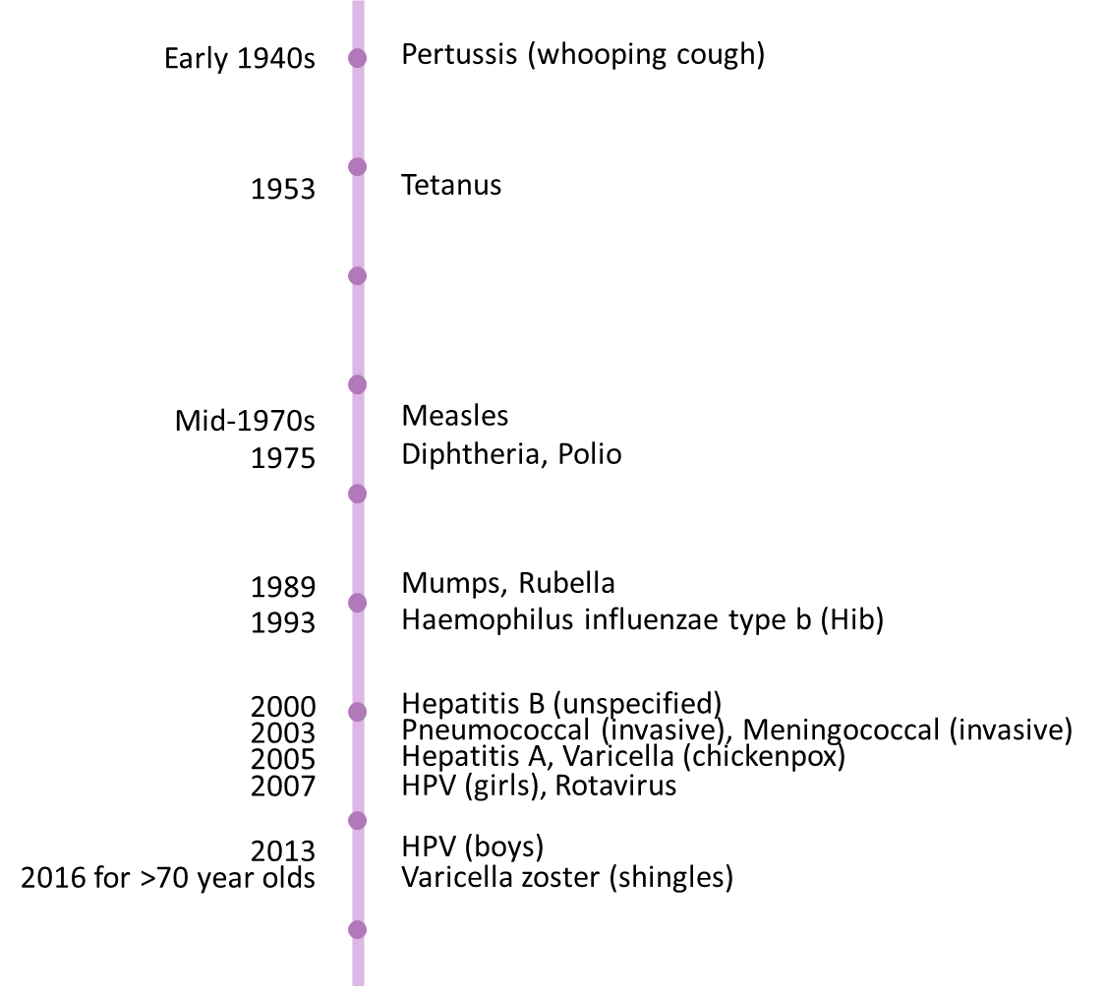
Source: The Australian Immunisation Handbook, Accessed on 20 May 2020; Department of Health, National Notifiable Diseases Surveillance System, Australia; Department of Health, National Centre for Immunisation Research and Surveillance, Canberra; Australian Institute of Health and Welfare, The burden of vaccine preventable diseases in Australia, canberra, 2019.

Delivery and management of the NIP
The appropriate administration of vaccines is underpinned by the Australian Immunisation Handbook (the Handbook), developed by the ATAGI. The Handbook provides clinical information and resources for those involved in the delivery of immunisation services throughout Australia. This includes comprehensive information about all vaccines approved for use in Australia, including routine vaccination throughout the life course, and vaccination for vulnerable groups.

The first National Partnership on Essential Vaccines
Currently, the NIP is jointly funded by the Commonwealth and state and territory governments and implemented by state and territory departments of health. The NIP has had various funding and management arrangements since its inception. Funding was initially agreed under Public Health Outcome Funding Agreements and subsequently Australian Immunisation Agreements.
Following changes to the federal financial arrangements between the Commonwealth Government and the states and territories as a result of the IGA FFR coming into effect and enactment of the Federal Financial Relations Act 2009, Australian Immunisation Agreements were replaced with the first NPEV in 2009.
The first NPEV introduced the arrangements for the funding and delivery of a national, coordinated and integrated approach to maintaining and improving effective immunisation coverage for vaccine-preventable diseases covered by the NIP. It delineated the roles and responsibilities of the Commonwealth and states and territories, and provided for incentive payments to the states and territories for achieving performance benchmarks (see Appendix D). The first NPEV focused on addressing the issue of social inclusion, including responding to the disadvantage experienced by some Aboriginal and Torres Strait Islander peoples.

The second National Partnership on Essential Vaccines
The second NPEV is an agreement between the Commonwealth and state and territory governments running from June 2017 to 30 June 2021. It provides an estimated $74.3 million in financial contributions to the states and territories over the life of the agreement. This equates to 4.5 per cent of the cost of vaccines purchased, comprising 3.75 per cent of the total annual cost of each state’s individual vaccine purchases and 0.75 per cent of the total annual cost of Commonwealth vaccine purchases, divided equally amongst the states and territories.
The second NPEV recognises all parties’ mutual interest in improving vaccination outcomes and reducing vaccine-preventable diseases through coordinated effort. The second NPEV, similar to the first NPEV, aims to cost-effectively and efficiently deliver immunisation programs under the NIP, specifically:
The objective of this Agreement is to protect the Australian public from the spread of vaccine preventable diseases through the cost-effective and efficient delivery of immunisation programs under the National Immunisation Program (NIP).
The NIP is a joint initiative of the Commonwealth and the States, making free vaccines available to eligible individuals through a range of vaccination providers, including general practice, community clinics, Aboriginal Medical Services, and aged care facilities. The NIP provides vaccines for eligible individuals against multiple disease groups, ensuring those most at risk are protected.
The second NPEV encourages the states and territories to achieve higher immunisation coverage rates, and to support program sustainability through targets for wastage and leakage. Furthermore, the second NPEV maintains a focus on improving immunisation coverage for Aboriginal and Torres Strait Islander infants, as this remains an important population group for whom immunisation rates can still be improved.
The specific outcomes, outputs, and performance benchmarks and milestone of the second NPEV are outlined in Box 1.1.
Box 1.1 Outcomes and outputs of the second NPEV
Outcomes
This Agreement will facilitate achievement of the following outcomes:
  - minimise the incidence of vaccine preventable diseases in the eligible Australian population for diseases with vaccines listed under the NIP
  - minimise the incidence of vaccine preventable diseases in Aboriginal and Torres Strait Islander people for diseases with vaccines listed under the NIP
  - minimise the incidence of Human Papillomavirus (HPV) in the eligible Australian population
  - ensure that Australian HPV immunisation data is provided to the Commonwealth annually
  - minimise the incidence of vaccine preventable diseases in the eligible Australian population in geographic areas of low coverage
  - ensure that vaccines listed under the NIP are managed in a way that minimises wastage and leakage, with a target rate of wastage and leakage of 5 per cent or lower.
Outputs
The objectives and outcomes of this Agreement will be achieved by:
  - increasing vaccination coverage rates for 60 ≤ 63 month olds
  - increasing vaccination coverage rates in Aboriginal and Torres Strait Islander children
  - increasing HPV coverage rates for adolescents
  - increasing coverage rates in areas of lowest coverage for 60 ≤ 63 month olds
  - reducing the wastage and leakage for vaccines listed on the NIP
  - providing agreed, quality assured data on HPV delivered in schools to the immunisation register.
Performance benchmarks and milestone for incentive payments
Incentive payments will be paid for each performance benchmark or milestone met by the state:
  - an increase in vaccination coverage rates for 60 ≤ 63 month olds relative to the baseline (coverage rate 95 per cent or higher is deemed to have met the benchmark)
  - an increase in the vaccination coverage rates for Aboriginal and Torres Strait Islander people in at least two of the following three cohorts: 12 ≤ 15 month; 24 ≤ 27 month; and 60 ≤ 63 month, relative to the baseline (coverage rate 95 per cent or higher is deemed to have met the benchmark)
  - an increase in the vaccination coverage rate for both adolescent boys and adolescent girls for HPV, relative to the baseline
  - an increase in vaccination coverage rates for 60 ≤ 63 month olds in four of the ten lowest vaccination coverage SA3 geographical areas, relative to the baseline
  - an annual decrease in the wastage and leakage rate for agreed vaccines, relative to the baseline (a wastage and leakage rate of 5 per cent or lower will be deemed to have met the benchmark)
  - provision of annual schools HPV immunisation data for the previous school year by 30 April each year.
Source: COAG (2017). National Partnership Agreement on Essential Vaccines. Canberra: Australian Government.

Delivery of the second NPEV
Figure 1.2 illustrates the parties involved in developing and implementing the activities funded under the second NPEV. The parties include:
- Commonwealth Department of Health
- Commonwealth Department of The Treasury (The Treasury)
- Commonwealth Department of The Prime Minister and Cabinet (DPMC)
- Services Australia
- Australia Institute of Health Welfare (AIHW)
- State and territory health departments / units
- Vaccination providers
- Support organisations.
FIGURE 1.2 KEY PARTIES INVOLVED IN THE SECOND NPEV
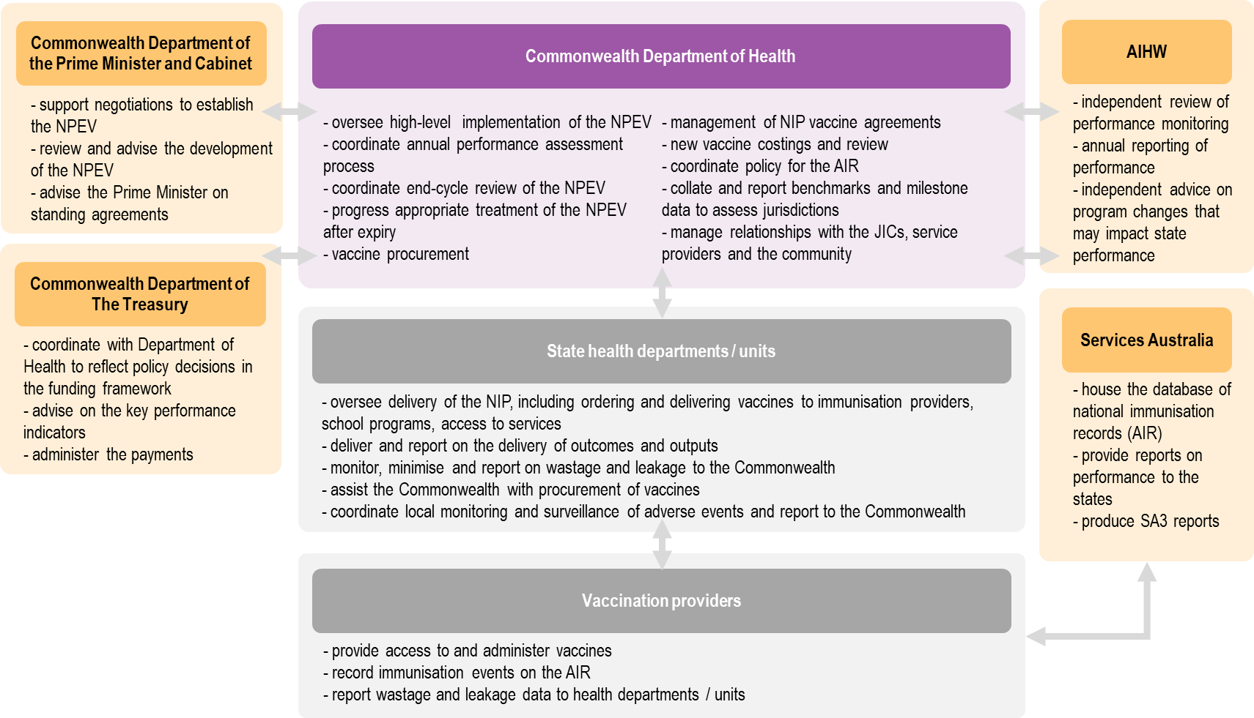
Source: ACIL allen consulting, Stakeholder consultations, 2020.
Under the second NPEV, the Commonwealth is responsible for contributing funding, supplying vaccines and providing leadership to support implementation of the second NPEV, monitoring and assessing performance, and coordinating national monitoring and surveillance of adverse events following immunisation.
The states and territories are responsible for delivering outputs and outcomes assigned to them under the second NPEV, delivering the NIP, assisting the Commonwealth with procuring vaccines to be supplied under the NIP, supporting access to immunisation, and reporting on performance, vaccine wastage and leakage and adverse events.
The specific roles of the Commonwealth and states and territories under the second NPEV are outlined in Box 1.2.
Box 1.2 Commonwealth and state and territory roles under the second NPEV
Under the NPEV, the Commonwealth agrees to be responsible for:
  - providing a financial contribution to the States to support the implementation of this Agreement
  - monitoring and assessing the performance in the delivery of the NIP under this Agreement to ensure that outputs are delivered and outcomes are achieved within the agreed timeframe
  - supplying vaccines, including:
    - listing vaccines on the NIP
    - tendering for the supply of all vaccines on the NIP through Commonwealth Own-Purpose Expenses, including any vaccines added over the life of the Agreement
    - funding and purchasing vaccines for delivery by the States through the NIP.
  - providing leadership in the development of national consumer and medical professional communication activities
  - coordinating national monitoring and surveillance of adverse events following immunisation.
Under the NPEV, the States agree to be responsible for:
  - delivering on outcomes and outputs assigned to the States for implementation
  - reporting on the delivery of outcomes and outputs as set out in Part 4 – Performance Monitoring and Reporting
  - delivering the NIP, including:
    - ordering vaccines from the contracted suppliers
    - delivering vaccines to immunisation providers in accordance with guidelines on vaccine safety and cold chain management
    - promptly notifying the Commonwealth of substantial or unavoidable situations relating to the volume and supply of vaccines
    - all necessary actions set out in the vaccine supply deeds
    - delivering school immunisation programs.
  - assisting the Commonwealth with procurement of vaccines to be supplied under the NIP, including:
    - providing advice on tender documentation
    - participating on tender panels and procurement processes
    - providing accurate forecasts of required volumes, including stock on hand doses distributed, of vaccines listed on the NIP and amending as required.
  - Supporting individuals’ access to immunisation services for immunisations covered under the NIP
  - monitoring, minimising and reporting on vaccine wastage and leakage and promptly notifying the Commonwealth of any substantial and unavoidable changes in levels of vaccine wastage and leakage
  - coordinating local monitoring and surveillance of adverse events following immunisation and reporting them to the Commonwealth.
Source: COAG (2017). National Partnership Agreement on Essential Vaccines. Canberra: Australian Government.
State and territory immunisation programs are managed from within public health, policy and communicable diseases divisions of the various health departments. The Jurisdictional Immunisation Coordinator (JIC) immunisation teams distribute vaccines and work with vaccination providers to deliver vaccination programs.
Effective supply chain management requires appropriate vaccine storage, handling, and stock management; rigorous cold chain temperature control; and maintenance of logistics management information systems.
Australia’s size and dispersed and remote population create significant challenges for immunisation service delivery and vaccine supply chain management. State and territory supply chains are complex and expensive to operate, particularly for states and territories with more remote populations. The supply chains in states and territories with small populations also face challenges as they do not generate economies of scale in distribution and storage.
Across Australia, vaccinations are administered by medical practitioners and general practitioners (GPs), appropriately certified nurses or nurses under a doctor’s order (without requiring additional immunisation training in delivering vaccinations), and pharmacists (in some states and territories). These are delivered through GPs’ clinics, state and territory or local council community health centres, Aboriginal Health/Medical Services and school-based programs. Some states and territories rely heavily on GPs to administer childhood vaccines, notably NSW, QLD and TAS, while Victoria relies heavily on local governments and NT relies heavily on territory or local government community health centres. In other states and territories, there is a more even balance between these providers.
The service delivery model influences the costs of provision, the sources of funding streams and therefore the level of influence and control that state and territory governments can exert over vaccination providers. Recognised vaccination providers (e.g. medical practitioners, midwives and nurse practitioners with a Medicare provider number) may receive Medicare benefits for the consultation relating to the administration of vaccines, therefore their financial relationship associated with these services is with the Commonwealth. Local government clinics and state or territory community health centres are funded by state and territory governments to deliver immunisation services. These services are not eligible for Medicare benefits.
Historically, the Seven Point Plan introduced in 1997 provided a framework for increasing immunisation coverage rates in Australia. This included incentive payments for vaccination providers, including a Service Incentive Payment, Outcomes Bonus Payment and Australian Childhood Immunisation Register (ACIR) notification payment for GPs (now the AIR notification payment). The Seven Point Plan supported GPs to adhere to good immunisation practice (including accurate and timely immunisation data reporting). This support has been withdrawn over time. The current level of financial support for vaccination providers is limited to the AIR Notification Payment provided to vaccination providers for notifying the AIR of a completed NIP childhood schedule for a child under seven years old, and the Catch-up Payment for following up and vaccinating a child under seven years old who is more than 2 months overdue for their childhood vaccinations under the NIP Schedule and recording it on the AIR, noting that eligible providers receive the MBS payment for consultation at which vaccinations are administered.

Financial arrangements
The second NPEV contains three key funding arrangements (described below):
- performance benchmark payment
- milestone payment
- payment to the AIR.

Performance benchmark payment
The performance benchmark payment is a payment directly from the Commonwealth to the states and territories based on performance across five benchmark indicators (performance benchmarks a-e in Box 1.1). For each benchmark met, the state or territory receives a payment that equates to 0.75 per cent of the total value of vaccines purchased by their jurisdiction. The combined value of state’s performance benchmark payments is up to 3.75 per cent of the total value of vaccines purchased by their jurisdiction.

Milestone payment
As with the performance payment, the milestone payment is a payment from the Commonwealth to the states and territories. The payment is provided to each jurisdiction based on the jurisdiction providing annual schools HPV immunisation data by April 30. The combined value of states’ and territories’ milestone payments equates to 0.75 per cent of the cost of vaccines purchased nationally. This is divided equally among the states and territories.

AIR payments
The AIR payments are payments made from the Commonwealth and most states and territories to recognised vaccination providers to encourage accurate and timely notification of vaccination events. The payments are made through the AIR Special Account following reporting of vaccination events by providers to the AIR. The financial arrangements underpinning the AIR payments are summarised in Figure 1.3 and detailed below.
FIGURE 1.3 AIR PAYMENTS
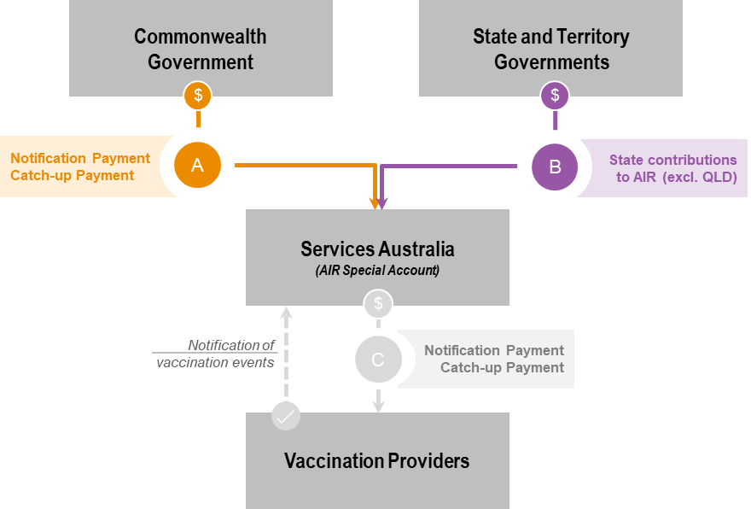
Source: ACIL Allen consulting, 2020

A. Commonwealth to Special Account
The Commonwealth contributes two types of funding to vaccination providers following vaccination reporting. This funding is provided to the Special Account administered by Services Australia for the AIR.
- Notification Payment: contributions are based on a forecast of the number of vaccination notifications to be completed for the given year. The Commonwealth contributes $4 (67 per cent of the schedule payment) for each schedule completed for children under seven years old in Victoria and $3 (50 per cent of schedule payment) for schedules completed in all other states and territories. In 2019-20, it is estimated the funding contributed by the Commonwealth for Notification Payments will be $6.53 million.
- Catch-up Payment: in addition to the Notification Payments, the Commonwealth contributes funding for a $6 payment (100 per cent of the payment) for vaccination providers to administer and report completed catch-up vaccination schedules for children under seven years old who are more than two months overdue. In 2019-20, the funding contributed by the Commonwealth for Catch-up Payments it is estimated to be $0.54 million.

B. States and territories to Special Account
The states and territories contribute Notification Payments to the Special Account for the AIR. These are distributed to vaccination providers following vaccination reporting. The contributions are based on a forecast of the number of vaccination notifications to be completed for the given year. The contributions made by each state and territory are as follows:
- Victorian Government contributes $2 (33 per cent of the schedule payment) for each forecast vaccination schedule completed in the state. In 2019-20, Victoria will contribute an estimated $1.05 million in funding to the AIR.
- Queensland Government does not contribute to the AIR.
- All other states and territories contribute $3 (50 per cent of the schedule payment) for each vaccination schedule completed in their state. In 2019-20, the estimated state and territory contributions are:
  - NSW: $1.93 million
  - WA: $0.64 million
  - SA: $0.37 million
  - Tasmania: $0.11 million
  - ACT: $0.11 million
  - NT: $0.07 million.
If there is a variance between forecast schedule notifications and actual notifications, the surplus/deficit funding is accounted for in the Commonwealth or state and territory funding obligation for the following period.
All funding commitments are made twice annually on 30 January and 31 August, in equal amounts (plus or minus any surplus/deficit payments from the preceding period).

C. Special Account to vaccination provider
Services Australia makes Notification and Catch-up Payments to vaccination providers from the Special Account.
- Notification Payment: payments to vaccination providers are based on notifications received by the AIR from vaccination providers for each schedule completed for children under seven years old.
- Catch-up Payment: payments to vaccination providers for administering and reporting completed catch-up vaccination schedules for children under seven years old who are more than two months overdue.
Across Australia in 2019-20, 82 per cent ($7.95 million) of Notification and Catch-up Payments are estimated to be made to GPs. The next largest payment is made to councils (9 per cent, $0.90 million) and Community Health Centres (7 per cent, $0.71 million). The remaining 2 per cent ($0.19 million) is paid to nine other provider types including Public Hospitals, Aboriginal Health Services, and the Royal Flying Doctor Service.

Change in performance payments between the first and second NPEV
The performance payments changed significantly between the first and second NPEVs, shifting from incentive payments to performance payments:
- Under the first NPEV, the incentive payments rewarded states and territories that improved the cost-effectiveness of their service delivery by investing in activities directly related to the provision of vaccines and undertaking projects to maintain or increase vaccine coverage among agreed cohorts.
- Under the second NPEV, the performance payments were restructured to reward states and territories that meet each of the five performance benchmarks and one milestone.
The financial arrangements for the second NPEV are outlined in Box 1.3.
Box 1.3 Funding allocations and payments
The Commonwealth will allocate a total of 4.5 per cent of the cost of vaccine purchases to the States for the purposes of this Agreement as follows:
  - 0.75 per cent of the cost of each State’s total vaccine purchases to each of the five performance benchmarks, as set out at clauses 20(a) to (e) of this Agreement, totalling 3.75 per cent
  - 0.75 per cent of the total cost of vaccines purchases, to be divided equally amongst the States, to the milestone set out at clause 20(f) of this Agreement.
Source: COAG (2017). National Partnership Agreement on Essential Vaccines. Canberra: Australian Government.

Incidences of childhood diseases included under the NIP
Immunisation rates have increased over recent decades, correlating with a reduction in health complications caused by vaccine-preventable diseases. Continued success of the NIP depends on maintenance and improvement of vaccination rates for all eligible Australians.
The introduction of new vaccines and their inclusion in the NIP have resulted in large declines in the incidence of a range of diseases. As a result of the success of the NIP, many diseases, such as rubella, tetanus, diphtheria, Haemophilus influenzae type b and measles, are rare in Australia. Incidences of other diseases, such as rotavirus, chickenpox and meningococcal and pneumococcal have declined dramatically and remained low in 2019.
Appendix E details the notifications and hospitalisation rates for vaccine-preventable diseases with publicly available data pre-dating the addition of the associated vaccine on the NIP. For example, Figure 1.4 shows the crude hospitalisation rates for chickenpox (top) and notifications for varicella zoster (shingles) (bottom). The introduction of the chickenpox vaccine to the NIP in 2005 (represented by a vertical black dotted line) correlates with a decrease in hospitalisation rates from 2007-2016.
In contrast, the introduction of the shingles vaccine to the NIP in 2016 does not impact the rate of notifications, with notifications continuing to rise to 2019. This reflects the complex interplay between disease and immunisation where other factors contribute to disease trends, such as changes in testing policies, target screening programs, improved diagnostic tests and immunisation awareness campaigns.
Figure 1.4 Disease trends for Chickenpox and shingles
Crude hospitalisation rates for chickenpox, 1994 to 2016
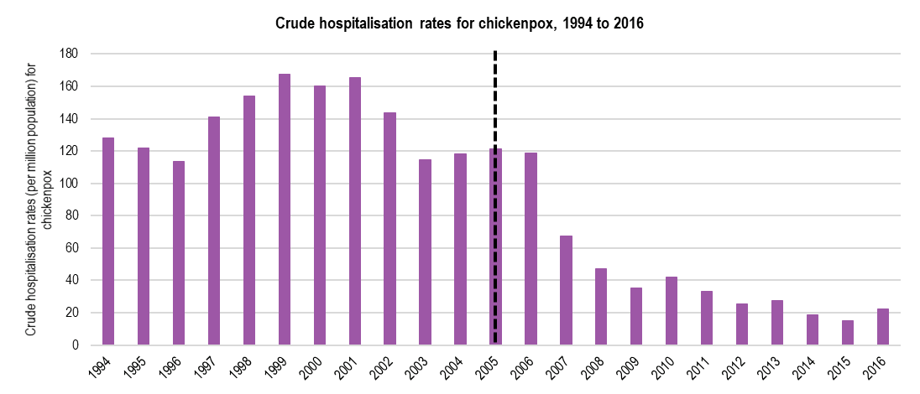
Number of notifications for shingles, 2006 to 2019
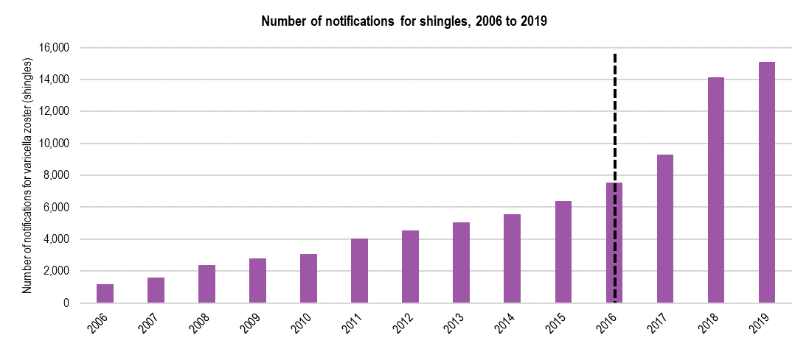
Notes: Results may vary from those published in other reports due to retrospective data revisions. Notifications and hospitalisation rate data represent a proportion of the total cases occurring in the community, that is, only cases for which health care was sought, a test conducted, and a diagnosis made, followed by notification to health authorities. The degree of under-representation of cases is unknown and is likely variable by disease and state.
Crude hospitalisation rates = hospitalisations per million population. Vertical dotted line represents the year the vaccine was introduced to the NIP.
Source: Data is based on the NNDSS database accessed on 25 May 2020.

Prior reviews
The effectiveness, efficiency and appropriateness of the first NPEV were reviewed in 2014. The review found that the first NPEV was effective in funding and delivering a national, coordinated and integrated approach to effective immunisation, with governments fulfilling their commitments and meeting the performance benchmarks required for incentive payments. Recommendations were made to improve the first NPEV in line with the National Immunisation Strategy 2013-2018. The first NPEV review supported the negotiation and development of the second NPEV.
In 2016, a ‘rapid review’ of the first NPEV was conducted. The review involved mapping changes in the immunisation landscape under the first NPEV and developing options for a future NPEV agreement based on extensive consultation with the states and territories.
In 2017-18, the Australian National Audit Office (ANAO) conducted an audit of the effectiveness of monitoring and payment arrangements under 17 of 71 NPAs funded as of 1 July 2016, including the first NPEV. The first NPEV was the last NPA to include reward payments. The ANAO Report concluded that the first NPEV had an outcomes focused performance framework, sound payment design and a ‘strong’ evidence base with evidence verified by an independent third party.

Approach to the Review
This Review has been undertaken in five stages:
- Stage 1: Project planning
- Stage 2: Development of Evaluation and Risk Management Plans
- Stage 3: Data collection and stakeholder consultation
- Stage 4: Review and data analysis
- Stage 5: Project reporting.
The review has been led by ACIL Allen with oversight from a Review Steering Committee comprised of representatives from the Commonwealth and each state and territory government, and support of the Immunisation Strategies section in the Department. The Review Steering Committee has:
- provided a decision-making forum for key stages of the Review (e.g. guiding the review scope, approving the Evaluation and Risk Management Plan and endorsing the Terms of Reference, providing feedback on the presentation of the draft Interim Report and draft Final Report)
- provided strategic guidance and support
- facilitated consultation with stakeholders and data collection across each state.

Project planning
An initial discussion and inception meeting were held with the Department and ACIL Allen in February 2020. These discussions focused on background to the review, the project scope and objectives, methodology and project management arrangements, and the role of the Department’s Immunisation Strategies section in coordinating the Review and the various teams involved throughout the review.
A Project Plan incorporating the outcomes of the inception meeting was prepared by ACIL Allen and accepted by the Department.

Development of Evaluation and Risk Management Plans
A preliminary desktop review informed the development of the draft Evaluation and Risk Management Plans. The Plans were submitted as a consolidated document (referred to hereafter as the Evaluation and Risk Management Plan), for consideration by the Review Steering Committee during the 5 March 2020 meeting. Feedback on the draft Evaluation and Risk Management Plan from the Review Steering Committee was incorporated into the Final Evaluation and Risk Management Plan, which the Department accepted as final on 3 April 2020.

Data collection and stakeholder consultation

Data collection
The Review has drawn from a detailed desktop review of existing data, available through the Commonwealth, states and territories, AIR, and AIHW. This has included administrative and financial data.
Several data considerations were identified, including:
- HPV coverage data: There appear to be data inconsistencies arising from a shift in HPV data housing from the National HPV Vaccination Program Register (HPV Register) to the AIR in 2018. The recent reductions in HPV coverage rate need to be interpreted with caution as it is unclear whether the data presented represents a real reduction in coverage rate or is merely an artefact of the data migration.
- Immunisation coverage rates rely on timely, complete and accurate reporting to the AIR. Errors or delays in vaccination notifications may result in under reporting and therefore, underestimate a state’s immunisation coverage rates. The extent of notification errors may differ by jurisdiction, due to service delivery models, the presence of state and territory-based immunisation registers and the degree of data cleansing conducted by the states and territories. Retrospective updates to immunisation data by states and territories may cause variances in coverage rates between different published sources.
- SA3 coverage data: For the 2018-19 assessment period, the SA3 coverage reports were found to contain geocoding errors, potentially causing some states and territories to incorrectly select areas of low coverage. The provision of updated coverage reports to the states and territories was delayed, which may have prevented the states and territories from undertaking follow up activities prior to the end of the 2018-19 assessment period. For these reasons, the Commonwealth decided, based upon feedback from the states and territories, that all states and territories would be assessed as meeting performance benchmark 4 in full for the 2018-19 assessment period.
- Wastage and leakage data: Applying the methodology for calculating performance in the second NPEV means that it is possible to achieve a negative wastage and leakage rate. The wastage and leakage calculation does not account for viable stock remaining in vaccination providers’ fridges, which is considered ‘wasted’ by the approach.
- Disease incidence data: Data on vaccine-preventable diseases was obtained from the diseases National Notifiable Diseases Surveillance System (NNDSS). Where the number of notifications was not available, crude hospitalisation rates are presented. Changes in disease incidence do not solely reflect vaccination coverage. Other factors contribute to these rates, such as changes in testing policies, targeted screening programs, improved diagnostic tests and immunisation awareness campaigns.
- Definition of ‘fully immunised’: The definition varies over time with the addition of new vaccines on the NIP. This may influence the coverage rates for certain age groups.
- Comparisons presented between assessments of coverage over time (using data obtained from AIR) and second NPEV performance reports and other sources should be interpreted carefully to ensure the data is comparative.
- second NPEV administration data: The costs to administer the second NPEV are not routinely collected or reported. Estimates were provided specifically for this Review. At the time of writing, all states and territories except Tasmania had submitted cost estimates. There are potential inconsistencies in the administrative data obtained from the states and territories. While a consistent data collection template was used to guide reporting of administrative data, data categories were open to interpretation.
- Vaccine price saving analysis: The estimate of savings from a reduction in vaccines prices were calculated by ACIL Allen and are based on Department transaction data (changes in prices and volumes of vaccines procured).
- Vaccine delivery data: Timing and delivery performance analysis for 2019 is based on data and analysis from the Department. Average estimates are based on total vaccine orders and are not weighted according to vaccine volumes. Therefore, individual outlier orders can significantly impact the calculated estimates.

Stakeholder consultation
The Review has drawn on stakeholder understanding of and experiences with the second NPEV, including lessons learned. Stakeholder perspectives contributed important information to the Review and assisted with interpretation of qualitative and quantitative data.
The stakeholder consultation component of the evaluation was completed between 23 April and 15 May 2020. Discussion guides were circulated to stakeholders prior to consultations, which were held via telephone or videoconference, or input was otherwise received in writing, due to the restrictions associated with COVID-19. ACIL Allen engaged with:
- Officials from the Department (Immunisation Branch)
- Officials from the Department of The Prime Minister and Cabinet
- Officials from the Department of The Treasury
- Officials from state and territory Departments of Health (ACT, NSW, NT, Queensland, SA, Tasmania, Victoria and WA).
- Officials from the AIHW.

Review and data analysis
A thematic analysis of qualitative information from the stakeholder consultations was conducted and combined with assessment of data relating to the appropriateness, effectiveness and efficiency of the second NPEV. This included analysis of outputs, outcomes and performance, and assessment of cost-effectiveness.

Federal financial relations
Both the IGA FFR and leading practice principles for Financial Arrangements provided a framework for assessing the appropriateness of the second NPEV in facilitating the policy objectives of the second NPEV.
The Commonwealth provides ongoing financial support to states and territories for a variety of purposes through arrangements set out in the IGA FFR. This includes:
- general revenue assistance, including the ongoing provision of GST payments, to be used by the states and territories for any purpose
- National Specific Purpose Payments (SPPs) to be spent in the key service delivery sectors
- National Health Reform (NHR) Funding
- National Partnership payments to support the delivery of specified outputs or projects, to facilitate reforms or to reward those states and territories that deliver on nationally significant reforms
- Project Agreements, which are a simpler form of National Partnership, for low value and/or low risk projects.
The IGA FFR:
… recognises that the States have primary responsibility for many areas of service delivery but that coordinated action is necessary to address Australia’s economic and social challenges.
It aims to improve the quality and effectiveness of government services by providing the States with increased flexibility in the way they deliver services to the Australian people, clarify the roles and responsibilities of each level of government and improve the accountability for the achievement of outcomes.
The Commonwealth may provide payments to other levels of government as Commonwealth Own-Purpose Expenses (COPE). COPEs are expenses made by the Commonwealth in the conduct of its own general government sector entities in circumstances where the funding is contestable (available to all sectors of the economy, including but not limited to other levels of government) or does not reflect an activity that is through legislation the responsibility of, or regulated by the government receiving the funding. COPEs are not subject to the IGA FFR framework. The Commonwealth uses COPE to secure vaccines through a competitive tendering process (see Section 5.1).
The classification of the payment type influences which rules the payment is subject to and its treatment in the Budget papers. The Commonwealth Department of Finance is responsible for classification of revenue and expenses in the Federal Budget papers and has classified a National Partnership payment as the appropriate mechanism for payment from the Commonwealth to the states and territories for the purposes set out in the second NPEV.

Leading practice principles
Leading practice principles establish a frame of reference against which an assessment of the second NPEV Financial Arrangements can be made, namely the AIR payment, the performance benchmark payment and the milestone payment. This assessment focuses on whether the second NPEV provides an equitable and adequately remunerative funding model for state and territory activity.
The following leading practice principles were identified for the assessment:
- Outcomes focussed: The funding model should encourage states and territories to deliver against the six outcomes of the second NPEV.
- Equity: The funding model should apply second NPEV incentives and disincentives to all states and territories equitably.
- Choice and Control: The funding model should align responsibility with influence so that states and territories have autonomy to deliver the program in a manner that is most suitable.
- Flexible, Responsive and Scalable: The funding model should be suitable for delivery and implementation of the second NPEV under the range of Australian settings.
- Efficient: The funding model should encourage the efficient delivery and implementation of the second NPEV.
- Certainty and Predictability: The funding model should provide states and territories with a high degree of predictability around expected funding.
- Transparent and Simple: The mechanics of the funding model should be easy to understand and readily available to states and territories.

This report
This Final Report presents the assessment of the second NPEV according to the Terms of Reference and evaluation framework (Appendices A-B).

Report structure
The remainder of this report is structured as follows:
- Chapter 2: The performance of the second NPEV
- Chapter 3: Roles and responsibilities of involved parties
- Chapter 4: Performance monitoring and reporting arrangements
- Chapter 5: Financial arrangements and contributions
- Chapter 6: Appropriateness of an NPA for implementing the NIP
- Chapter 7: High level findings and future developments
- Appendix A: Terms of Reference
- Appendix B: Evaluation framework
- Appendix C: NIP Schedule
- Appendix D: Outcomes and outputs of the first NPEV
- Appendix E: Disease trends
- Appendix F: Vaccine-preventable diseases covered by vaccines under the NIP
- Appendix G: Second NPEV definition of ‘fully immunised’
- Appendix H: Additional data.

Performance of the second NPEV | 2
This Chapter focuses on the performance of the states and territories according to the objectives, outcomes and outputs under the NIP and second NPEV.

To what extent is the NPEV appropriately facilitating the cost-effective and efficient delivery of immunisation programs under the NIP?
This Section addresses the evaluation sub-questions relating to the delivery of the program objectives, outcomes and outputs, and performance. The sub-questions concerning cost-effectiveness and efficiency of the second NPEV as well as the appropriateness of the financial contributions and performance and milestone payments are addressed in Chapter 5.
Key Finding 1 To what extent is the NPEV appropriately facilitating the cost-effective and efficient delivery of immunisation programs under the NIP?
The second NPEV provides a clear, focused and nationally consistent framework for delivering state and territory-based immunisation programs. The second NPEV’s objectives and outcomes are consistent with those of the NIP.
The outputs specified in the second NPEV focus on a limited range of activities undertaken by states and territories to achieve the abovementioned objectives and outcomes. It is unclear if these outputs reflect areas of reform and while they are important, it is not clear if they represent the areas most likely to drive reductions in the spread of vaccine-preventable diseases or improve vaccination coverage rates.
Over the two assessment periods, the states and territories were assessed as meeting 92 per cent of performance benchmarks and the milestone, and as such, are contributing towards delivering the objectives and outcomes of the NIP.

Delivery of immunisation program objectives, outcomes and outputs under the NIP
The second NPEV provides a nationally consistent framework for delivering state and territory-based immunisation programs to achieve the objectives and outcomes under the NIP. The objectives and outcomes articulated in the second NPEV are consistent with those of the NIP.
The outputs specified in the second NPEV focus on a subset of outputs required to achieve the broader objectives and outcomes of the second NPEV, and of the NIP, and most states and territories pointed to this. The selection of a subset of outputs is consistent with, but not required to fulfil, the circumstances where National Partnerships are utilised, which are to support the delivery of specified projects (not relevant to the second NPEV), facilitate reforms, or reward those jurisdictions that deliver on nationally significant reforms. The outputs included in the second NPEV should reflect areas of the NIP where reform is required to support achievement of the second NPEV’s outcomes and objectives, or be linked to nationally significant reforms.
While the outputs specified in the second NPEV contribute to achieving very important outcomes, it is unclear if they reflect areas associated with reform or if the four outputs that address vaccination coverage rates are the most relevant for driving further improvements in coverage levels across the life of the second NPEV, given the high levels of coverage already achieved.
The Review acknowledges the importance of activities that maintain (rather than continue to increase) the high levels of vaccination coverage for 60 ≤ 63 month olds generally and for Aboriginal and Torres Strait Islander children specifically given their vulnerability to vaccine preventable diseases, as linked to outputs a) and b). Output c) increasing HPV coverage rates for adolescents is also important and is a comparatively new vaccine in the NIP Schedule (specifically its inclusion for boys). Associated with this, output f) providing agreed, quality assured data on HPV delivered in schools to the immunisation register could more readily be interpreted as demonstrating reform as it encourages improvements in data collection and reporting, without which it is difficult to accurately reflect program efficiency, effectiveness and impact.
Output d) increasing coverage rates in areas of lowest coverage for 60 ≤ 63 month olds directly addresses an area where additional effort is required and therefore could be viewed as one of reform, noting there are difficulties associated with measuring this output (see Section 4.1.1).
Output e) reducing the wastage and leakage for vaccines listed on the NIP again represents an important area of focus addressing efficiency of the NIP. There are issues associated with which party is best placed to impact on this output, discussed further in Section 2.1.2.
Most stakeholders reflected that the selection of outputs (and associated performance benchmarks and milestones) influences the areas in which effort is applied, underpinning the importance of selecting the most appropriate outputs. They also put forward the view that output selection was more heavily influenced by which data are available to measure performance rather than the activities that contribute most to reducing the spread of vaccine-preventable diseases or improving vaccination coverage rates.
There was widespread frustration that many activities associated with implementing the NIP were not covered by the outputs specified in the second NPEV. The second NPEV’s outputs, performance benchmarks and milestone do not address all vaccines or cohorts specified under the NIP (e.g. people of all ages in vulnerable cohorts, including the elderly, pregnant women, people with certain medical risk factors, and Aboriginal and Torres Strait Islander peoples) nor reward effort expended towards strategic priorities specified under the NIP, such as:
- enhancing vaccine safety monitoring systems
- maintaining and ensuring community confidence in the NIP through effective communication strategies
- strengthening monitoring and evaluation of the NIP through assessment and analysis of immunisation register data and vaccine-preventable disease surveillance
- ensuring an adequately skilled immunisation workforce through promoting effective training for vaccination providers.
Several stakeholders noted the value of these strategic priorities in improving immunisation coverage rates more broadly, and in ensuring that every administered vaccine is viable, safe and of high quality, and that every dose is reported to the AIR. The second NPEV’s outputs, performance benchmarks and outcomes focus on a narrow subset of state and territory activities, which may divert state and territory effort away from activities that are not measured through the NPEV but have the potential to impact significantly on achievement of NIP objectives.
Monitoring of activities to support adult vaccination and vaccination across the lifespan could improve coverage for vaccines provided free to adults under the NIP by focussing efforts on these cohorts.
Potential monitoring of adult immunisation was considered during early consultations leading into the negotiation of the second NPEV. However, the limitations in national data collections at the time meant that the second NPEV retained the focus on childhood immunisation, with the addition of adolescent immunisation via the HPV Register (and now available through the AIR following data transition in 2019). For adult immunisation coverage to be effectively monitored, vaccination provider reporting may need mandating.
The performance benchmarks do not account for the significant resources allocated to immunisation and immunisation-related activities to meet the performance benchmarks and to increase immunisation coverage rates for vaccines and cohorts identified under the NIP, yet not covered by the second NPEV. The Commonwealth does not have direct visibility of these activities. They include:
- Immunisation programs:
  - Influenza, which is a large program with adolescent and adult vaccinations. This doubles the workload for many states and territories, with increased ordering and distribution of vaccines, and awareness programs.
  - School-based programs, excluding HPV.
  - At-risk groups, such as pregnant women, culturally and linguistically diverse communities, and older adults.
  - State and territory-based programs, such as pertussis vaccines for expectant and new parents.
- Immunisation-related activities:
  - Communication and awareness raising strategies.
  - Education for vaccination providers.
  - Registration of vaccination providers and licensing of pharmacists as vaccination providers.
  - Telephone clinical advisory services, which provide information on issues such as immunisation catch-up and cold chain breaches. This supports public accessibility and effective and appropriate immunisation by health care workers.
  - Development of state and territory-based immunisation databases to record school and other immunisation data.
  - Development of resources for school-based and council-run programs.
  - Supply chain distribution, particularly in larger states and territories, or those with more remote populations and complex distribution networks.
  - State and territory-funded programs on disease epidemiology.

Performance against the performance benchmarks and milestone
Table 2.1 summarises the assessments against the performance benchmarks and milestone for states and territories under the second NPEV.
All states and territories have performed well by meeting most of the performance benchmarks and milestones for the first two assessment periods of the second NPEV. Of the 88 benchmarks and milestones assessed so far, 81 were met (92 per cent), one was partially met and six were not met. In the 2017-18 and 2018-19 assessment periods:
- Performance benchmark 1: all states and territories met this benchmark in both assessment periods by improving (or maintaining above 95 per cent) vaccination coverage rates for 60 ≤ 63 month olds.
- Performance benchmark 2: all states and territories met this benchmark in both assessment periods by improving (or maintaining above 95 per cent) vaccination coverage rates for at least two of three age groups for Aboriginal and Torres Strait Islander children (12 ≤ 15, 24 ≤ 27 or 60 ≤ 63 month olds).
- Performance benchmark 3: all states and territories met this benchmark in 2018-19, the first year of assessment, by improving HPV vaccination coverage rates for adolescents.
- Performance benchmark 4: SA partially met this benchmark in 2017-18 (achieved an increase in coverage rate for three of four SA3 areas), while the remaining states and territories met the benchmark in full in 2017-18. All states and territories were assessed as having met this benchmark in full in 2018-19 due to data issues (discussed further below).
- Performance benchmark 5: ACT, NSW, NT and SA met this benchmark in 2017-18 by achieving either a wastage and leakage rate of less than 5 per cent or an annual decrease in the wastage and leakage rate for agreed vaccines, but did not meet this benchmark in 2018-19. Tasmania did not meet this benchmark in either assessment period. Queensland, Victoria and WA met this benchmark in both assessment periods.
- Milestone: all states and territories met the milestone for both assessment periods by providing HPV vaccination data.
Detail of each performance benchmark follows.
Table 2.1 Summary of assessment against the perfoRmance benchmarks for states and territories 2017-18 to 2018-19
 | PB 1 |  | PB 2 |  |  | PB 3 |  |  | PB 4 |  |  | PB 5 |  |  | Milestone
 | 2017  –2018 | 2018  -2019 |  | 2017  –2018 | 2018  –2019 |  | 2017  –2018 | 2018  –2019 |  | 2017  –2018 | 2018  –2019 |  | 2017  –2018 | 2018  –2019 |  | 2017  –2018 | 2018  –2019
ACT | YES | YES |  | YES | YES |  | N/A | YES |  | YES | YES |  | YES | NO |  | YES | YES
NSW | YES | YES |  | YES | YES |  | N/A | YES |  | YES | YES |  | YES | NO |  | YES | YES
NT | YES | YES |  | YES | YES |  | N/A | YES |  | YES | YES |  | YES | NO |  | YES | YES
Queensland | YES | YES |  | YES | YES |  | N/A | YES |  | YES | YES |  | YES | YES |  | YES | YES
SA | YES | YES |  | YES | YES |  | N/A | YES |  | Partial | YES |  | YES | NO |  | YES | YES
Tasmania | YES | YES |  | YES | YES |  | N/A | YES |  | YES | YES |  | NO | NO |  | YES | YES
Victoria | YES | YES |  | YES | YES |  | N/A | YES |  | YES | YES |  | YES | YES |  | YES | YES
WA | YES | YES |  | YES | YES |  | N/A | YES |  | YES | YES |  | YES | YES |  | YES | YES
Note: (YES) represents the performance benchmark was met, ‘partial’ represents that the performance benchmark was partially met and cross (NO) represents the performance benchmark was not met. Data were extracted from the AIHW performance reports pertaining to the first year (2017-18) and second year (2018-19) of the second NPEV.
PB = Performance benchmark.
N/A = not assessed. HPV vaccination coverage rates were not assessed for the 2017-18 assessment period.
Source: AIHW performance report 2017-18 and 2018-19

Performance benchmark 1: Vaccination coverage rates for 60 ≤ 63 month olds
All states and territories met performance benchmark 1 in 2017-18 and 2018-19: An increase in vaccination coverage rates for 60 ≤ 63 month olds relative to the baseline.
Under the second NPEV, the vaccination coverage rates for 60 ≤ 63 month olds have increased for all states and territories (see Figure 2.1). This continues a long-standing, increasing trend across the states and territories from 2005. In 2019, Victoria (95.62 per cent) was the only state or territory with a coverage rate above 95 per cent. This was followed closely by Tasmania (94.95 per cent), NT (94.95 per cent), ACT (94.83 per cent), NSW (94.68 per cent), SA (94.64 per cent), Queensland (94.40 per cent) and WA (93.53 per cent).
Although the coverage rates are high, this does not mean the focus on this area of activity should be reduced. With 315,147 registered births in 2018, there is a continual need for education and awareness raising among new parents and vaccination of new children.
FIGURE 2.1 VACCINATION COVERAGE RATES FOR 60 ≤ 63 MONTH OLDS, BY STATE, 2005-2019
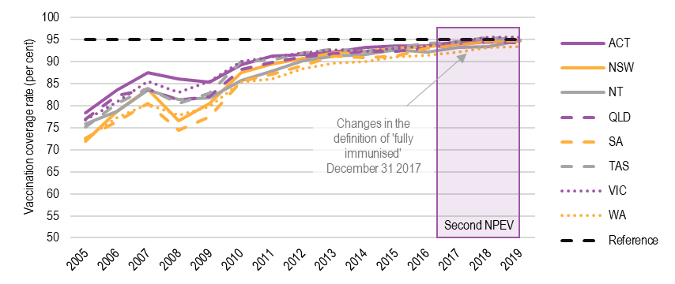
Note: As at July 2020, 'fully immunised' at 60 months of age is defined as a child having a record on the AIR of dose 4 or 5 of a diphtheria (D), tetanus (T) and pertussis (P)-containing vaccine; and dose 4 of a polio containing vaccine. Note that from 31 December 2017, the definition of ‘fully immunised’ at 60-<63 months of age changed, with MMR no longer being assessed. The reference line (black dashed line) represents a 95 per cent vaccination coverage.
Purple shading indicates the coverage period of the second NPEV.
Source: AustrALian Immunisation register

Performance benchmark 2: Vaccination coverage rates for Aboriginal and Torres Strait Islander children
All states and territories met performance benchmark 2 in 2017-18 and 2018-19: An increase in the vaccination coverage rates for Aboriginal and Torres Strait Islander people in two of the following three cohorts:
12 ≤ 15 month; 24 ≤ 27 month; and 60 ≤ 63 month, relative to the baseline.
The states’ and territories’ performance across the three age groups for the Year 1 and 2 assessment periods is shown in Table 2.2. Details of the three age groups are provided below.
All states and territories achieved an increase in vaccination coverage in the 12 ≤ 15 and 60 ≤ 63 month age groups for 2017-18, and all states and territories achieved an increase in vaccination coverage across all age groups in 2018-19.
Only NT and WA did not achieve an increase in the 24 ≤ 27 month age group in 2017-18.
Table 2.2 Summary of performance for Performance benchmark 2
State or territory | 2017-18 |  |  |  |  | 2018-19
 | 12 ≤ 15 month | 24 ≤ 27 month |  | 60 ≤ 63 month |  | 12 ≤ 15 month |  | 24 ≤ 27 month | 60 ≤ 63 month
ACT | YES |  | YES |  | YES |  | YES | YES | YES
NSW | YES |  | YES |  | YES |  | YES | YES | YES
NT | YES |  | NO |  | YES |  | YES | YES | YES
Queensland | YES |  | YES |  | YES |  | YES | YES | YES
SA | YES | YES |  | YES |  | YES |  | YES | YES
Tasmania | YES | YES |  | YES |  | YES |  | YES | YES
Victoria | YES | YES |  | YES |  | YES |  | YES | YES
WA | YES | NO |  | YES |  | YES |  | YES | YES
Source: AustrALian Immunisation register
Figure 2.2 shows the vaccination coverage rates for Aboriginal and Torres Strait Islander children in the youngest age group for this benchmark: 12 ≤ 15 month olds, for all states and territories from 2003-2019.
Under the second NPEV, the vaccination coverage rates for Aboriginal and Torres Strait Islander children remained steady or increased. This extends the trend in increased coverage rates from 2014-2019 across most states and territories. WA and SA appear to lag behind other states and territories with the lowest vaccination coverage rate each year. In 2019, ACT (98.38 per cent) and Tasmania (95.49 per cent) had vaccination coverage rates above 95 per cent.
FIGURE 2.2 VACCINATION COVERAGE RATES FOR ABORIGINAL AND TORRES STRAIT ISLANDER CHILDREN 12 ≤ 15 MONTH OLDS, 2003-2019
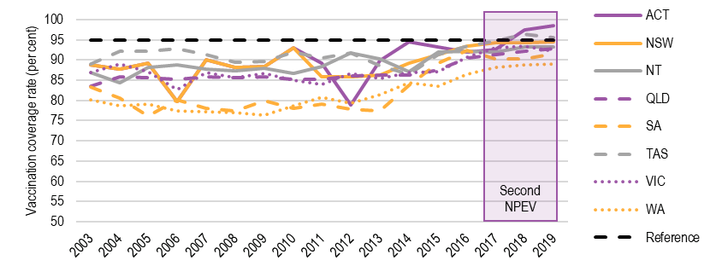
Note: as at July 2020, 'fully immunised' at 12 ≤ 15 months of age is defined as a child having a record on the AIR of dose 3 of a DTP-containing vaccine; dose 3 of polio vaccine; dose 2 or 3 Haemophilus influenzae type b (Hib) containing vaccine depending on pathway; dose 3 of hepatitis B (hepB) vaccine; and dose 3 of 13-valent pneumococcal conjugate vaccine (13vPCV).
The reference line (black dashed line) represents a 95 per cent vaccination coverage.
Purple shading indicates the coverage period of the second NPEV.
Source: AustrALian Immunisation register
Figure 2.3 shows the vaccination coverage rates for Aboriginal and Torres Strait Islander children aged 24 ≤ 27 months old, for all states and territories from 2003-2019.
Vaccination coverage rates for Aboriginal and Torres Strait Islander 24 ≤ 27 month olds have improved across most states and territories under the second NPEV. However, in 2019, no states or territories had a coverage rate above 95 per cent. ACT is closest to achieving this goal at 94.12 per cent.
Vaccination coverage rates were previously higher (2004-2014) yet fell in 2014 with changes to the definition of ‘fully immunised’ and inclusion of additional vaccines. While this event is outside the period covered by the second NPEV, it is important to understand how changes in definitions can impact on coverage rates. AIHW notes that increasing the number of vaccines in the definition/assessment reduces the likelihood that the child will meet the definition of ‘fully immunised’. These changes usually resolve over time as the changes to the definition become routine. This has implications for future assessment of state and territory performance against the performance benchmarks following the addition of new vaccines or definition changes.
FIGURE 2.3 VACCINATION COVERAGE RATES FOR ABORIGINAL AND TORRES STRAIT ISLANDER CHILDREN 24 ≤ 27 MONTH OLDS, 2003-2019
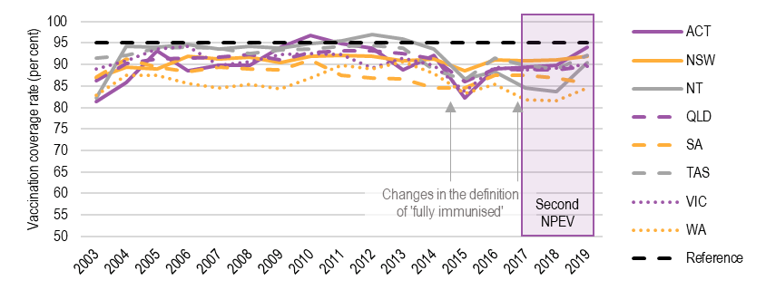
Note: The definition of ‘fully immunised’ for 24 ≤ 27 months of age changed to include additional vaccines:
- from the quarter ending 31 December 2014, meningococcal c (given at 12 months), dose 2 measles, mumps, rubella (MMR) and dose 1 varicella (given as MMRV at 18 months) were included in the definition.
- from March 2017: diphtheria, tetanus and pertussis dose 4 was included in the definition.
The previous calculation was based on diphtheria, tetanus and pertussis dose 3.
As at July 2020, 'fully immunised' at 24 ≤ 27 months of age is defined as a child having a record on the AIR of dose 4 of a DTP-containing vaccine; dose 3 of polio vaccine; dose 3 or 4 of Hib containing vaccine depending on pathway; dose 3 of hepatitis B vaccine; dose 2 of a measles, mumps and rubella-containing (MMR) vaccine; dose 1 of meningococcal C (MenC) vaccine; and dose 1 of varicella vaccine.
The reference line (black dashed line) represents a 95 per cent vaccination coverage.
Purple shading indicates the coverage period of the second NPEV.
Source: AustrALian Immunisation register
Figure 2.4 shows the vaccination coverage rates for Aboriginal and Torres Strait Islander children aged 60 ≤ 63 months old, for all states and territories from 2003-2019.
Vaccination coverage rates for Aboriginal and Torres Strait Islander 60 ≤ 63 month olds have remained very high (near 95 per cent) under the second NPEV. In 2019, all states and territories had a coverage rate above 95 per cent. NSW had the highest coverage at 97.69 per cent.
These vaccination coverage rates are currently higher than those of non-Aboriginal and Torres Strait Islander children. The trajectory of change (while beyond the period covered by the NPEV) shows the improvement in vaccination coverage rates that can be achieved by focusing resources.
The number of Aboriginal and Torres Strait Islander 60-<63 month olds varies significantly between states and territories, and in 2017-18 ranged from 144 children in ACT to 5,102 in Queensland. The proportion of 60-<63 month olds who are Aboriginal and / or Torres Strait Islander varies significantly also, and in 2017-18 this ranged from 1 per cent in Victoria to 35 per cent in NT. Figures for each state and territory are provided in Appendix H, Table H.1. The ACT has demonstrated the most variation in vaccination coverage rates from 2007-2019. This is potentially due to movements among the small numbers of Aboriginal and Torres Strait Islander peoples residing in the ACT.
Vaccination coverage rates fell in the ACT in 2008, 2011 and 2016 and were quickly rectified. While these events are outside the period covered by the second NPEV, this demonstrates the sensitivity of the vaccination coverage rates (and performance) for states and territories with a small population size, where there are a small number of Aboriginal and Torres Strait Islander peoples. Such states and territories may benefit from a different measurement approach.
FIGURE 2.4 VACCINATION COVERAGE RATES FOR ABORIGINAL AND TORRES STRAIT ISLANDER CHILDREN 60 ≤ 63 MONTH OLDS, 2003-2019
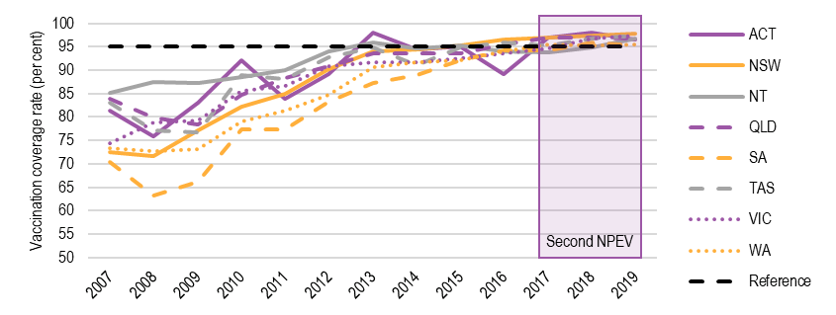
Note: as of July 2020, 'fully immunised' at 60-<63 months of age is defined as a child having a record on the AIR of dose 4 or 5 of a DTP-containing vaccine; and dose 4 of a polio containing vaccine. Note that from 31 December 2017, the definition of ‘fully immunised’ at 60-<63 months of age changed, with MMR no longer being assessed.
The reference line (black dashed line) represents a 95 per cent vaccination coverage.
Purple shading indicates the coverage period of the second NPEV.
Source: AustrALian Immunisation register

Performance benchmark 3: HPV vaccination coverage rates for adolescents
All states and territories met performance benchmark 3 in 2018: An increase in the vaccination coverage rate for both adolescent boys and adolescent girls for HPV, relative to the baseline.
2018 was the first year this benchmark was assessed.
Table 2.3 shows the HPV vaccination coverage rates for adolescent females and males for the Year 2 assessment period. All states and territories were assessed as having met the performance benchmark in 2018-19.
Table 2.3 HPV vaccination coverage rates for adolescent females and males, 2018-19
State or territory | Adolescent females  % | Adolescent males  %
ACT | 79.4 | 76.1
NSW | 80.6 | 76.6
NT | 75.6 | 68.0
Queensland | 73.5 | 69.4
SA | 74.6 | 70.8
Tasmania | 76.6 | 73.4
Victoria | 79.6 | 76.3
WA | 76.2 | 74.4
Note: As of July 2020, 'fully immunised' for HPV is defined as a child having a record on the AIR of the number of doses of HPV-containing vaccine as set out in the National Health (Immunisation Program – Designated Vaccines) Determination 2014 by age 15 years.
Source: AustrALian Immunisation register
Under the second NPEV (since 2017) HPV vaccine data has been recorded on the AIR. The AIR dataset contains unique individuals registered with Medicare. The AIR produces coverage reports at a specific point in time. If data is not reported to the AIR by the time coverage is calculated it is not included in the coverage reports.
Prior to recording HPV vaccine data on the AIR (before 2017), data was stored on the National HPV Register. These data have not been used to calculate state and territory performance under the second NPEV. The National HPV Register data included ‘rolling coverage’ data and was calculated using a different denominator compared with the HPV results reported for the second NPEV which uses AIR data (Estimated Resident Population compared with Medicare enrolled individuals). The National HPV Register data included ‘late’ notifications.
The data from the AIR and the National HPV Register are not comparable. The data from the National HPV Register for 2014-17 is reported separately in Appendix H, Figure H.1 to provide historical context for HPV vaccination coverage rates that predate the second NPEV.

Performance benchmark 4: Vaccination coverage rates for low coverage SA3 geographical areas
Performance benchmark 4 is: An increase in vaccination coverage rates for 60 ≤ 63 month olds in four of the ten lowest vaccination coverage SA3 geographical areas, relative to the baseline.
SA partially met this benchmark in 2017-18 (achieved an increase in coverage rate for three of four SA3 areas), while the remaining states and territories met the benchmark in full in 2017-18. All states and territories were assessed as having met this benchmark in full in 2018-19 due to data issues (discussed further below).
The data at Appendix H, Section H.1.3, are based on the SA3 areas selected for the 2017-18 assessment period. This shows the coverage rates from 2014-2019 for 60 ≤ 63 month olds in four of the ten lowest vaccination coverage SA3 geographical areas in each state.
Vaccination coverage rates across the selected SA3 geographical areas were high in the 2017-18 assessment period, with a quarter of the 32 selected SA3 geographical areas achieving vaccination coverage rates above 95 per cent, and 26 of 32 selected SA3 geographical areas achieving above 90 per cent. The highest vaccination coverage rate was for Litchfield, NT (97.82 per cent) and the lowest for the Eastern Suburbs – North, NSW (87.78 per cent).
State and territory performance against this benchmark may be impacted by the following factors, discussed further in Section 4.1.1:
- The different number of SA3 geographical areas each state and territory has from which to select the four lowest coverage areas. For example, NT has fewer SA3 geographical areas to select from, such that additional focus may not be required if the SA3 is already above 95 per cent.
- Very small changes in population. These may disproportionately impact on the achievement of the performance benchmark, as may have occurred with SA in the 2017-18 assessment period.
The timing of selecting SA3 geographical areas. For the 2018-19 assessment period, the SA3 coverage reports for the ten lowest SA3 geographical areas were provided to the states and territories in August 2018. These reports were later found to contain geocoding errors. As a result, some states and territories may have selected low coverage areas based on incorrect information. Further, the provision of updated coverage reports to the states and territories was delayed, which may have prevented the states and territories from undertaking follow up activities prior to the end of the 2018-19 assessment period. For these reasons, the Commonwealth agreed that all states and territories would be assessed as meeting performance benchmark 4 in full, for the 2018-19 assessment period. This event is important for understanding the future value of the performance benchmark, as the impact of selecting various SA3 areas is diminished if selection is delayed.

Performance benchmark 5: Wastage and leakage rates
Performance benchmark 5 is: An annual decrease in the wastage and leakage rate for agreed vaccines, relative to the baseline (where a state achieves a wastage and leakage rate of 5 per cent or lower, it will be deemed to have met the Benchmark).
Vaccine wastage is caused by cold chain breaches, expiry, or other damage. Leakage occurs when a vaccine that is purchased for administration to eligible cohorts is administered to a person who is not eligible to receive the government-funded vaccine.
Wastage and leakage is an important, yet challenging component of the second NPEV. Including the wastage and leakage performance benchmark provides incentive for monitoring and recording, however, only one jurisdiction felt that the second NPEV is facilitating minimisation of vaccine wastage and leakage. Importantly, states and territories have limited influence or control over avoidable wastage or leakage, as this is largely controlled by vaccination providers, and state and territory governments have few ways in which they can influence the behaviour of GPs in particular.
Some states and territories have implemented processes to reduce wastage and leakage, including vaccination provider awareness and education activities and supply auditing, developing state and territory-wide protocols on correct vaccine storage, use of vaccine thermostability data, limiting the number of vaccines distributed, requiring vaccination providers to speak with the vaccine distribution team to discuss current stock and future requirements, and requiring vaccination providers to order certain ‘high-leakage’ vaccines as needed.
For example, such activities allow the states and territories to identify instances where vaccination providers have requested a disproportionate increase in the number of vaccines compared with the previous year. States and territories could use this information to cap the number of vaccines distributed and reduce wastage and/or leakage. However, this monitoring approach would be challenging and resource-intensive, particularly for larger states and territories, given the states and territories do not have access to real-time AIR data and the AIR is not linked to distribution systems. Access to such data and linkage between systems would better inform efforts to manage vaccine supply at the local level.
The Commonwealth recently implemented a digital cloud-based Vaccine Administration System (VAS), which facilitates vaccine ordering. This has provided greater oversight of forecasting and ordering patterns and may reduce wastage. However, it is noted that the VAS does not allow oversight of individual clinics. The impact of the VAS has not been examined.
Vaccine wastage is usually unavoidable and caused by natural disasters, power outages and other major events. However, some wastage is caused by human error, for example, not properly storing vaccines after delivery, accidentally turning off fridges and forecasting and ordering too many vaccines and letting stock expire. This was observed during the recent 2020 influenza season, where some states or territories ordered more than 100 per cent of the eligible cohorts’ vaccines. This may lead to avoidable wastage.
Unavoidable wastage, such as that caused by natural disasters or power outages, is included in the calculation for the performance benchmark as a variable that is discounted, such that states and territories are not penalised for unavoidable wastage reported.
States and territories have limited influence over vaccine leakage. This is controlled by vaccination providers, who are Commonwealth accredited, licensed and funded. Although vaccination providers are strongly encouraged to report to the AIR, the states and territories have little influence over vaccination provider reporting to the AIR or reporting on wastage and leakage. Most states and territories reported that their efforts to increase vaccination provider reporting to the AIR were restricted to educating providers about the benefits associated with reporting and that any sanctions could be counterproductive. This is because the only lever the states and territories control that encourages vaccination providers to report to the AIR is withholding supply of vaccines. This could result in vaccination providers reducing their focus on vaccination services rather than increasing reporting.
States and territories indicated that the largest cause of leakage is supply shortages in the private market. One such example is strong demand for both NIP-funded and private influenza and pneumococcal vaccines early in the influenza season (particularly in 2020 during COVID-19), where private market supply may not keep up with demand. This can result in vaccination providers using NIP-funded vaccines for non-eligible cohorts to meet immediate demand, with the intention of replacing these with privately sourced stock. Leakage of the influenza vaccine is not currently monitored under the second NPEV. Other prominent areas of leakage include administration of NIP-funded antenatal vaccines (e.g. influenza and pertussis vaccines) to grandparents and partners, and other instances of administering NIP-funded vaccines to private patients.
Meeting performance benchmark 5 under the second NPEV requires that for agreed vaccines, states and territories achieve either:
- an annual decrease in the rate of wastage and leakage; or
- a wastage and leakage rate of less than 5 per cent.
This assessment is made across two categories: ‘previously assessed’ vaccines and ‘newly assessed’ vaccines.
The states’ and territories’ performance for agreed vaccines for the Year 1 and 2 assessment periods is shown in Table 2.4 and discussed below. Details of the wastage and leakage rates are provided in Table H.2.
Table 2.4 Summary of performance for Performance benchmark 5
State or territory | Vaccine status | Year 1 2017-18 |  |  | Year 2 2018-19
 |  | Result less  than 5% | Decrease  achieved | Benchmark met | Result less  than 5% | Decrease  achieved | Benchmark met
ACT | Previously assessed | YES | YES | YES | NO | NO | NO
 | Newly assessed | YES | YES |  | N/A | N/A
NSW | Previously assessed | NO | YES | YES | NO | NO | NO
 | Newly assessed | NO | YES |  | N/A | N/A
NT | Previously assessed | YES | YES | YES | NO | NO | NO
 | Newly assessed | NO | YES |  | N/A | N/A
Queensland | Previously assessed | YES | NO | YES | YES | YES | YES
 | Newly assessed | NO | YES |  | N/A | N/A
SA | Previously assessed | YES | NO | YES | NO | NO | NO
 | Newly assessed | YES | YES |  | N/A | N/A
Tasmania | Previously assessed | NO | NO | NO | NO | NO | NO
 | Newly assessed | NO | NO |  | N/A | N/A
Victoria | Previously assessed | YES | YES | YES | YES | NO | YES
 | Newly assessed | YES | YES |  | N/A | N/A
WA | Previously assessed | YES | YES | YES | YES | YES | YES
 | Newly assessed | NO | YES |  | N/A | N/A
Note: This benchmark is deemed to have been met if, for both vaccine status categories (previously and newly assessed), a decrease in the wastage and leakage rate is achieved or if the wastage and leakage rates is less than 5 per cent.
The 2017-18 assessment includes 12 vaccines assessed in Year 1 of the second NPEV (2 ‘previously assessed’ and 10 ‘newly assessed’). ‘Previously assessed’ vaccines in 2017-18 are: Infanrix Hexa (DTPa-hepB-IPV-Hib) and Menitorix (Hib-MenC). ‘Newly assessed’ vaccines in 2017-18 are: Infanrix (DTPa), Tripacel (DTPa), ProQuad (MMRV), Priorix-Tetra (MMRV), Infanrix IPV (DTPa-IPV), Quadracel (DTPa-IPV), Rotarix (Rotavirus), Rotateq (Rotavirus), Prevenar 13 (Pneumococcal), Vaqta Paediatric (HepA).
The 2018-19 assessment includes 10 vaccines assessed in Year 2 of the second NPEV. ‘Previously assessed’ vaccines in 2018-19 are: Infanrix Hexa (DTPa-hepB-IPV-Hib), Infanrix (DTPa), Tripacel (DTPa), ProQuad (MMRV), Priorix-Tetra (MMRV), Infanrix IPV (DTPa-IPV), Quadracel (DTPa-IPV), Rotarix (Rotavirus), Prevenar 13 (Pneumococcal), Vaqta Paediatric (HepA). No newly assessed vaccines were included in the assessment for the 2018–19 assessment period.
N/A = not applicable. Source: Australian Institute of Health and Welfare; Wastage and leakage rate supplied by the department of Health.

2017-18 assessment period
In transitioning from the first NPEV to the second NPEV in 2017-18, the calculation of wastage and leakage shifted from including two vaccines under the first NPEV to twelve vaccines in the first year of the second NPEV – the two ‘previously assessed’ vaccines (assessed under the first NPEV) and ten ‘newly assessed’ vaccines.
All states except Tasmania were assessed as meeting the performance benchmark in 2017-18. According to the two ‘previously assessed’ vaccines, all states and territories except Tasmania (5.51 per cent) and NSW (7.27 per cent), recorded less than 5 per cent wastage and leakage. All states and territories except Queensland, SA and Tasmania reduced wastage and leakage over the assessment period.
Of note, the ACT recorded a rate less than zero in 2017-18. During consultation, states and territories noted that this could be a positive outcome of a smaller population state and territory and the delivery model used by the ACT, which enable direct monitoring of wastage and leakage. This negative rate suggests that:
- more vaccines were administered in the reference period than were sent to vaccination providers in the reference period (i.e. existing doses in vaccination provider fridges at the start of the period may have contributed to the number of vaccines administered in the period in addition to doses sent to vaccination providers in the period); and/or
- the 3 per cent adjustment factor applied in the methodology for calculation may overestimate the level of under-reporting of vaccinations to the AIR in the ACT.

2018-19 assessment period
The 2018-19 assessment period included an updated set of ten ‘previously assessed’ vaccines (i.e. vaccines that were assessed in the prior year, with two exclusions) against which to calculate wastage and leakage. No ‘newly assessed’ vaccines were introduced for this assessment year.
As shown in Table 2.4, in 2018-19, the wastage and leakage rate was below 5 per cent for Queensland, Victoria and WA. Over this period, the wastage and leakage rate decreased for Queensland (to 3.21 per cent) and WA (to 3.25 per cent). Wastage and leakage increased for ACT, NSW, NT, SA, Tasmania and Victoria. This was particularly notable for NT (increased from 6.46 to 13.79 per cent) and ACT (increased from 0.00 to 5.88 per cent).

To what extent has the NPEV increased activity levels in the areas of immunisation and immunisation coverage?
Key Finding 2 To what extent has the NPEV increased activity levels in the areas of immunisation and immunisation coverage?
The second NPEV focuses states’ and territories’ efforts and resources on immunisation and improving immunisation coverage rates for the performance benchmarks. However, some immunisation areas not covered by the second NPEV may receive less focus than may be needed to improve vaccination coverage rates.
While the second NPEV has likely contributed to increased vaccination coverage rates, this has been supported by other Commonwealth and state and territory immunisation policies and improved data quality. It is not possible to determine the extent to which increases in vaccination coverage rates are attributed to the second NPEV.
The second NPEV has encouraged states and territories to devote additional resources to improving the quality of data relevant to the performance benchmarks.

Immunisation coverage rates
The second NPEV drives a significant amount of the state’s activity and provides financial and reputational incentives to increase immunisation coverage rates, according to consultations with stakeholders. Without the second NPEV, the states and territories may distribute greater efforts toward a broader range of immunisation activities, rather than those specifically covered under the second NPEV. States and territories reported devoting additional resources to cleansing data relevant to the performance benchmarks.
Most states and territories noted that cohorts and vaccines measured under the performance benchmarks receive a significant proportion of their resources and efforts due to being linked to performance payments, in addition to being high priority cohorts for protection. As such, it is essential that the performance benchmarks focus on the most important immunisation issues to focus state and territory efforts, noting that the most important issues may differ between states and territories.
Immunisation rates have largely increased over the life of the second NPEV. However, this is likely due to a range of factors, including Commonwealth and state and territory policies and higher data quality.
Two states or territories agreed that the second NPEV is increasing immunisation coverage rates, particularly in low coverage areas. However, the remaining states and territories attributed a large portion of this increase in immunisation coverage rates to:
- The implementation of No Jab, No Pay (Commonwealth) and No Jab, No Play (state) policies, with associated changes to Commonwealth and state and territory-based legislation. These policies prompted both increased vaccination encounters and improvements in data, as previously undecided families chose to vaccinate their children, and families were provided with the incentive to ensure vaccination providers properly reported immunisations to the AIR.
- Higher data quality – as currently structured, the second NPEV’s financial arrangements encourage states and territories to allocate significant resources to data cleaning to ensure the performance benchmarks are met.
The Commonwealth supported these views, noting that a range of policy initiatives have likely contributed.

Roles and responsibilities of involved parties | 3
This Chapter focuses on the roles and responsibilities of the Commonwealth and states and territories in delivering the NIP and second NPEV.

How well have the parties performed in delivering the NIP in accordance with the terms of the agreement?
Key Finding 3 How well have the parties performed in delivering the NIP in accordance with the terms of the agreement?
The Commonwealth has performed its roles and responsibilities well in reducing the price and securing the supply of vaccines and engaging more with the states and territories, particularly during challenging circumstances. However, there have been delays in providing data and reports to the states and territories, which is not monitored through the NPEV.
The states and territories have performed well in meeting the vast majority of performance benchmarks and the milestone and in meeting their responsibilities outlined in the second NPEV.
The roles and responsibilities of the parties of the second NPEV are overviewed in Section 1.2.4.

Commonwealth performance
Overall, the Commonwealth is performing its roles and responsibilities well. The Commonwealth is seen to have a highly skilled, dedicated and efficient staff, who are responsive and supportive. This was particularly evident during challenging circumstances, such as the recent need for early influenza vaccines to respond to increased demand in the context of COVID-19 and prepare for the 2020 influenza season.
The Commonwealth has performed well in reducing the price and securing the supply of vaccines (discussed further in Section 5.1). As part of centralised procurement of vaccines under the second NPEV, the Commonwealth has also performed well in examining the robustness of the manufacture, supply chain, delivery, and storage of vaccines for the NIP, and negotiating longer expiry dates of supplied vaccines. This has reduced wastage.
The Commonwealth’s performance, communication approach and transparency has improved over time. This has built trust and engagement between the Commonwealth and the states and territories and enabled an effective working relationship. States and territories felt more engaged through weekly email updates from the Commonwealth, monthly JIC meetings, and weekly teleconferences during the influenza season. In contrast, one jurisdiction suggested the second NPEV had become an annual reporting process, and that it would benefit from additional engagement with the Commonwealth, for example, through additional touch points throughout the assessment period. While this could involve the Commonwealth, the states and territories may also benefit from opportunities for peer support.
The Commonwealth has been delayed in providing data and reports to the states and territories. For example, in Year 2 (2018-19) and the current assessment period (2019-20) the Commonwealth was delayed in providing the SA3 reports to the states and territories, resulting in delayed selection of the four low coverage SA3 geographical areas (see Section 4.1). Further, the Commonwealth has been delayed in conducting annual performance assessments and providing performance assessment reports and associated payments to the states and territories. This is due to the complexities of the assessment process, and several additional issues that required resolution, such as the practical interpretation of Schedule C during the Year 1 (2017-18) performance assessments and the language used for the performance benchmarks (discussed further in Section 4.1.1).
The second NPEV does not require the Commonwealth to meet performance benchmarks or milestones, or to compensate states and territories based on Commonwealth performance.

States’ and territories’ performance
The states and territories have performed well in complying with requirements of the assessment processes set out in the second NPEV. Most states and territories met most performance benchmarks and the milestone in Years 1 and 2 (see Section 2.1.2).
All states and territories contribute to delivering the NIP by ordering vaccines from the contracted suppliers, delivering vaccines to immunisation providers in accordance with guidelines on vaccine safety and cold chain management, promptly notifying the Commonwealth of substantial or unavoidable wastage and leakage relative to the volume of supply of vaccines, and delivering (or supporting delivery of) school immunisation programs.
States and territories adopt different approaches to delivering vaccines to immunisation providers depending on their geographic contexts and size of population (and therefore the quantum of vaccine supply and distribution).
All parties are committed to evidence-based practice, reducing inequities and maintaining high immunisation coverage rates nationally. This is supported by information sharing at regular JIC meetings.
As discussed in Section 2.1.2, meeting the performance benchmark on wastage and leakage was difficult. This was particularly relevant for adult influenza programs, noting that adult influenza vaccines are not assessed under the second NPEV. Many states and territories noted the need to better control leakage, however the states and territories agree they have limited influence over the vaccines once they are distributed to vaccination providers.
Some states and territories rely on vaccination providers completing and submitting paper forms to calculate wastage. However, this is often inaccurate, is a manual process and is burdensome for both the vaccination provider and the state.
The size of the burden associated with monitoring the vaccine stocks held by vaccination providers is linked to the size of the jurisdiction and is lower for smaller states and territories (even where paper-based processes are used) than for larger jurisdictions. For example, one of the smaller jurisdictions has implemented a process to reduce the risk of over ordering and stock expiring by requiring vaccination providers to identify their vaccine stock on hand when reordering. However, such a process may be more challenging for larger states to implement due to the challenges associated with overseeing the stocks held by significantly larger numbers of vaccination providers.
States and territories are currently facing additional challenges in fulfilling their responsibilities under the second NPEV due to the COVID-19 pandemic. Important lessons can be learnt from the past when significant contextual changes occurred. The performance data provided in Chapter 2 and Appendix H identifies a decrease in immunisation coverage rates in 2008, which coincided with the Global Financial Crisis (GFC, mid-2007 to early 2009). The economic downturn experienced during the GFC caused increased unemployment and heightened uncertainty, as is currently occurring. There is evidence to suggest that disruptions in healthcare services in light of financial, political, and humanitarian crises may impact vaccine uptake rates, even in countries with well-established vaccination programs. For example, at least 68 countries have put immunisation programs on hold during COVID-19, as advised by the World Health Organization, in an effort to slow the spread of coronavirus.
Australia is currently observing these disruptions with COVID-19. School-based immunisation programs have been disrupted with new service delivery models in operation, stay-at-home orders may have reduced visits to vaccination providers and there may be reduced pressure for parents to participate in the Australian Government Healthy Start for School program. This has been noted by the Commonwealth for the January-March 2020 AIR reporting period, and while Australia’s response to COVID-19 has seen strong messaging from authorities that people should still access health services (including for vaccination) where required, the second NPEV does not identify a process for managing the impact of significant disruptions to service delivery on performance against benchmarks, for example in the case of a pandemic.

Performance monitoring and reporting arrangements | 4
This Chapter focuses on the NPEV’s Performance monitoring and reporting arrangements.

Are the NPEV’s performance monitoring and reporting processes effective and appropriate in measuring the agreement’s achievements and outputs?
Key Finding 4 Are the NPEV’s performance monitoring and reporting processes effective and appropriate in measuring the agreement’s achievements and outputs?
The second NPEV’s performance monitoring is linked to the outputs specified in the second NPEV. The performance monitoring and reporting processes provide a nationally consistent approach to assessment.
Consistent with the outputs, the performance indicators are narrow in focus and do not capture all the achievements or activities performed.
The performance monitoring approach drives a focus on improving data quality to ensure the states and territories meet the performance benchmarks and qualify for the associated payments.
Measurement of the outputs of the second NPEV is complicated and lacks clarity. States and territories are not well placed to influence wastage and leakage, other than by constraining delivery of vaccines to vaccination providers.
States and territories do not have access to real-time, accurate data on immunisation coverage and wastage and leakage and are therefore unable to make adjustments to improve their performance.
While reporting is often delayed, it is not overly onerous.
It is appropriate that an independent agency, the AIHW, compiles performance reports.

Performance monitoring processes
Performance monitoring aims to maintain a focus on meeting the performance benchmarks and milestone, with reference to the performance indicators.
The performance benchmarks and milestone should provide a robust approach to measuring the outputs identified in the second NPEV, which play a significant role in driving activity. There is general agreement that the benchmarks, performance indicators and milestones represent valid approaches to measuring the second NPEV’s outputs, which in turn are not comprehensive. For the areas and cohorts addressed, they produce nationally consistent information that is comparable across time and location and provide a strong foundation for achieving the objectives of the second NPEV.
They:
- are consistent with the second NPEV outputs and the NIP, although not comprehensive of the whole of life schedule
- align with an evidence-based aspirational target of 95 per cent immunisation coverage rate for children
- are consistent with the commitments made by all states and territories at a June 2017 COAG meeting, where all First Ministers agreed to work towards achieving coverage rates as close to 100 per cent as possible
- are consistent with the World Health Organization recommendation for program targets (5 per cent wastage and leakage target for performance benchmark 5), and aim to ensure the states and territories make efficient use of Commonwealth-funded vaccines
- focus on areas and cohorts of significant need, including Aboriginal and Torres Strait Islander children, children in low coverage areas and children generally.
The performance benchmarks focus on achieving increases in vaccination rates, except when the 95 per cent target level is reached, which is an aspirational target. While this is consistent with the underpinning notion of a National Partnership, which is not intended to reward maintenance of effort, it may be unrealistic to expect continual improvements in vaccination rates over the life of the second NPEV once achievements reach, or nearly reach, aspirational targets. Vaccination coverage rates that are only slightly below the 95 per cent aspirational target should not necessarily bring financial penalty. Substantially higher levels of resourcing may be required for small improvements in coverage rates (discussed further in Section 6.2.1). Performance benchmarks 1 and 2 include a measurement and reporting clause stating that “where a State has reached 95 per cent coverage, they will only be required to maintain coverage rates at 95 per cent”, further for performance benchmark 3, states and territories are only required to improve coverage in SA3 areas that have less than 95 per cent coverage. This is not the case for the performance benchmark associated with adolescent HPV vaccination rates.
Additionally, the performance benchmarks do not cover the full spectrum of important cohorts, vaccines or immunisation activities that occur, mainly due to limited availability of robust data. The NPEV only measures performance in relation to routine childhood immunisation, and immunisation for HPV in adolescents. Choosing outputs with better and nationally consistent data (for ease of measurement) can unnecessarily shift resourcing away from activities in areas of greater need that may have greater impact.
States and territories should be held accountable for issues they can influence. States and territories consistently identified performance benchmark 5 – concerning wastage and leakage – as an important performance benchmark, but one over which they have limited control. Wastage and leakage are primarily influenced by vaccination providers who are mostly funded by the Commonwealth through the Medicare Benefits Scheme.

Measurement methods

Detail and flexibility
Performance measures vary between being too high-level and too specific / inflexible. The performance measures are not sufficiently flexible to account for external factors influencing vaccine administration and immunisation coverage rates. For example, accounting for population movement and the current COVID-19 situation, which has already, and may continue to, reduce immunisation coverage rates (see Section 2.1.2).
The NIP Schedule changes, in part, based on changes in clinical advice. The second NPEV does not include a clear or flexible process for managing changes to the NIP Schedule in the context of the performance assessment framework. This can complicate the assessment process and result in allowances being made in the assessment process that weaken the measurement approach.

Measurement baselines
There is inconsistency in the baseline measurement across the performance benchmarks. Performance benchmarks 1 and 3 are measured using a baseline of the average over three years. This aims to maintain momentum in achieving high immunisation coverage rates. However, it may not be possible to constantly improve given the already very high coverage levels. In contrast, performance benchmark 2 is measured using a baseline of the lowest coverage rate from past three years. While this may make this performance benchmark more achievable, it is not consistent, and may mean that the states and territories lose momentum to improve. Performance benchmark 4 and 5 use the baseline of the rate for the previous 12-month period.

Assessment timeframes and the three-month lag period
The performance benchmarks and milestones are measured once per year. While baseline data for performance benchmarks 1, 2 and 4 are drawn from standard coverage data (12 months to 31 March) using data extracted at 31 March, the data used for the annual assessments includes a three-month lag (12 months to 31 March) using data extracted at 30 June.
This is not explicit under Schedule C and was open to some interpretation by the Commonwealth during Year 1 performance assessments. Consultation identified misunderstanding among the JICs on the measurement of the lag period, and whether this applied to the numerator / denominator calculation or the baseline. The baseline data using standard coverage reports and the assessment data including a three-month lag is seen to be inconsistent. This raises questions as to the appropriateness of this methodology.
The three-month lag was introduced in the second NPEV and aimed to allow vaccination providers sufficient time to update their records for vaccines administered in the assessment period, providing a more accurate reflection of administered vaccines. In developing the second NPEV, it was assumed that this feature would result in more vaccination encounters being recorded in the assessment period due to the extra time afforded to providers to complete records.
However, it has been found that the impact of the lag can be an advantage or disadvantage to states and territories. The coverage data for the same reference period can increase or decrease when extracted at time points three months apart, due to population movements in the jurisdiction between these two time points. This may cause states or territories to meet or not meet the performance benchmark for any given assessment year, and raises questions as to the usefulness of the lag period.
Further, the assessment year runs from 1 April to 31 March which does not align with financial years nor most NIP schedule changes, which typically occur from 1 January or 1 July. This reporting / assessment period was adopted in 2012 to align with a revised COAG Reform Council reporting cycle.

Performance Benchmark 1: Increase vaccination coverage rates for the 60 ≤ 63 month old population for diseases with vaccines listed under the NIP
There are misconceptions about what this performance benchmark measures. Commonwealth and state and territory stakeholders both raised the issue with defining ‘fully vaccinated’. ‘Fully vaccinated’ differs at various age points, and for the 60 ≤ 63 month (5 years) cohort, the definition does not consider all the vaccinations under the NIP that are required by this age.
The Department is considering definitions for the status of ‘fully vaccinated’ and reporting approaches to better reflect the cohorts of children who have received all of the required NIP vaccines by 5 years of age. Updates to the reporting approach need to consider the context of the second NPEV performance monitoring framework, as well as public perceptions of the change in the definition of the term ‘fully vaccinated’.

Performance Benchmark 2: Increase vaccination coverage rates in identified cohorts of Aboriginal and Torres Strait Islander people
This performance benchmark assesses states and territories against two of three possible cohorts (12 ≤ 15 month; 24 ≤ 27 month; and 60 ≤ 63 month). This enables states and territories to exclude the most challenging cohort, and reduces the burden on states and territories to fully meet this performance benchmark.
States and territories have different population demographics which impact this performance benchmark. For example, in all states and territories, the vaccination coverage rates are higher for 60 ≤ 63 month Aboriginal and Torres Strait Islander children than they are for non-Aboriginal and non-Torres Strait Islander children. Further, the ACT has a very high coverage rate across the small population of Aboriginal and Torres Strait Islander children. The ACT has the potential to record significant changes in coverage rate if a few children relocate during the lag period, as described above. This highlights the sensitivity of the performance benchmark to very small changes in the number of children living in an area, which is not the objective of the performance benchmark.
States and territories with smaller populations and smaller populations of Aboriginal and Torres Strait Islander peoples may benefit from a different measurement approach.

Performance Benchmark 3: Increase HPV vaccination coverage rates for adolescent boys and girls
Measuring this performance benchmark is challenging (more so than other performance benchmarks).
The HPV program is provided during year 7 or year 8, which targets adolescents ranging from 12 to 14 years. The performance benchmark measures adolescents at 15 years. This was seen to be appropriate, as this allows time for adolescents who have moved schools or states or territories to ‘catch up’ and become fully immunised. This is consistent with the National HPV Register's approach to reporting on coverage for HPV, as per World Health Organization recommendations.

Performance Benchmark 4: Increase the vaccination coverage rate in identified areas of lowest coverage for 60 ≤ 63-month olds
The performance benchmarks pose different challenges to each state given the differences in area and population. For example, performance benchmark 4 requires improvement in four areas of low coverage. Small states have fewer SA3 areas to select from and the utility of allocating resources to target SA3 areas known to have high rates of vaccine refusal was questioned. Similarly, states with smaller populations also have very small populations in some of the SA3 areas with low coverage rates and achievement of benchmarks can be impacted more significantly by reporting and data errors and very small changes in population.
This is an important performance benchmark but the assessment process involves several steps that introduce more opportunity for error and delay than other benchmarks. For example, for one year’s selection process, the states and territories were provided with incorrect data for selecting the SA3 areas, which impacted their ability to implement relevant immunisation activities in a timely manner. This was considered by the Commonwealth when assessing this performance benchmark (see Section 2.1.2). The provision of accurate and timely data should be part of an ongoing discussion between the Commonwealth and the states and territories regarding the selection of SA3 areas and agreement of measurement conditions.
This performance benchmark is complicated by significant delays of up to four months in selecting the state’s target SA3 areas: assessment begins on 1 April, with Services Australia producing the required SA3 reports by 30 June. These are prepared by the Department, and are intended to be provided to the JICs by July. The JICs then select four of the ten lowest coverage SA3 areas by August. Some states and territories note that SA3 areas have been nominated as late as November. The lengthy process for generating the required report and identifying the SA3 areas can impact states’ and territories’ ability to implement timely, relevant immunisation activities to meet the performance benchmark.

Performance Benchmark 5: Decrease the annual rate of wastage and leakage for vaccines listed under the NIP
The formula for measuring performance against this benchmark is:
Number of National Immunisation Program vaccines lost to wastage and leakage x 100
Total number of vaccines distributed
The assessed wastage and leakage rate for a given year resulting from this formula is compared to the baseline: the previous year’s wastage and leakage rate for that jurisdiction.
The numerator of the formula for measuring wastage and leakage is the ‘number of National Immunisation Program vaccines lost to wastage and leakage’. However, the specific method for calculating the numerator is not defined under Schedule C. The Department conducted additional work in Year 1 to determine the best calculation method for the numerator from the available data. From this, the Commonwealth continued to use the formula from the first NPEV, though applying it to all childhood vaccines as required under the second NPEV instead of the two covered under the first NPEV. The formula provides an allowance of 3 per cent for AIR notifications to account for a potential lack of reporting to the AIR. However, this is not included in the measurements for the remaining performance benchmarks.
A limitation of the approach is that the formula does not account for viable stock remaining in vaccination providers’ fridges. This stock is considered ‘wasted’ by the methodology. Some states and territories advised the Commonwealth in Year 1 that they do not have access to nor visibility of this data. As such, it was not included in the calculation.
Importantly, unavoidable wastage is included in the calculation as a variable that is discounted, such that states and territories are not penalised for unavoidable wastage reported. This includes wastage resulting from natural disasters, power outages and cold chain breaches where these were beyond the control of the individual state.

Milestone: Provision of annual schools HPV immunisation data for the previous school year by 30 April each year
The Commonwealth indicated that HPV immunisation data is now reported directly to the AIR, and therefore is not required from states and territories in the future.

Reliability of the data sources
The second NPEV draws on three main data sources: immunisation coverage data provided by the AIR, wastage and leakage data provided by the states and territories and population data provided by the Australian Bureau of Statistics (ABS).
Immunisation coverage data is obtained from the AIR, a nationally consistent database. This is reliable to the extent that vaccination providers accurately report in a timely manner. The quality of the data is influenced by:
- Inaccurate information, for example, misspelt names requiring data cleaning. Several states and territories conduct audits of GPs and have found that the data provided to the AIR is of poor quality.
- Underreporting, for example, states and territories noted that:
  - On follow up of an overdue cohort, 10 per cent were found to be vaccinated, but not accurately recorded. This may be increasing with the rise in pharmacy immunisers.
  - Underreporting was more common in adults, as vaccination providers are financially incentivised to report for children.
  - In multi-dose immunisations, the co-payment is only made on completion of the doses, which may result in underreporting of the initial dose(s).
  - Underreporting was more common in areas of higher socio-economic status, with providers relying less on the co-payment.
- Batching of immunisation reports can lead to underrepresentation of immunisation coverage rates where immunisation reports are batched, and not submitted to the AIR before the end of the assessment period.
- Software. Several states and territories identified structural issues between GP software and the AIR. This prevented the seamless transition of information to the AIR.
The Department identified some issues with the data provided by Services Australia resulting from current system constraints. Two states or territories noted that data extraction from the AIR is challenging. There is poor visibility over the processes for extracting data and limited ability to interrogate the data for information on vulnerable groups.
Further, the AIR was only recently extended to record data on non-child ages and the data is not yet sufficient to conduct monitoring.
Data on wastage and leakage is provided to the Commonwealth by the states and territories. This is combined with Commonwealth data on the distribution and provision of vaccines. Although the second NPEV details that the states and territories must provide certified reports of wastage resulting from uncontrollable events, there is no formal certification process for this data. All states and territories believe wastage and leakage is much lower than is reported and that vaccination providers are not properly collecting and reporting this information. One jurisdiction uses a manual, spreadsheet-based system for recording wastage and leakage, which is time consuming relative to states and territories using online databases. Some stakeholders stated that requiring vaccination providers to report directly to the AIR could streamline the approach and improve the accuracy of the data.
Data for selecting the SA3 low coverage areas is provided by the ABS and is considered reliable.

Performance monitoring to support the achievement of second NPEV objectives and outcomes
The performance monitoring approach is designed to keep all parties accountable for their respective obligations in delivering the outputs and outcomes under the NIP in a cost-effective and efficient manner. It provides public accountability and outlines the expectations of what will be achieved and the timeframe for achievement.
The performance monitoring approach is consistent with and supports the achievement of the second NPEV. However, the second NPEV encourages states and territories to focus on administrative tasks including data cleaning and manipulation, rather than activities that aim to increase immunisation coverage, such as improving access to and awareness of immunisation services. Further, delayed information from the Commonwealth on low coverage areas reduces the time available to dedicate resources to meeting this performance benchmark.
States and territories would be better able to meet the performance benchmarks if they could monitor their performance in real-time and adjust their efforts as needed. This could be supported by quarterly progress reports (and quarterly lag reports if required) from the Commonwealth.

Gaps in the performance monitoring processes
There are several gaps in the performance monitoring processes.
Access to real-time, accurate data on immunisation coverage and wastage and leakage is essential for guiding states’ and territories’ efforts. This information is not currently available for all performance benchmarks, which prevents states and territories from monitoring and managing their own performance. This is compounded by batching of immunisation reports, delays in reporting and lag periods.
Real time, accurate data could enable states and territories to better focus their activities and resources to address areas of greatest need and meet the performance benchmarks and milestone. Real-time Commonwealth data and monitoring information would benefit states and territories in conducting reporting within their respective state or territory.
There is emerging capability to provide daily data for influenza and HPV data through Qlik. The Department is developing a business case to shift the accessibility of reporting data from Services Australia to the Department. This would allow the Department to provide real-time data to the states and territories in a usable format.

Appropriateness of the reporting processes
The states and territories are required to work with the Commonwealth annually to support the performance assessment process in demonstrating whether the agreed performance benchmarks and milestone have been met. States and territories contribute data on unavoidable wastage of vaccines for the respective period, and as indicated in the second NPEV, the states and territories are required to provide:
- a quarterly, 15-month rolling estimate of vaccine purchases
- a quarterly report outlining the vaccines distributed, and remaining in storage
- other agreed reporting to the AIR and other data sources.
The annual reports on AIR coverage data sourced from Services Australia cover the period 1 April to 31 March and are generated on 30 June each year for most performance benchmarks.
Once the outcomes for annual performance assessments have been independently verified by the AIHW, they are distributed to the states and territories for comment. The Commonwealth provides a central point of contact for discussing the reporting. The report is then provided to the Departmental delegate and the Minister for Health, and published on the AIHW’s website. This process ensures a level of transparency.
The Commonwealth also publishes quantitative data or timeseries performance information derived from the AIR, including 12-month annualised coverage reports every three months (quarter). The data for each report is available two weeks after the end of the quarter and becomes publicly available about a month later (approximately six weeks following the end of the quarter).
Immunisation reporting is conducted directly from the vaccination provider to the AIR, with the exception of SA, where vaccination providers report to the daily immunisation database, the Immunisation Register and Inventory System (IRIS). This data is then provided to the AIR. IRIS integrates well with the AIR.
Wastage and leakage, including unavoidable wastage, is reported to the Commonwealth by the states and territories. This may change in the future if new systems for reporting on wastage and leakage are implemented. One example of a potential system is the recently implemented VAS system (see Section 2.1.2). This national software platform enables the Commonwealth to receive orders from the states and territories and document the distribution of vaccines to the states and territories. This system could be enhanced, at a cost, to calculate wastage and leakage. A new system allowing access to different users would need to be considered if vaccination providers were required to report on their stock level and/or vaccine wastage.
The reporting requirements are not overly onerous. However, reporting on wastage and leakage under the second NPEV has shifted to include all childhood vaccines (up to 12 in 2017-18 assessment period) compared with two under the first NPEV. Some of these vaccine brands are also used outside the childhood program (e.g. Nimenrix), which complicates the data. This makes reporting more time consuming.
There are significant delays in the assessment process and reporting to the states and territories. For example, the states and territories were only notified in early July 2020 whether they had met the performance benchmarks and milestone (and whether they would receive performance payments) for Year 2 (2018-19), which finished on 31 March 2019 (notwithstanding the required lag period for data extraction at 30 June 2019) for most benchmarks.

Financial arrangements and contributions | 5
This Chapter focuses on the financial arrangements and contributions underpinning the second NPEV.

To what extent is the NPEV appropriately facilitating the cost- effective and efficient delivery of immunisation programs under the NIP?
The cost-effectiveness and efficiency of the second NPEV as well as the appropriateness of the financial contributions and performance and milestone payments are addressed below. The performance sub-questions of this evaluation question are addressed in Chapter 2, including the delivery of the program objectives, outcomes and outputs, and performance.
Key Finding 5 To what extent is the NPEV appropriately facilitating the cost-effective and efficient delivery of immunisation programs under the NIP?
Administrative cost data is not routinely collected and there is no consistent or agreed approach to doing so. This prevents quantitative assessment of cost-effectiveness. The agreement is relatively easy to administer, although states and territories are devoting significant administrative effort to cleansing data. Cost-effectiveness could be strengthened through streamlined performance assessment and payment processes.
The second NPEV has achieved cost-efficiencies by centralising procurement, undertaking competitive tendering, bundling pricing offers and streamlining the purchasing workload. This has resulted in approximately $5 million in savings.
The states and territories benefit from these cost-efficiencies by being able to order vaccines at the nationally negotiated vaccine prices.

Cost-effectiveness of the Agreement in facilitating outputs, outcomes and objectives
To assess the cost-effectiveness of the second NPEV in facilitating outputs, outcomes and objectives, it is important to understand the costs of administration for each state, their magnitude, nature and variability.
However, the costs to administer the second NPEV are not routinely collected or reported, and there is no consistent or agreed approach to doing so. While estimates were provided specifically for this Review, the responses show a large degree of variability in both the availability of cost data and interpretation of the data categories requested. This also reflects the different delivery models and cost drivers in each state or territory (as discussed in Section 1.2.4).
This limits the usefulness of quantitative assessment of the cost-effectiveness.
In the absence of quantitative assessment, the states and territories all reflected that the second NPEV is relatively easy to administer from their perspective – other than data cleansing (see Section 4.1.1). There are indications that the cost-effectiveness of the second NPEV could be improved, including through addressing the causes of delays in assessing performance and making payments, and simplifying the performance assessment process where possible and appropriate.

Efficiency of the second NPEV: supply and price
The Department has secured efficiencies in vaccine supply due to centralised procurement. Although the states and territories generally lacked visibility of the total cost, and cost-effectiveness of the second NPEV, they perceived that the second NPEV had improved the efficiency of vaccine purchasing and supply due to centralised procurement.
The efficient supply of vaccines is discussed below in terms of the average time between order and receipt of vaccines, and the price of vaccines purchased.

Time between order and receipt of vaccines
To meet the second NPEV objectives, it is important that each state or territory receive vaccines in a timely manner.
The ordering process has three key dates, namely when the:
- state or territory places an order for vaccines (the Order Date)
- state or territory requests the vaccines to be delivered (the Requested Date)
- vaccine order is received by the state or territory (the Delivered Date).
The duration between the Order Date and the Requested Date is the planned lag between order and delivery (see Section H.2). Any difference in the Requested Date and the Delivered Date is deemed a delay.
The Commonwealth notifies states and territories of supply delays.
The supply of vaccines to state and territory warehouses occurs in a reasonable timeframe. Most states and territories reported that there has been no change in the average time between the order and receipt of vaccines since the implementation of the second NPEV.
The states and territories continue to have general issues with delays and shortages of supply, particularly with certain suppliers and when implementing new immunisation programs. The states and territories perceived these issues to result from the reliance on foreign vaccine manufacturers and the volume of vaccines purchased by Australia, which the states and territories suggested can be too small for some suppliers to prioritise compared to the United States or Europe. The Commonwealth’s centralised procurement has led to greater purchasing power and a contractual requirement for secure supply of vaccines for the NIP and Australia. While there have been instances of global constraints to certain vaccines in recent years, the Commonwealth confirmed Australia is regularly prioritised for vaccine supply.
Two states and territories previously encountered longer supply times due to remoteness. These states and territories indicated that centralised procurement has reduced the time taken to receive vaccines, and made supply times more equitable across the states and territories. This was attributed to the Commonwealth having greater purchasing power than individual states and territories, which in turn, has incentivised suppliers to better manage their contracts with the Commonwealth.
Delay data for 2019, supports these comments. During the 2019 calendar year, there was a national total of 957 orders, which were delivered over 1,246 deliveries for a total of 14,570,987 doses of NIP vaccines. The national average for all deliveries was 1.9 days, with the shortest delay for orders destined for Tasmania (0.1 days) and the longest being Victoria with a delay of 3.9 days, almost double the national rate (1.9 days) (see Figure 5.1).
Approximately six out of ten orders were delivered either early or on time (see Appendix H, Figure H.12). Of the delayed orders, one in five were delayed by more than seven days.
FIGURE 5.1 AVERAGE NUMBER OF DAYS DELAY IN VACCINE ORDERS, BY STATE, 2019
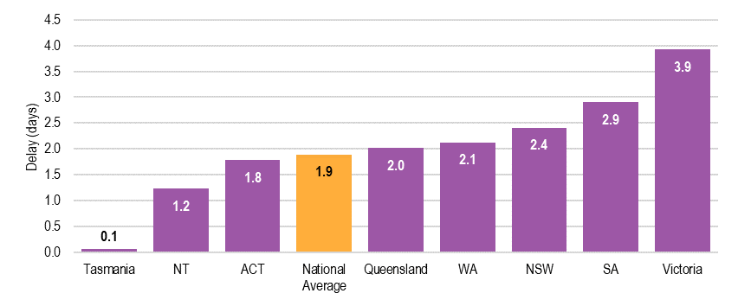
Source: commonwealth department of health
The higher average number of days delay in vaccine orders in Victoria was primarily due to one supplier, with an average delay of 7.5 days in Victoria and 3.5 days nationally (see Appendix H, Figure H.11). Although Victoria did not order more vaccines from this supplier relative to other states and territories, there were large delays in a few orders that resulted in longer average delays than other states and territories. For example, nine order lines for one vaccine were delivered with an average delay of 27.1 days (two of which were delayed by 85 days) and 17 order lines for another vaccine were delivered with an average delay of 15.0 days. Across the remaining three suppliers, delays ranged between 0.7 and 1.2 days on average.

Price of vaccines purchased
It is estimated that based on the order volumes in 2018-19, reductions in vaccine prices since 2017 have resulted in approximately $5 million in savings under the second NPEV.
The Nationally Negotiated Price for all NIP vaccines is established by the Pharmaceutical Benefits Advisory Committee (PBAC). Further to this, the Immunisation Branch of the Department undertakes a competitive tendering process to secure vaccines, in line with the requirements under the Commonwealth Procurements Rules. This is funded through Commonwealth Own-Purpose Expenditure (COPE) arrangements. Vaccines are then supplied to the states and territories under multipartite deeds with vaccine suppliers. Since the transition to centralised vaccine procurement through COPE, several procurement processes and Deeds of Variation have occurred.
The Commonwealth seeks opportunities to bundle procurement processes to:
- secure bundled (reduced) pricing offers from vaccine suppliers
- streamline the workload, creating efficiencies for the Commonwealth and states and territories.
The centralised procurement process agreed to under the second NPEV directly contributes to the Commonwealth’s ability to secure these prices and efficiencies.
As part of the tendering process, the Commonwealth looks to mitigate vaccine supply risks by contracting multiple manufacturers to provide vaccines where possible. This aims to safeguard the supply of essential vaccines. Based on the tendering selection criteria, which includes vaccine efficacy and the vendor’s ability to provide vaccines in sufficient quantities, manufacturers are engaged to provide a fixed Market Share of the total vaccines procured as part of the second NPEV.
As discussed above, the states and territories all agreed that the price of vaccines has significantly reduced due to centralised procurement. This is supported by vaccine price data which shows that the price of several vaccines listed under the NIP have reduced since 2017.
The states and territories also benefit from using the Commonwealth-negotiated vaccine prices to purchase additional vaccines for state and territory-funded immunisation programs. This was particularly useful for smaller states and territories that may lack the resources and / or purchasing power to independently negotiate lower prices.

How appropriate are the financial contributions and the structure of the performance and milestone payments?
Key Finding 6 How appropriate are the financial contributions and the structure of the performance and milestone payments?
The second NPEV aligns with some leading practice principles more than others, including Outcomes-focussed, Choice and control and Efficient. The second NPEV does not meet the principle of Transparent and simple.
The second NPEV’s Financial Arrangements provide a clear policy intention linked to performance indicators. The second NPEV does not cover the breadth of immunisation activities conducted by the states and territories.
While the second NPEV has reduced the administrative burden on the states and territories due to centralised procurement (also reduced the overall size of the payments), the states and territories need to allocate significant resources to monitoring, performance reporting and data cleaning. The financial contributions aim to improve state and territory performance, and do not reflect state and territory activities or fund service delivery.
Performance assessment is complex, varies across years and is often delayed.
The structure of the performance benchmark is equitable yet unreliable and non-recurrent. In contrast, the structure of the milestone payment is reliable yet inequitable. The state’s contributions to the AIR are inequitable.

Leading practice principles
As overviewed in Section 1.3.5, the following leading practice principles have been defined to support an assessment of the second NPEV funding model. The principles were selected from a literature scan and ACIL Allen’s experience in assessing the performance of funding models in the healthcare sector. The purpose of the principles is to establish a frame of reference against which to assess the funding model.
The second NPEV funding model was assessed against each of the principles and scored as ‘meets’, ‘partially meets’ or ‘does not meet’ the principle. A rationale for the assessment is provided.
The assessment is based on the three key payment types made under the second NPEV – namely the AIR payment, the performance benchmark payments and the milestone payment.
In summary, across the leading practice principles the second NPEV:
- meets the Outcomes-focussed principle
- partially meets the Equity, Choice and control, Flexible, responsive and scalable, Efficient and Certainty and predictability principles
- does not meet the Transparent and simple principle.
Table 5.1 leading practice principles Assessment of the NPEV funding model
Principle | Assessment
- Outcomes-focussed:  The funding model should encourage states and territories to deliver against the six outcomes of the second NPEV. | MEETS
The second NPEV funding model is directly linked to the achievement of the second NPEV outcomes (see Box 1.1). In particular, the five performance benchmark payments and one milestone payment are conditionally reliant on each state or territory meeting the second NPEV’s six outputs, which are closely aligned to the second NPEV outcomes. Refer to Section 1.2.5 for a further discussion on the requirements of these funding mechanisms.
Assessment: The second NPEV funding model meets this principle – the funding model is clearly linked to the six outputs of the second NPEV.
- Equity:  The funding model should apply second NPEV incentives and disincentives to all states and territories equitably. | PARTIALLY MEETS
The second NPEV funding model applies a mix of approaches to calculate payment values.
The value of the performance benchmark payment is determined based on the value of vaccines purchased by each state. This aims to achieve equity across the states and territories, whereby states and territories with greater vaccine requirements are allocated more funding.
Alternatively, eligible states and territories receive a milestone payment of equal value, which does not account for the differing effort in collecting and submitting vaccine data. However, this may reflect that there is a fixed cost component to delivering immunisation programs, discussed in Section 5.1.1.
The AIR payment to vaccination providers is based on the number of notifications (including catch-up notifications) made each year, and thus is generally reflects population size. However, each state’s and territory’s contribution to the AIR varies. While most states and territories contribute 50 per cent of the payment, Victoria only contributes 33 per cent and Queensland does not contribute to this payment. The rationale behind these contributions is further discussed in Section 5.2.5. While this rationale may have supported equity when the second NPEV was negotiated, the circumstances of some states and territories have changed (e.g., Queensland no longer operates a state and territory-based database, while SA has recently implemented a database). These contributions should be revisited to ensure ongoing equity.
The performance benchmark payment mechanisms only consider the volume of vaccines purchased by each state or territory. Other factors impacting the cost of delivery are not accounted for in the model, such as the distribution of regional and remote populations, varied service delivery models, and differences in the wage or salary of healthcare workers.
Assessment: The second NPEV funding model partially meets this principle. Basing the performance benchmark payment on the value of vaccines purchased is designed to be equitable, however, this does not consider state and territory-specific immunisation factors. Further, the milestone payment is not equitable and other important equity factors are not accounted for in the funding model, such as jurisdictional cost delivery difference and regional and remote populations.
- Choice and Control:  The funding model should align responsibility with influence so that states and territories have autonomy to deliver the program in a manner that is most suitable. | PARTIALLY MEETS
The three payment types are designed to align the flow of funding with the obligation to deliver under the second NPEV. One benefit of this approach is that it aligns funding, and therefore choice and control, with the responsibility to deliver the second NPEV.
The selection of key performance indicators is critical to NPAs. As Commonwealth central agencies, the Departments of the Prime Minister and Cabinet and the Treasury were involved in developing and negotiating the second NPEV, and the Treasury continues to be involved in reviewing and administering the performance benchmark and milestone payments. The central agencies are guided by health policy advice from the Department. In addition, the states and territories were central in negotiating the second NPEV, including the performance indicators. The central agencies indicated the NPA is intended to be a flexible vehicle that should be modified to consider the nuances of the specific policy area. In practice, the second NPEV may not have utilised this flexibility. Further, some states and territories indicated during consultation that they did not fully consider the impact of the wording of the performance indicators on their future performance and outcomes under the second NPEV.
Another issue of control, discussed further in see Sections 2.1.2 and 3.1.2, is the quality, timeliness and accuracy of vaccination provider’s reporting of vaccinations and wastage and leakage. The states and territories feel very strongly that they have limited influence over vaccination providers and should not be accountable for their compliance reporting to the AIR.
Consultations also indicated that AIR funding to government agencies does not always reach the cost centres of parties administering the vaccine, and instead may be held at the state or territory Department of Health level.
Assessment: The NPEV funding model partially meets this principle. The design of the funding model attempts to align responsibility with funding, however, in practice, choice and control are not always aligned to responsibility.
- Flexible, Responsive and Scalable:  The funding model should be suitable for delivery and implementation of the second NPEV under the range of Australian settings. | PARTIALLY MEETS
As noted under the equity principle, the performance benchmark payments account for the variable volume and value of vaccines purchased in each state and territory, and the AIR payments account for the number of children in the eligible cohorts for each state or territory (adjusted for the actual number of completed schedules for children under seven years old). These two payments scale for population size and are the only payments that utilise scaling methods. Consequently, the second NPEV does not account for other important variations that drive service delivery costs such as distribution and administration arrangements for servicing remote populations.
As noted in Section 3.1.2 and discussed further in Section 6.3.1, the second NEPV does not have the flexibility to accommodate NIP changes or issues that have arisen during the term of the second NPEV. The second NPEV does not identify a process for managing the impact of significant disruptions to service delivery on performance against benchmarks. Assessment: The NPEV funding model partially meets this principle. While payments based on the overall vaccine spend are designed to scale the payment each state or territory receives, this approach does not align with the direction of cost movements, nor does it account for other important scalable considerations.
- Efficient:  The funding model should encourage the efficient delivery and implementation of the NPEV. | PARTIALLY MEETS
Given that payments are linked to outcomes (i.e. the achievement NPEV objectives) rather than inputs, the states and territories are empowered to meet these outcomes efficiently. While the shift to centralised procurement has reduced the states’ and territories’ administrative spend on vaccine procurement, the states and territories incur significant costs in conducting data cleansing and reporting to demonstrate performance (see Section 6.3.1). Uncertainty of funding (see principle below) may lead some states and territories to implement less efficient immunisation activities.
Assessment: The NPEV funding model partially meets this principle. The funding model imposes significant administrative costs (and inefficiencies) in order to demonstrate outcomes.
- Certainty and Predictability:  The funding model should provide states and territories with a high degree of predictability around expected funding. | PARTIALLY MEETS
The states and territories have limited real-time visibility over their performance. As a result, the states and territories are uncertain if they are on-track to meet the performance benchmarks. This disrupts the states’ and territories’ ability to effectively budget and fund the most impactful activities (see Section 6.3.1). One exception to this is the milestone payment, which is considered reliable.
Additionally, the value of performance benchmark and milestone payments are linked to vaccine prices, which can change across years.
Lastly, qualifications and caveats may be applied to the assessment of states’ and territories’ performance, as occurred with SA3 coverage reports provided to jurisdictions in which geocoding errors were made which can override existing assessment criteria (see Section 2.1.2).
Assessment: The NPEV funding model partially meets this principle. The monitoring and assessment process and vaccine value-based payments mean the amount and reliability of funding is not predictable.
- Transparent and Simple:  The mechanics of the funding model should be easy to understand and readily available to states and territories. | DOES NOT MEET
While broadly outlined in this Review, a comprehensive set of funding model guidelines is not readily available. The Commonwealth and states and territories both indicated that the methods for calculating performance are complex, open to interpretation and not readily understood. For example:
- Schedule C is not explicit on how performance should be measured, and this was open to some interpretation by the Commonwealth during Year 1 performance assessments.
- During consultations, the states and territories presented different interpretations of the three-month lag period (see Section 4.1.1).
Furthermore, state and territory contributions to the AIR vary, increasing the complexity of the funding model and creating issues with interpretation and equity. Additionally, qualifications and caveats may be applied to the assessment of performance, as occurred in 2018-19 with SA3 coverage reports provided to jurisdictions in which geocoding errors were made which overrides the existing assessment criteria (see Section 2.1.2).
Lastly, achievement of the six outcomes are associated with two separate payment types – a performance benchmark payment for five outcomes and a milestone payment. This adds an additional layer of complexity to the funding model.
Assessment: The NPEV funding model does not meet this principle. A lack of guidelines, differences in rules between states and territories, rule amendments and the number of payment types contribute to the complexity of the NPEV funding model.
Source: acil allen consulting, 2020

Financial Arrangements in the second NPEV

Strengths of the second NPEV’s Financial Arrangements and financial gains
The financial arrangements have the following strengths:
- The policy intention behind the selection of the performance benchmarks and milestone is clear. (However, the methods used to calculate them are not. The Commonwealth and states and territories agree they are challenging to understand. As a result, the states and territories have limited visibility over whether they will meet the performance benchmarks each year.)
- The performance benchmark payments are equitable. These payments are based on each state’s or territory’s total vaccine costs, which account for differences in population.
- The milestone payment is considered by many states and territories to be a reliable funding source. This provides financial security for budgeting, planning activities and programs and employing staff.
- Centralised procurement has shifted the responsibility for contract tendering, negotiation, and management of vaccine suppliers to the Commonwealth, reducing the states’ and territories’ staffing and administrative efforts in this area.
In general, the NPEV has resulted in financial gains for the states and territories. Performance Benchmark and milestone payments are substantial. Most states and territories met most performance benchmarks and the milestone in the Year 1 and Year 2 performance assessments.

Financial barriers of the Financial Arrangements and financial losses
The NPEV’s Financial Arrangements have led to financial barriers and some losses.
In contrast to the performance benchmark payments, the milestone payment is based on Australia’s total vaccine costs, distributed equally across the states and territories. As such, the value of the milestone payment compared to population size (per-capita milestone payment) differs across states and territories. Some states and territories see this as inequitable. Geographically large states and territories with dispersed, remote populations spend a relatively larger proportion of funding on ensuring these populations are immunised compared with geographically smaller states and territories, or those with fewer remote populations. Several states and territories indicated that the second NPEV needed to further consider the costs of vaccine distribution and administration, as well as activity-based funding, which was removed following the first NPEV.
In contrast to the security of the milestone payment, the performance benchmark payments are a less reliable source of funding: states and territories have all met the milestone in both assessment periods, while performance against the performance benchmark varies (see Section 2.1.2 and Table 5.2 below). This complicates states’ and territories’ budgeting and is compounded by the delays in receiving payments. All states and territories agreed that they could allocate their resources more efficiently if they could monitor their performance in real-time, across all performance benchmarks. This is not currently possible.
Centralised procurement has resulted in smaller performance payments (due to reduced national spend) and loss of state and territory-vaccine supplier relationships, which generated financial and in-kind benefit for the states and territories under the first NPEV. As discussed in Section 5.1.2, the Commonwealth has saved an estimated $5 million since 2017 under the second NPEV. This has decreased the total value of the performance benchmark and milestone payments by more than $200,000.
Funding under the second NPEV is non-recurrent. States and territories cannot use the funding to employ staff on a permanent or ongoing basis or commit to long-term projects including programs targeting cohorts with lower immunisation rates. Some states and territories agreed that the proportion of the NPEV allocated to performance benchmarks (3.75 per cent) and the milestone (0.75 per cent) should be switched, to allow for greater funding reliability.
Many states and territories are now allocating more resources to monitoring, performance reporting and data cleaning as they need to ensure the data used to calculate payments under the second NPEV is as accurate as possible to optimise the funding received. One jurisdiction reported that over the life of the second NPEV there have been more frequent vaccine schedule changes, and there is a need to deliver larger immunisation programs and participate in Commonwealth procurement panels. These add to delivery costs and the burden on states and territories.
The performance benchmarks aim to drive momentum in achieving high coverage rates, rather than maintenance. However, states and territories could fail to meet the performance benchmarks if they encounter small decreases in immunisation coverage rates. For example, to date, the states and territories have received performance payments for Year 1 (2017-18 reference period) and will shortly receive payments for Year 2 (2018-19 reference period). Under the Year 1 performance assessment, two jurisdictions did not quality for payments as follows:
- SA did not qualify to receive funding of approximately $38,034 (ex GST) for partially meeting performance benchmark 4 (SA achieved an increase in 3 out of the 4 nominated low coverage SA3 areas according to the assessment methodology employed).
- Tasmania did not qualify to receive funding of approximately $44,224 (ex GST) for failing to meet performance benchmark 5 (Tasmania did not demonstrate a decrease in wastage and leakage rates or wastage and leakage rates below 5 per cent for either previously assessed or newly assessed vaccines).
As summarised in Table 5.2, under the Year 2 performance assessment, all states and territories met performance benchmarks 1-4 and received the milestone payment of $0.31 million. Queensland, SA and Victoria met performance benchmark 5.
For Year 2, the total amount that the states and territories did not qualify to receive for failing to demonstrate either a decrease in wastage and leakage rates or wastage and leakage rates below 5 per cent of either previously assessed or newly assessed vaccines were:
- ACT did not qualify to receive funding of approximately $40,000 (ex GST)
- NSW did not qualify to receive funding of approximately $748,000 (ex GST)
- NT did not qualify to receive funding of approximately $32,000 (ex GST)
- SA did not qualify to receive funding of approximately $157,500 (ex GST) (totalling $195,534 over Year 1 and 2)
- Tasmania did not qualify to receive funding of approximately $52,267 (ex GST) (totalling $96,491 over Year 1 and 2).

Table 5.2 NPEV payments received ($), by state or territory and payment type, 2018-19
State or territory | Benchmark 1  $ | Benchmark 2  $ | Benchmark 3  $ | Benchmark 4^  $ | Benchmark 5*  $ | Milestone payment  $ | Total  $ | Losses  $
ACT | 40,000 | 40,000 | 40,000 | 40,000 | 0 | 310,000 | 470,000 | 40,000
NSW | 748,000 | 748,000 | 748,000 | 748,000 | 0 | 310,000 | 3,302,000 | 748,000
NT | 32,000 | 32,000 | 32,000 | 32,000 | 0 | 310,000 | 438,000 | 32,000
Queensland | 527,200 | 527,200 | 527,200 | 527,200 | 527,200 | 310,000 | 2,946,000
SA | 157,500 | 157,500 | 157,500 | 157,500 | 0 | 310,000 | 940,000 | 157,500
Tasmania | 52,300 | 52, 300 | 52, 300 | 52, 300 | 0 | 310,000 | 519,200 | 52,300
Victoria | 643,500 | 643,500 | 643,500 | 643,500 | 643,500 | 310,000 | 3,527,500
WA | 301,500 | 301,500 | 301,500 | 301,500 | 301,500 | 310,000 | 1,817,500
Total | 2,502,000 | 2,502,000 | 2,502,000 | 2,502,000 | 1,472,200 | 2,480,000 | 13,960,200 | 1,029,800
^Due to geocoding errors and delayed reporting, all states and territories were deemed to have met benchmark 4.
* The ActHIB vaccine schedule was changed during the year and therefore this vaccine was excluded from the performance calculation for benchmark 5.
Data excludes GST. Figures may not add due to rounding.
Source: Commonwealth Department of Health 2020

Several states and territories indicated that failing to meet a performance benchmark or milestone causes significant financial loss, and reduces the funding available to address the underlying causes of that failure and meet the performance benchmark the next year. Further, two jurisdictions noted that payments from the Commonwealth (such as reimbursements for vaccines purchased by the states and territories and incentive payments) were larger under previous agreements.
Overall, one jurisdiction noted that the financial gains and losses incurred as a result of moving to the second NPEV were comparable, so the jurisdiction has been in a similar financial position under the first and second NPEV. Two other states or territories felt the first NPEV created more favourable financial circumstances.

Major programs that are funded, but not measured under the NPEV
The Commonwealth and states and territories identified a number of major programs that are funded and delivered under the NIP but not measured or linked to available payments under the second NPEV. These include:
- influenza, which represents approximately half of the vaccine stock for one jurisdiction, is a 12-month program that requires ongoing efforts to distribute the vaccine, communicate with involved parties (including the community and government) and plan for the following season
- adult and not all adolescent immunisation programs
- communication and education programs
- Hepatitis A vaccine available for Aboriginal and Torres Strait Islander children in selected states and territories.
Two states or territories noted that the Commonwealth (through the NPEV) contributes approximately 5-20 per cent of the state’s costs of implementing their immunisation programs.

Processes for performance payments
Under the second NPEV, the Commonwealth is responsible for a large part of the assessment of the states’ and territories’ performance, including data gathering, an initial assessment, and data transfer to the AIHW for formal independent assessment and report compilation.
Once the Commonwealth delegate notes the final assessment report of the states’ and territories’ performance against the benchmarks and milestone from the AIHW and approves the associated payments, the Department’s Financial Reporting and Treasury team schedules the release of payments in the next Specific Purpose Payment run through the Department of the Treasury. Payments are made from the Commonwealth Department of the Treasury to the state and territory Departments of Treasury. Payments are made one to two times per year (milestone payments may be made earlier in the year than performance benchmark payments), in arrears.
The assessment processes are complex and vary across years. There can be delays of up to 12 months in finalising the assessment results and subsequently releasing payments. The Department noted that potential efficiencies could be gained through improved assessment processes, however, the process of scheduling and releasing the payments to states and territories is relatively efficient.
In general, states and territories agreed that the performance payments were substantially delayed. The performance payments for the 2018-19 reference period had not been paid at the time of writing (July 2020).

Service delivery costs
The costs of administering the NPEV were discussed in Section 5.1.1.
States and territories are responsible for managing NIP service delivery, including costs. The NPEV was not intended to fund service delivery through performance payments. Instead, funding under the NPEV is an incentive to improve state and territory performance. As such, the performance payments are not expected to meet the full cost of service delivery.
Commonwealth funding for service delivery is provided via Medicare Benefits (payments to vaccination providers for the consultations at which vaccinations are administered) and overarching Health Care Agreements. This funding does not include funding for local governments to provide immunisation services, which are subsidised by the states and territories.
Correspondingly, states and territories indicated that the funding provided under the NPEV does not reflect the substantial cost of maintaining an immunisation program. This includes the costs of:
- procurement of vaccines for state and territory-funded vaccine programs
- contributions to the AIR
- vaccine distribution, particularly across larger states and territories, or those with more remote populations and complex supply chains
- awareness raising and promotion
- educational activities for vaccination providers
- outreach activities and ensuring access to and provision of services
- data cleaning
- development of tools and systems
- monitoring of vaccine safety and adverse events
- program planning and management.
These costs are increasing as the number of vaccines on the immunisation schedule and the required immunisation services grow.

Measuring and funding activity relating to increased vaccination coverage
As discussed in Section 1.2.5, Schedule B of the second NPEV (see Appendix A) provides for financial contributions by the states and territories to support the AIR. These are outlined in Table 5.3. Currently:
- Queensland is not contributing to the AIR
- Victoria pays one third of the contribution to the AIR
- the remaining states and territories pays one half of the contribution to the AIR.
Table 5.3 Schedule B: contributions to the AIR for vaccination provider payments for notifications to the AIR
State or territory | Maintains state or territory-based register? | Proportion of the $6 contribution to AIR provided by the state | Value of contribution to the AIR
Queensland | Yes | 0% | $0
Victoria | No* | 33% | $2
NT, SA | Yes | 50% | $3
NSW, ACT, WA, Tasmania | No | 50% | $3
* The Victorian Government supports the local government immunisation software (ImPS) which records vaccinations against the individual and automatically transfers this data to the AIR.
Source: NATIONAL PARTNERSHIP ON ESSENTIAL VACCINES, 2017
In general, states and territories were unclear about the different contributions made to the AIR. Stakeholders all understood that Queensland, who maintains a state-based childhood immunisation register (Vaccination Information and Vaccination Administration System, VIVAS), does not contribute to the AIR. Historically, Queensland vaccination providers reported vaccinations directly to Queensland Health through VIVAS. Although this ceased on 1 April 2019, with all vaccination providers now directly recording immunisations on the AIR, Queensland does not contribute to the AIR. VIVAS is still used for vaccine ordering and distribution and recording of cold chain breach information.
In general, stakeholders were unclear why Victoria provides one-third of the $6 contribution to the AIR ($2), compared with half ($3) for the remaining states and territories, with some states and territories perceiving this arrangement to be inequitable. While Victoria does not maintain a separate immunisation register, it does incur additional costs in assisting local governments to meet their immunisation reporting and recording responsibilities. In Victoria, local governments have legislated responsibility for delivering (or overseeing delivery of) some immunisation services and, as such, are a major service provider. The Victorian Government pays subsidies to local governments based on the number of immunisation encounters to children under the age of 7 years and for school vaccinations per vaccine administered. Local government vaccination providers are required to hold records of childhood vaccinations until a person reaches 25 years. The Victorian Government supports the local government immunisation software (ImPS) which records vaccinations against the individual and automatically transfers this data to AIR. Victoria is in the process of developing a new register to continue to support local government reporting.
In line with Queensland, SA (SA School Immunisation Program) and NT (Northern Territory Immunisation Register) also maintain state and territory-based immunisation registers, yet provide half of the contribution ($3).

appropriateness of an NPA for implementing the NIP | 6
This Chapter discusses the future of the NPEV, including its continuing appropriateness compared to leading practice principles, strengths and weaknesses, the requirement for further funding and any lessons that could improve the NPEV.

To what extent does the NPEV remain appropriate in facilitating the policy objectives of the NPEV?
Key Finding 7 To what extent does the NPEV remain appropriate in facilitating the policy objectives of the NPEV?
An NPA remains an appropriate mechanism for Commonwealth funding to flow to states and territories to facilitate objectives of the NPEV. The NPEV fulfils the requirements of an NPA in terms of value and national significance, and provides targets and financial incentives. Related policy initiatives do not appear to duplicate the NPEV.
However, the NPEV does not adequately account for state and territory differences and is not comprehensive of the policy objectives of the NIP. The states and territories lack real-time visibility (and thus control) of their performance against the objectives.

The NPEV as a National Partnership
As outlined in Section 1.3.5, the Review has considered the framework provided by the IGA FFR, including the suitability of the NPEV as a NPA.
Whilst the current NPEV was being negotiated, some states and territories raised concerns about the ongoing suitability of a national partnership as the vehicle for implementing the NIP, given the Commonwealth’s increased role particularly with respect to purchasing of essential vaccines. One argument put forward at that time centred on whether the states and territories should be seen as assisting the Commonwealth to deliver immunisation services, in contrast to sharing responsibility for doing so, and therefore a COPE would be more appropriate than an NPA. However, such a change may require either legislative change with respect to the responsibilities of the states and territories or local governments for immunisation programs, or that delivery of immunisation services become contestable, which may not provide optimal outcomes, particularly with respect to increasing immunisation rates in areas and with cohorts that have low rates of coverage.
Another key argument raised by the states and territories referred to the principles of the IGA FFR, which include that NPA payments support the delivery of specified outputs or projects to facilitate reforms or reward jurisdictions that deliver on nationally significant reforms. It is arguable whether the improvements encouraged through the NPEV benchmarks and milestone represent nationally significant reforms.
Advice from the Department of Finance (at the time of negotiating the second NPEV) and the Treasury (during this Review) is consistent and advises that an NPA remains the most appropriate mechanism for Commonwealth funding to flow to states and territories for this activity, which they interpret as being primarily a state and territory responsibility. This is supported by consultation conducted for this Review, whereby stakeholders generally agreed that if immunisation coverage remains a national health priority, then an NPA is the most appropriate mechanism for managing Commonwealth-state and territory relations to deliver immunisation programs under the NIP.
The NPEV fulfils the requirements of an NPA in terms of value and national significance and ensures a national focus on implementing the NIP. The use of an NPA also raises the profile and prioritisation of immunisation in several states and territories.
Some states and territories indicated that the NPEV could evolve over time to take a state and territory-specific approach (with individual targets to areas of most need), while becoming even more collaborative.
Two stakeholders suggested that the NPEV is an effective payment mechanism for securing and distributing lower-priced vaccines. However, it may be less appropriate for the delivery, implementation and administration of the NIP. A suggested alternative approach could be the use of individual agreements between Health Ministers, coordinated through the COAG Health Council (or equivalent).

Strengths and weaknesses of the NPEV
The policy objectives of the NPEV are outlined in Section 1.2.3. The strengths and weaknesses of the NPEV in facilitating achievement of the policy objectives are described below.

Strengths of the second NPEV
The second NPEV has a strong focus on achieving the policy objectives outlined under the NIP.
The second NPEV formalises the commitment and joint responsibilities of the Commonwealth and state and territory governments with respect to delivering the NIP. This establishes clear roles and responsibilities, incentivises the parties to collaborate and coordinate, provides a platform that encourages national consistency, provides an evidence-based approach to improving immunisation coverage and ensures the Australian people receive nationally consistent immunisations.
The use of a national vehicle to drive coordinated policy ensures that immunisation remains on the policy agenda of the states and territories.
States and territories are provided with targets and financial incentives (performance benchmark and milestone payments) to improve vaccination rates by implementing local level programs and other support activities. These payments are directly linked to performance data showing improved vaccination coverage rates.

Weaknesses of the second NPEV
The second NPEV has some weaknesses in facilitating achievement of the policy objectives.
While a nationally consistent approach is generally useful in facilitating equal consideration across multiple parties, under the second NPEV this results in inequitable treatment across states and territories with varied challenges, population size, demographics (e.g. culturally and linguistically diverse and Aboriginal and Torres Strait Islander peoples, as well as high rates of vaccine refusal in some areas), resourcing across states and territories and geography (e.g. rural and remote accessibility and service delivery over large areas).
The Commonwealth noted that the milestone payment was designed to, in part, address these disparities, particularly for the smaller states and territories, by equally distributing the payment. During negotiation for the second NPEV, some states and territories disagreed with this equal distribution approach, noting this did not recognise the additional costs incurred by more populous states and territories with more complex supply networks. In contrast, some states and territories noted that the per-capita cost of running an immunisation program is higher for less populous states and territories.
As discussed in Section 4.1, the performance benchmarks and milestone are aligned with the policy objectives, yet focus on a narrow set of vaccines and cohorts. This shifts resources away from other high-needs populations.
The states and territories do not currently have good visibility of real-time immunisation coverage, and as such, cannot monitor their performance and adjust resource allocation to improve immunisation coverage in areas of highest need.
States and territories indicated they would be better resourced to facilitate the policy objectives of the NPEV if the funding arrangements allowed for a larger proportion of reliable funding (such as that of the Milestone, rather than the performance benchmark payment), and facilitated activity-based funding.

Related policy initiatives
Most stakeholders did not identify duplication or overlap between the NPEV and policy initiatives being pursued through other agreements. Some examples of related policy initiatives focusing on increasing immunisation rates include:
- No Jab, No Pay (Commonwealth-level) and No Jab, No Play (State and territory-level) policies and associated legislation
- state and territory government immunisation programs and strategies, including school programs funded by states and territories and programs for other vaccines and cohorts not funded under the NIP
- state and territory and local level awareness and communication campaigns and activities
- incentive payments for vaccination providers to catch-up children more than two months overdue for vaccines
- Aboriginal and Torres Strait Islander Child Health Assessments (0-14), which request information on the child’s current immunisation status.

To what extent may further funding beyond the expiry of the Agreement be required if any increased levels are to be maintained?
Key Finding 8 To what extent may further funding beyond the expiry of the Agreement be required if any increased levels are to be maintained?
Further funding is required beyond the expiry of the second NPEV to maintain immunisation coverage rates. This is needed to support the supply of safe and free vaccines, ensure public access to evidence-based immunisation information, and incentivise vaccination providers to report data.
Changes to regulation and governance and the addition of performance indicators that are not linked to funding may also support maintenance of immunisation coverage rates.

Maintaining increased levels in vaccination coverage rates
To maintain increased levels of vaccination coverage, several factors should be considered.
States and territories require continued financial contributions from the Commonwealth through an appropriate mechanism to support the supply of free vaccines under the NIP, as well as continued public access to evidence-based information regarding immunisation. This is important for improving and sustaining public awareness and trust in vaccination, which requires strong communication efforts with parents and carers about the importance and safety of childhood and adolescent vaccination to maintain high coverage rates and address vaccine hesitancy. This is needed to support the many new births each year and to continue to address access barriers for rural and remote, culturally and linguistically diverse, and Aboriginal and Torres Strait Islander populations.
The Commonwealth and states and territories need to continue to engage with vaccination providers to ensure they are aware of their obligations to report to the AIR and value the data collected. This includes continuation of incentive payments to vaccination providers for catching up on missed doses and investment in software integration between vaccination providers and the AIR.
Once immunisation coverage rates reach a high level, increasing levels of resources are required to secure further, relatively small improvements. It may not be fair, achievable, or attractive as a performance benchmark to focus on improving already high coverage rates. Instead, financial rewards should be linked to addressing specific state and territory gaps. Future arrangements could consider including key performance indicators that are not linked to funding.
More broadly, effort should be directed to maintain the integrity of the immunisation program through continued regulation, and appropriate clinical or corporate governance, to deliver a safe and effective service. The longer-term implications of adding more vaccines to the NIP Schedule should also be considered. Increases in the number of vaccines impacts the whole supply chain infrastructure; for example, this causes the need for larger capacity in warehouses, planes, and clinic fridges, as well as more time to manage recall notices.

What other lessons have been learned that could improve future NPEVs?
Key Finding 9 What other lessons have been learned that could improve future NPEVs?
The NPEV has been effective in raising the profile of immunisation in some states and territories and can be leveraged to improve state and territory performance.
Lessons have emerged from the unintended outcomes of the second NPEV, including a reduced overall spend on vaccines and reduced value of performance payments, lack of specificity or flexibility for different elements of the agreement, and the punitive nature of the performance indicators. In particular, the requirement for increasing coverage rates to 95 per cent may not be fair or achievable over time. There is a lack of focus on state and territory-specific issues and emerging disease trends.
The assessment measures and process and performance monitoring are complex and do not enable real-time monitoring.

Unintended outcomes as a result of the design of the second NPEV
The design of the second NPEV has resulted in a range of positive and negative unintended consequences. Several unintended outcomes are identified throughout Chapter 3, including the sometimes negative unintended outcomes of lag reporting, the need to allocate resources for data cleansing rather than to activities that support increased vaccination rates, the sensitivity of the performance benchmarks for smaller states and territories and the punitive nature of the performance benchmarks.
Additional positive and negative unintended outcomes are identified below.

Positive unintended outcomes

Funding of immunisation programs
The second NPEV was seen to create opportunities for the Commonwealth to nationalise programs. One jurisdiction noted that some state and territory-funded immunisation programs can and have been nationalised by the Commonwealth over time, for example, the pertussis vaccination for pregnant women and influenza vaccination for children under 5 years. Under current NPEV arrangements, this would shift the burden of procurement to the Commonwealth, and increase the number and value of vaccines funded under the NPEV.

Reputation
Some states and territories have used the NPEV to raise the profile of their work and to justify their efforts.

Negative unintended outcomes

Centralised procurement
As discussed in Section 5.1, centralised procurement of vaccines has resulted in smaller performance benchmark and milestone payments to the states and territories. Some states and territories suggested that this could incentivise states and territories to order more vaccines than needed, to boost the overall value of the performance payments. However, the states and territories also noted that the wastage and leakage performance benchmark discourages over-ordering. Therefore, it is necessary to ensure that the balancing influence between these incentives is maintained.
One jurisdiction perceived that reducing the price of vaccines makes Australia a less globally attractive market to vaccine manufacturers. In instances of supply shortages, pharmaceutical companies may prioritise orders from other countries where they receive a higher profit margin. However, as noted in Section 5.1.2, the Commonwealth has contractual requirements that secure supply of vaccines and Australia is regularly prioritised for vaccine supply.

Flexibility vs specificity
The second NPEV was designed to allow for flexibility in its implementation, yet does not provide sufficient detail in some areas. This creates room for interpretation and disagreement between parties, particularly around the language used for the performance benchmarks (see Section 4.1).
Further, the design of the second NPEV lacks flexibility to accommodate NIP changes or issues that have arisen during the term of the second NPEV. For example, there are currently complications with the benchmarks relating to school programs, which have been disrupted during COVID-19, with consequent shifts to new service delivery models. The second NPEV does not identify a process for managing the impact on performance against benchmarks of significant disruptions to service delivery or managing issues with data or changes to the NIP. This is compounded by staffing changes over the life of the agreement and loss of institutional knowledge.
In contrast, the performance benchmarks are seen by many stakeholders as too specific and inflexible. The shift from using the terms ‘maintaining or increasing’ in the first NPEV to ‘increasing’ in the second NPEV has created significant difficulties for some states and territories to meet the benchmarks due to already high levels of immunisation coverage.

Coverage rates and data quality and reliability
Since the first NPEV began in 2009, there has been an increase in the number and proportion of children fully immunised within Australia, particularly at 5 years, from 79.4 per cent in 2008 to 94.7 per cent as of March 2020. The second NPEV strives to stretch state and territory performance to 95 per cent immunisation coverage rates. There is a need to consider whether the requirement for 95 per cent coverage is required for disease reduction and health policy, as this may not be required for herd immunity for all vaccines. With vaccination coverage rates nearing or surpassing this target, future arrangements should consider whether this remains a fair, achievable, and attractive performance benchmark.
As discussed above, the narrow focus of the performance benchmarks means that other high-needs cohorts do not receive the focus that is required to increase vaccination coverage, such as pregnant women, Aboriginal and Torres Strait Islander peoples (beyond child cohorts), and refugees / asylum seekers.
As discussed in Section 4.1.1, the ten lowest coverage SA3 areas are provided to states and territories late in the reference period, which limits the time available to improve coverage rates.

Performance benchmarks
The performance benchmarks and milestone are seen as punitive. This has negative financial and reputational consequences for states and territories that do not meet performance benchmarks. Some states and territories have needed to defend their results to their respective Ministerial authorities, which can impact the reputation of the JICs (in not meeting performance benchmarks) and the Commonwealth (that may have been seen to have implemented imperfect measurement methodologies). As a result, states and territories have advocated strongly for clear caveats in published data to qualify the results and their interpretation.

Funding
As discussed above, states and territories agree that the funding provided under the NPEV is not secure. This impacts their ability to plan and focus their resources and activities to the areas of highest need.

HIGH LEVEL FINDINGS AND future developments | 7

High level findings

To what extent is the NPEV appropriately facilitating the cost-effective and efficient delivery of immunisation programs under the NIP?
Key Finding 1
The second NPEV provides a clear, focused and nationally consistent framework for delivering state and territory-based immunisation programs. The second NPEV’s objectives and outcomes are consistent with those of the NIP.
The outputs specified in the second NPEV focus on a limited range of activities undertaken by states and territories to achieve the abovementioned objectives and outcomes. It is unclear if these outputs reflect areas of reform and while they are important, it is not clear if they represent the areas most likely to drive reductions in the spread of vaccine-preventable diseases or improve vaccination coverage rates.
Over the two assessment periods, the states and territories were assessed as meeting 92 per cent of performance benchmarks and the milestone, and as such, are contributing towards delivering the objectives and outcomes of the NIP.

To what extent has the NPEV increased activity levels in the areas of immunisation and immunisation coverage?
Key Finding 2
The second NPEV focuses states’ and territories’ efforts and resources on immunisation and improving immunisation coverage rates for the performance benchmarks. However, some immunisation areas not covered by the second NPEV may receive less focus than may be needed to improve vaccination coverage rates.
While the second NPEV has likely contributed to increased vaccination coverage rates, this has been supported by other Commonwealth and state and territory immunisation policies and improved data quality. It is not possible to determine the extent to which increases in vaccination coverage rates are attributed to the second NPEV.
The second NPEV has encouraged states and territories to devote additional resources to improving the quality of data relevant to the performance benchmarks.

How well have the parties performed in delivering the NIP in accordance with the terms of the agreement?
Key Finding 3
The Commonwealth has performed its roles and responsibilities well in reducing the price and securing the supply of vaccines and engaging more with the states and territories, particularly during challenging circumstances. However, there have been delays in providing data and reports to the states and territories, which is not monitored through the NPEV.
The states and territories have performed well in meeting the vast majority of performance benchmarks and the milestone and in meeting their responsibilities outlined in the second NPEV.

Are the NPEV’s performance monitoring and reporting processes effective and appropriate in measuring the agreement’s achievements and outputs?
Key Finding 4
The second NPEV’s performance monitoring is linked to the outputs specified in the second NPEV. The performance monitoring and reporting processes provide a nationally consistent approach to assessment.
Consistent with the outputs, the performance indicators are narrow in focus and do not capture all the achievements or activities performed.
The performance monitoring approach drives a focus on improving data quality to ensure the states and territories meet the performance benchmarks and qualify for the associated payments.
Measurement of the outputs of the second NPEV is complicated and lacks clarity. States and territories are not well placed to influence wastage and leakage, other than by constraining delivery of vaccines to vaccination providers.
States and territories do not have access to real-time, accurate data on immunisation coverage and wastage and leakage and are therefore unable to make adjustments to improve their performance.
While reporting is often delayed, it is not overly onerous.
It is appropriate that an independent agency, the AIHW, compiles performance reports.

To what extent is the NPEV appropriately facilitating the cost-effective and efficient delivery of immunisation programs under the NIP?
Key Finding 5
Administrative cost data is not routinely collected and there is no consistent or agreed approach to doing so. This prevents quantitative assessment of cost-effectiveness. The agreement is relatively easy to administer, although states and territories are devoting significant administrative effort to cleansing data. Cost-effectiveness could be strengthened through streamlined performance assessment and payment processes.
The second NPEV has achieved cost-efficiencies, by centralising procurement, undertaking competitive tendering, bundling pricing offers and streamlining the purchasing workload. This has resulted in approximately $5 million in savings.
The states and territories benefit from these cost-efficiencies by being able to order vaccines at the nationally negotiated vaccine prices.

How appropriate are the financial contributions and the structure of the performance and milestone payments?
Key Finding 6
The second NPEV aligns with some leading practice principles more than others, including Outcomes-focussed, Choice and control and Efficient. The second NPEV does not meet the principle of Transparent and simple.
The second NPEV’s Financial Arrangements provide a clear policy intention linked to performance indicators. The second NPEV does not cover the breadth of immunisation activities conducted by the states and territories.
While the second NPEV has reduced the administrative burden on the states and territories due to centralised procurement (also reduced the overall size of the payments), the states and territories need to allocate significant resources to monitoring, performance reporting and data cleaning. The financial contributions aim to improve state and territory performance, and do not reflect state and territory activities or fund service delivery.
Performance assessment is complex, varies across years and is often delayed.
The structure of the performance benchmark is equitable yet unreliable and non-recurrent. In contrast, the structure of the milestone payment is reliable yet inequitable. The state’s contributions to the AIR are inequitable.

To what extent does the NPEV remain appropriate in facilitating the policy objectives of the NPEV?
Key Finding 7
An NPA remains an appropriate mechanism for Commonwealth funding to flow to states and territories to facilitate objectives of the NPEV. The NPEV fulfils the requirements of an NPA in terms of value and national significance, and provides targets and financial incentives. Related policy initiatives do not appear to duplicate the NPEV.
However, the NPEV does not adequately account for state and territory differences and is not comprehensive of the policy objectives of the NIP. The states and territories lack real-time visibility (and thus control) of their performance against the objectives.

To what extent may further funding beyond the expiry of the Agreement be required if any increased levels are to be maintained?
Key Finding 8
Further funding is required beyond the expiry of the second NPEV to maintain immunisation coverage rates. This is needed to support the supply of safe and free vaccines, ensure public access to evidence-based immunisation information, and incentivise vaccination providers to report data.
Changes to regulation and governance and the addition of performance indicators that are not linked to funding may also support maintenance of immunisation coverage rates.

What other lessons have been learned that could improve future NPEVs?
Key Finding 9
The NPEV has been effective in raising the profile of immunisation in some states and territories and can be leveraged to improve state and territory performance.
Lessons have emerged from the unintended outcomes of the second NPEV, including a reduced overall spend on vaccines and reduced value of performance payments, lack of specificity or flexibility for different elements of the agreement, and the punitive nature of the performance indicators. In particular, the requirement for increasing coverage rates to 95 per cent may not be fair or achievable over time. There is a lack of focus on state and territory-specific issues and emerging disease trends.
The assessment measures and process and performance monitoring are complex and do not enable real-time monitoring.

Potential developments to the second NPEV
A number of potential developments to the second NPEV were identified during the course of the Review. These include:
- Streamlining the assessment measures and process to improve their clarity, effectiveness, and appropriateness. This includes:
  - ensuring that the performance benchmarks are fair, achievable, and attractive for states and territories as NIP implementation partners; that is, reconsidering the current 95 per cent immunisation coverage target
  - retaining the language from the first NPEV regarding ‘maintaining or increasing’, instead of ‘increasing’
  - removing the three-month lag from the performance assessment
  - focusing on performance measures within the control of the states and territories
  - accounting for activity undertaken to increase immunisation coverage, including communication and collaboration across the involved parties
  - increasing flexibility for unanticipated circumstances, including changes to the NIP schedule, emerging vaccines research, or the impact of COVID-19
  - broadening the coverage of the NPEV to include additional vaccines and / or cohorts covered under the NIP
  - selecting targets with each state or territory each year that will address the specific gaps in that state
- Shifting the funding approach to:
  - readjust the proportion of funding that is considered secure
  - consider proportionate rewards for partially meeting the performance benchmarks
  - change the language to specify that states and territories spend the funding on immunisation activities
  - allow for a large-scale upgrade in infrastructure to ensure vaccines continue to be distributed effectively
  - allow for innovation and research to develop Australia’s vaccine distribution model in line with best practice
  - Improving performance monitoring, including:
  - providing for real-time data accessibility for all vaccines and cohorts
  - developing performance measures for the Commonwealth
  - developing performance indicators not linked to funding
  - ensuring that every administered vaccine is viable, safe and of high quality, and reported to the AIR.
Sufficient time should be allowed to develop a new NPEV (or alternative approach). This would support each party to negotiate and modify the NPEV to secure the flexibility required to achieve better outcomes, including relationships between the parties and future management and implementation of the agreement. This could also incorporate feedback from Aboriginal and Torres Strait Islander communities and immunisation specialists in Primary Health Networks.

Recommendations
The findings of the Review inform the following recommendations.

A National Partnership is an appropriate mechanism for improving outcomes under the NIP.
Implementing the NIP requires a focus on ensuring target populations receive the recommended vaccinations safely, in a timely manner and with minimal wastage and leakage. This involves activities focused on maintaining current immunisation rates for some cohorts and vaccines, and increasing immunisation rates for others. Assuming immunisation remains a national priority and it is agreed that the Commonwealth and states and territories share responsibility for achieving the outcomes of the NIP, a National Partnership is an appropriate mechanism for driving improvements in immunisation coverage rates, as National Partnerships are intended to focus on specific projects or areas of reform.
It is feasible to continue to use the National Partnership as one mechanism through which the Commonwealth assists states and territories to implement the NIP, both through purchasing of vaccines and through funding. However, there would be benefit in clarifying the extent to which the Commonwealth will fund activities required to maintain immunisation coverage rates and the mechanism through which this funding will flow, given many states and territories have reached or nearly reached the stretch target levels. To ensure equity between the states and territories, considerations should take into account the different approaches taken across the states and territories to administer vaccinations, and the associated funding arrangements including through the Medicare Benefits Scheme. Where immunisation services are primarily delivered by local councils, states and territories contribute a higher proportion of funding to deliver immunisation services than when delivery is primarily by GPs.

NPEV should focus on areas of most need.
Many of the outputs and associated benchmarks contained in the second NPEV are reaching the point where the cost of achieving further improvement is open to question. The selection of outputs and associated benchmarks should be based on disease prevalence and gaps in vaccination coverage rates, which may differ across states and territories. It is not appropriate from a policy perspective to withhold payments based on small movements in already high vaccination coverage rates. Considering a broader range of outcomes and outputs would realign the focus of the NPEV on reforming areas of most need.

Data limitations necessitate an alternate approach
Criticisms of the second NPEV include the lack of recognition given to the full spectrum of activities that the states and territories perform in implementing the NIP. While this is addressed in part in the recommendations above, it is also relevant to consider the impact of data limitations on the selection of NPEV outputs and associated performance benchmarks. The AIR moved to a whole of life register in 2016, and there is currently limited data to report on adult immunisations, which constitute a significant and important part of states’ and territories’ activities. A different approach is needed to drive vaccination coverage in areas where data is poor during this data building phase. Further, there is currently limited capacity for states and territories to monitor real-time performance. This will improve over time, particularly if this becomes a focus of the Commonwealth and states and territories.
During this data building phase, a suitable approach used for the National Partnership on Universal Access to Early Childhood Education 2018-2020 is to require states and territories to develop, and agree with the Commonwealth, an annual Implementation Plan. This Plan outlines targets that reflect each state’s individual needs and circumstances. If a similar approach is incorporated in the next NPEV, plans could target areas and cohorts where improvements in vaccination coverage is desired (and feasible). This approach could be used to drive activity on currently difficult to measure vaccines and cohorts.
The Plan is linked to a 30 per cent funding payment, and as such, would provide additional certainty to the states and territories to enable better planning and budgeting for activities most likely to improve vaccination coverage rates.
The requirement for an Implementation Plan would provide national consistency (a requirement of a National Partnership), but enable flexibility to nuance some outputs and activities based on state and territory-specific areas of greatest need. This would also provide for a focus on immunisation-related activities required to increase vaccination coverage rates.

States and territories should be able to influence outputs
Outputs should be tied to factors the states and territories can influence and control. The states and territories have control over ordering and delivery of vaccines, yet not over other factors influencing wastage and leakage. The Commonwealth is better placed to influence this output, including through mandating that vaccination providers report all vaccinations to the AIR.
States and territories have invested considerable effort in data cleansing in order to meet the performance benchmarks. However, they have limited influence on the quality, timeliness and accuracy of reporting to the AIR. The Commonwealth is better placed to influence data quality, through mandating of vaccination providers to report to the AIR and developing a broader strategy in collaboration with the Royal Australian College of General Practitioners, the Australian Health Practitioner Regulation Agency, and local government. This would provide an opportunity for states and territories to make better use of the resources they have available to implement the NIP.

AIHW should inform the benchmarks
While the Commonwealth and states and territories should discuss and agree upon the outputs required under future agreements, the AIHW is best placed to inform on vaccination coverage data and benchmark calculations, compared with good practice. This should focus on streamlining the calculations to improve clarity.

Terms of reference | A
TERMS OF REFERENCE – END OF TERM REVIEW OF THE SECOND NATIONAL PARTNERSHIP ON ESSENTIAL VACCINES (NPEV)
Scope
- The Review will be conducted in accordance with Paragraphs 36-38 of Part 6 of the relevant NPEV, taking into account guidance provided in the Intergovernmental Agreement on Federal Financial Relation’s (IGA FFR) A Short Guide to Reviewing National Partnerships.
- The Review will inform decisions regarding the treatment of the NPEV upon its expiry and consider whether policy objectives and outcomes and/or outputs of the NPEV have been achieved, and whether they have been delivered in an effective, efficient and appropriate manner.
  - The Schedule to the Terms of Reference at Attachment A sets out the Review’s specific requirements.
Process
- The Commonwealth Department of Health is responsible for ensuring that the review is conducted in accordance with the requirements of the relevant NPEV.
- A Review Steering Committee chaired by the Commonwealth (person assuming the role of Assistant Secretary, Immunisation Branch) and comprising State and Territory representatives will participate in and oversee the conduct of the Review.
- The Review Steering Committee will identify any other stakeholders to be consulted during the Review, as appropriate.
- The Commonwealth will meet the costs of an external evaluator conducting the review on behalf of all Parties.
- State and Territory representatives will meet the costs of their participation in the review.
Committee Name
- The Review Steering Committee shall be known as the NPEV 2017-2021 Review Steering Committee.
Operating Procedures
- A minimum of four meetings are proposed in 2020:
  - March (early) – introductory meeting following engagement of evaluator
  - March (late) – face to face meeting to coincide with a scheduled Jurisdictional Immunisation Coordinators (JIC) face to face meeting
  - May (early)– following submission of interim report in April 2020
  - June (late) – following submission of draft final report in June 2020
  - Additional meetings may be arranged, as required.
- Meetings will be held via teleconference with one face-to-face meeting planned for late March.
- The Commonwealth (Immunisation Strategies section) will assume secretariat duties, including, but not limited to:
  - Organising meetings;
  - Drafting and disseminating Agendas;
  - Drafting Minutes within seven days following meetings; and
  - Following up outstanding action items and out-of-session items.
Governance
- The independent report will be finalised in consultation with all Review Steering Committee members before being made available to relevant authorities (refer to section: Review outcomes).
Review outcomes
- The final report of the Review will be provided to the COAG Health Council and other relevant authorities, which may include state and territory central agencies and Health Ministers, at the discretion of the Review Steering Committee following its completion in 2020-21 prior to expiry of the NPEV. The report may inform future policy and funding arrangements for the NPEV.

Attachment A
SCHEDULE TO TERMS OF REFERENCE
National Partnership under Review
- This Schedule relates to the Review of the second National Partnership on Essential Vaccines (NPEV).
Background
- Effected on 27 July 2017, the second NPEV is an agreement between the Commonwealth and the states and territories (States) to protect the Australian public from the spread of vaccine preventable diseases though the cost-effective and efficient delivery of immunisation programs under the National Immunisation Program (NIP).
- Through the second NPEV, the Commonwealth purchases and facilitates the supply of vaccines listed on the NIP to the States and provides the States with financial contributions to support the implementation of this Agreement.
- Financial contributions are made based on the achievement of performance benchmarks and a milestone; measures which support monitoring of the cost-effective and efficient delivery of the NIP.
- The Agreement is due to expire on 30 June 2021, unless terminated earlier or extended as agreed in writing by all Parties.
- As specified in clause 36 of the Agreement, a Review should be conducted and completed by approximately 30 June 2020.
Specific Requirements
- The Review will consider:
  - the appropriateness of the NPEV to facilitate the cost-effective and efficient delivery of immunisation programs under the National Immunisation Program;
  - a review of the performance benchmarks and milestone in measuring the achievement of outcomes;
  - the quality, timeliness, accuracy and appropriateness of performance monitoring processes and reporting;
  - appropriateness of financial contributions and the structure of performance and milestone payments; and
  - whether the NPEV as an Agreement has increased activity levels in the areas of immunisation and immunisation coverage in such a way that further funding beyond the expiry of the Agreement may be required if those levels are to be maintained.
- The Review will also consider, where appropriate:
  - any ‘lessons learned’ to ensure that performance and the monitoring framework can be improved for any future agreements; and
  - whether, based on the evidence considered as part of the review, the policy or program remains appropriate, including whether related policy initiatives or any aspects of the NPEV are being pursued through other agreements.
- The Review is expected to be completed by July 2020.
- The Review will be undertaken by an independent evaluator reporting to the NPEV 2017-2021 Review Steering Committee.

EVALUATION FRAMEWORK | B
Table B.1 outlines the detailed evaluation framework.

Table B.1 EVALUATION FRAMEWORK
Evaluation questions | Evaluation sub-questions | Focus | NPEV benchmarks / performance indicators | Data sources
To what extent is the NPEV appropriately facilitating the cost-effective and efficient delivery of immunisation programs under the NIP? | To what extent is the NPEV appropriately facilitating the delivery of immunisation program objectives and outcomes under the NIP? | Objective of the NPEV  - To protect the Australian public from the spread of vaccine preventable diseases through the cost-effective and efficient delivery of immunisation programs under the NIP  The NPEV facilitates achievement of the following outcomes:  - Minimise the incidence of vaccine preventable diseases in the eligible Australian population for diseases with vaccines listed under the NIP  - Minimise the incidence of vaccine preventable diseases in Aboriginal and Torres Strait Islander people for diseases with vaccines listed under the NIP  - Minimise the incidence HPV in the eligible Australian population  - ensure that Australian HPV immunisation data is provided to the Commonwealth annually  - Minimise the incidence of vaccine preventable diseases in the eligible Australian population in geographic areas of low coverage  - Ensure that vaccines listed under the NIP are managed in a way that minimises wastage and leakage, with a target rate of wastage and leakage of 5 per cent or lower | Performance indicators:  - Increase vaccination coverage rates for the 60 ≤ 63 month old population for diseases with vaccines listed under the NIP  - Increase vaccination coverage rates in identified cohorts of Aboriginal and Torres Strait Islander people  - Increase HPV vaccination coverage rates for adolescent boys and girls  - Increase the vaccination coverage rate in identified areas of lowest coverage for 60 ≤ 63 month olds  - decrease the annual rate of wastage and leakage for vaccines listed under the NIP | Australian Immunisation Register (AIR)  AIHW  Administrative data
 | To what extent is the NPEV appropriately facilitating the delivery of immunisation program outputs under the NIP? | Outputs that the objectives and outcomes of the NPEV will be achieved by:  - Increasing vaccination coverage rates for 60 ≤ 63 month olds  - Increasing vaccination coverage rates in Aboriginal and Torres Strait Islander children  - Increasing HPV coverage rates for adolescents  - Increasing coverage rates in areas of lowest coverage for 60 ≤ 63 month old  - reducing the wastage and leakage for vaccines listed on the NIP  - providing agreed, quality assured data on HPV delivered in schools to the immunisation register | Performance benchmarks  - Increase in vaccination coverage rates for 60 ≤ 63 month olds relative to the baseline*  - Increase in the vaccination coverage rates for Aboriginal and Torres Strait Islander people in at least two of the following three cohorts: 12 ≤ 15 month; 24 ≤ 27 month; ad 60 ≤ 63 month, relative to the baseline**  - Increase in the vaccination coverage rate for both adolescent boys and adolescent girls for HPV, relative to the baseline  - Increase in vaccination coverage rates for 60 ≤63 month olds in four of the ten lowest vaccination coverage SA3 geographical areas, relative to the baseline  - Annual decrease in the wastage and leakage rate for agreed vaccines, relative to the baseline (States and territories achieving wastage and leakage rate of 5 per cent or lower will be deemed to have met the benchmark)  Milestones  - Provision of annual schools HPV immunisation data for the previous school year by 30 April each year | AIR  AIHW
 | How cost-effective is the Agreement in facilitating outputs, outcomes and objectives? | Cost of administering the Agreement in the context of the outcomes (as stated in the NPEV) achieved and compared to alternative use of funds |  | Administrative data  Stakeholder consultations
 | To what extent is the Agreement facilitating the efficient supply of vaccines? | Average time between order and receipt of vaccines  Price of vaccines purchased |  | Administrative data  Stakeholder consultations
 | To what extent is the second NPEV facilitating minimisation of vaccine wastage and leakage? | Wastage and leakage causes and rates |  | Administrative data  Stakeholder consultations
To what extent does the NPEV remain appropriate in facilitating the policy objectives of the NPEV? | What are the strengths and weaknesses (lessons learned) of the NPEV in facilitating achievement of the policy objectives? | Commonwealth, state and territory representatives’ perspectives on the current NPEV  Commonwealth, state and territory representatives’ perspectives on how the NPEV could be improved |  | Stakeholder consultations
 | To what extent are related policy initiatives being pursued through other agreements? | Areas of overlap between aspects of the NPEV and other agreements |  | Document review  Stakeholder consultations
To what extent has the NPEV increased activity levels in the areas of immunisation and immunisation coverage? | To what extent is the NPEV facilitating an increase in immunisation coverage rates? | The extent to which the NPEV has facilitated any changes in vaccination rates, as measured by the Performance benchmarks | - Increase in vaccination coverage rates for 60 ≤ 63 month olds relative to the baseline*  - Increase in the vaccination coverage rates for Aboriginal and Torres Strait Islander people in at least two of the following three cohorts: 12 ≤ 15 month; 24 ≤ 27 month; ad 60 ≤ 63 month, relative to the baseline**  - Increase in the vaccination coverage rate for both adolescent boys and adolescent girls for HPV, relative to the baseline  - Increase in vaccination coverage rates for 60 ≤63 month olds in four of the ten lowest vaccination coverage SA3 geographical areas, relative to the baseline | AIR  AIHW  Stakeholder consultations
To what extent may further funding beyond the expiry of the Agreement be required if any increased levels are to be maintained? | What factors need to be considered, including further funding, to maintain increased levels in vaccination coverage rates? | The need for further funding or other activities to maintain improvements in vaccination coverage rates |  | Stakeholder consultations
Are the NPEV’s performance monitoring and reporting processes effective and appropriate in measuring the agreement’s achievements and outputs? | To what extent are the performance monitoring processes effective and appropriate? | Validity of the benchmarks, performance indicators and milestones  Measurement methods are appropriate  Reliability of data sources  Benchmarks, performance indicators and milestones reflect state and territory activity levels  Performance monitoring approach supports achievement of NPEV objectives and outcomes |  | Document review  Stakeholder consultations
 | Are there gaps in the performance monitoring processes? | Sufficiency of benchmarks, performance indicators and milestones |  | Document review  Stakeholder consultations
 | To what extent are the reporting processes appropriate? | Proportionality of the reporting processes  Frequency of reporting |  | Stakeholder consultations
How appropriate are the financial contributions and the structure of the performance and milestone payments? | To what extent do the Financial Arrangements in the NPEV provide an equitable and adequately remunerative funding model for state and territory activity to enable implementation of the NPEV? | Strengths of the Financial Arrangements in the NPEV  Nature and frequency of financial barriers arising from the Financial Arrangements in the NPEV  Number of States and territories experiencing financial barriers to implementing the NPEV  Financial gains or losses for the Commonwealth, States and territories over the life of the NPEV as a result of performance benchmarks not being met  Financial gains or losses for the Commonwealth, States and territories over the life of the NPEV as a result of the progressive shift toward Commonwealth purchasing of vaccines for/on behalf of the States and territories  Major programs that are funded and not measured and the implications for existing resources that are taken away from focussing on NPEV benchmarks |  | Document review  Administrative data  Stakeholder consultations
 | To what extent are the processes for performance payments efficient and effective?
 | To what extent are service delivery costs reflected in the funding provided? | Cost of service delivery compared to funding provided |  | Document review  Administrative data  Stakeholder consultations
 | To what extent is activity relating to increased vaccination coverage measured and attracting additional funding? | Does Schedule B provide an equitable mechanism for defining States / Territories’ funding contributions to support the AIR?  Does this result in equitable funding contributions by States / Territories to support the AIR |  | Document review  Administrative data  Stakeholder consultations
How well have the parties performed in delivering the NIP in accordance with the terms of the agreement? | How well has the Commonwealth performed its roles and responsibilities under the Agreement? | Roles and responsibilities completed  Enablers and barriers to successful completion of roles and responsibilities |  | Document review  Administrative data  Stakeholder consultations
 | How well have the states or territories performed their roles and responsibilities under the Agreement? | Roles and responsibilities completed  Enablers and barriers to successful completion of roles and responsibilities |  | Document review  Administrative data  Stakeholder consultations
What other lessons have been learned that could improve future NPEVs? |  |  |  | Stakeholder consultations
* Where a state or territory achieves a coverage rate for the year of 95 per cent or higher, it will be deemed to have met the benchmark
**Where a state or territory achieves a coverage rate for the year of 95 per cent or higher, for a particular cohort, it will be deemed to have met the target for that cohort

NIP SCHEDULE | C
The NIP Schedule, current as of May 2020, is provided in Table C.1.
Table C.1 NATIONAL IMMUNISATION PROGRAM SCHEDULE
Age | Disease | Vaccine
Birth | Hepatitis B | H-B-Vax II Paediatric or Engerix B Paediatric
2 months | Diphtheria, tetanus, pertussis (whooping cough), hepatitis B, polio, Haemophilus influenzae type b (Hib) | Infanrix hexa
 | Pneumococcal | Prevenar 13
 | Rotavirus | Rotarix
Additional vaccine for Aboriginal and Torres Strait Islander children | Meningococcal B | Bexsero
4 months | Diphtheria, tetanus, pertussis (whooping cough), hepatitis B, polio, Haemophilus influenzae type b (Hib) | Infanrix hexa
 | Pneumococcal | Prevenar 13
 | Rotavirus | Rotarix
Additional vaccine for Aboriginal and Torres Strait Islander children | Meningococcal B | Bexsero
6 months | Diphtheria, tetanus, pertussis (whooping cough), hepatitis B, polio, Haemophilus influenzae type b (Hib) | Infanrix hexa
Additional dose for Aboriginal and Torres Strait Islander children (QLD, NT, WA and SA) and children with specified medical risk conditions | Pneumococcal | Prevenar 13
Additional dose for Aboriginal and Torres Strait Islander children with specified medical risk conditions | Meningococcal B | Bexsero
12 months | Meningococcal ACWY | Nimenrix
 | Measles, mumps, rubella | M-M-R II or Priorix
 | Pneumococcal | Prevenar 13
Additional vaccine for Aboriginal and Torres Strait Islander children | Meningococcal B | Bexsero
18 months | Haemophilus influenzae type b (Hib) | Act-HIB
 | Measles, mumps, rubella, varicella (chickenpox) | Priorix-Tetra or ProQuad
 | Diphtheria, tetanus, pertussis (whooping cough) | Infanrix or Tripacel
Additional vaccine for Aboriginal and Torres Strait Islander children (QLD, NT, WA and SA) | Hepatitis A | Vaqta Paediatric
4 years | Diphtheria, tetanus, pertussis (whooping cough), polio | Infanrix IPV or Quadracel
Additional vaccines for Aboriginal and Torres Strait Islander children (QLD, NT, WA and SA) | Hepatitis A | Vaqta Paediatric
Additional dose for Aboriginal and Torres Strait Islander children (QLD, NT, WA and SA) and children with specified medical risk conditions | Pneumococcal | Pneumovax 23
12-13 years  (Year 7 or 8 School programs, depending on State) | Human papillomavirus (HPV) | Gardasil 9
 | Diphtheria, tetanus, pertussis (whooping cough) | Boostrix
14-16 years  (Year 10 School programs) | Meningococcal ACWY | Nimenrix
50 years and over (Aboriginal and Torres Strait Islander people) | Pneumococcal | Pneumovax 23
70 years and over | Pneumococcal | Pneumovax 23
70–79 years | Shingles (herpes zoster) | Zostavax
Pregnant women | Pertussis (whooping cough) | Boostrix or Adacel
Other immunisations
- All people aged less than 20 years are eligible for catch-up vaccines
- Adult refugees and humanitarian entrants are eligible for catch-up vaccines
- State and territory health departments also fund some additional vaccines
- Funded annual influenza vaccination provided to:
  - Children 6 months to less than 5 years of age
  - People 6 months and over with specified medical risk conditions
  - Aboriginal and Torres Strait Islander people 6 months and over
  - People 65 years and over
  - Pregnant women.
Source: Australian Government Department of health, National Immunisation Program Schedule. Accessed on 20 May 2020

OUTCOMES AND OUTPUTS OF THE FIRST NPEV | D
The specific outcomes, outputs and performance benchmarks of the first NPEV are outlined below.
Box D.1 outcomes and outputs of the first npev
Outcomes
The Agreement will contribute to the following outcomes:
  - minimise the incidence of major vaccine preventable diseases in Australia
  - maintain and where possible increase immunisation coverage rates for vulnerable groups and, in particular, minimise disparities between Indigenous and non-Indigenous Australians
  - all eligible Australians are able to access high quality and free essential vaccines through the National Immunisation Program in a timely manner
  - increase community understanding and support for the public health benefits of immunisation.
Outputs
The objectives and outcomes of this Agreement will be achieved by:
  - high immunisation coverage rates for all eligible children, adolescents and adults, including Indigenous, disadvantaged and high-risk groups
  - high quality vaccines supplied in a timely manner in accordance with the eligible population cohorts listed in the national immunisation schedule
  - high quality professional education and communication to the community of the public health benefits of immunisation
  - efficient service delivery through minimisation of vaccine wastage and leakage
  - effective national surveillance and reporting of immunisation coverage, including to the Australian Childhood Immunisation Register, the Human Papillomavirus Register and vaccine preventable diseases to monitor the program.
Performance benchmarks for incentive payments
Incentive payments will be paid if the State meets two of the following performance benchmarks:
  - maintaining or increasing vaccine coverage for Indigenous Australians (12 ≤ 15 months, 24 ≤ 27 months and 60 ≤ 63)
  - maintaining or increasing coverage in agreed areas of low immunisation coverage (coverage rates in agreed areas where there is more than 5 per cent below national levels for immunisation coverage rates for 12 ≤ 15 months and 60 ≤ 63 months of age)
  - maintaining or decreasing wastage and leakage
  - maintaining or increasing vaccination coverage for four-year olds (60 ≤ 63 months of age as compared to previous year at the jurisdictional level)
Source: COAG (2017). National Partnership Agreement on Essential Vaccines. Canberra: Australian Government.

Disease trends | E
Figure E.1-E.7 below describes the number of notifications for vaccine-preventable diseases, for vaccines included in the NIP. Vaccine-preventable diseases with publicly available data pre-dating the addition of the associated vaccine on the NIP have been included below. Where the number of notifications was not available, crude hospitalisation rates are presented.
Changes in notifications and hospitalisation rate data over time may not solely reflect changes in disease incidence. Other factors likely contribute to these rates, such as, changes in testing policies, target screening programs, improved diagnostic tests and immunisation awareness campaigns.
The vertical black dotted line represents the year the vaccine was made available in Australia.
FIGURE E.1 NUMBER OF NOTIFICATIONS OF HEPATITIS A, 1991-2019
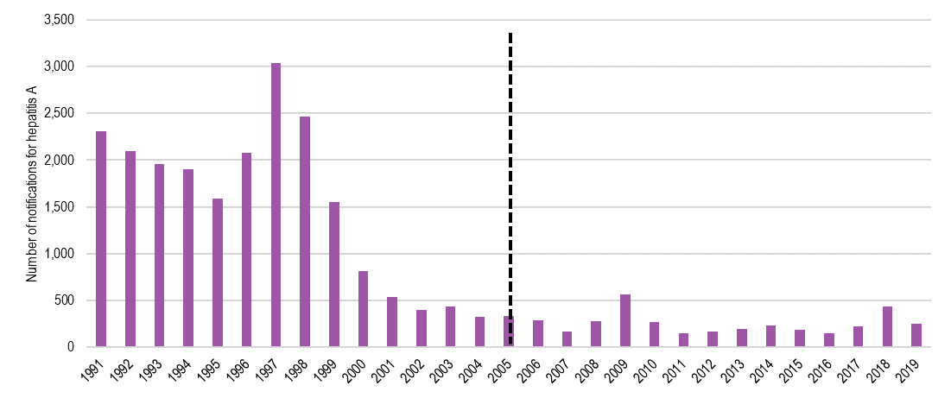
Source: Data is based on the NNDSS database ACCEssed on 25 May 2020.
Notes: Results may vary from those published in other reports due to retrospective data revisions. Notification and hospitalisation rate data represent a proportion of the total cases occurring in the community, that is, only cases for which health care was sought, a test conducted, and a diagnosis made, followed by notification to health authorities. The degree of under-representation of cases is unknown and is likely variable by disease and jurisdiction.
FIGURE E.2 NUMBER OF NOTIFICATIONS OF HEPATITIS B (NEWLY ACQUIRED), 1993-2019
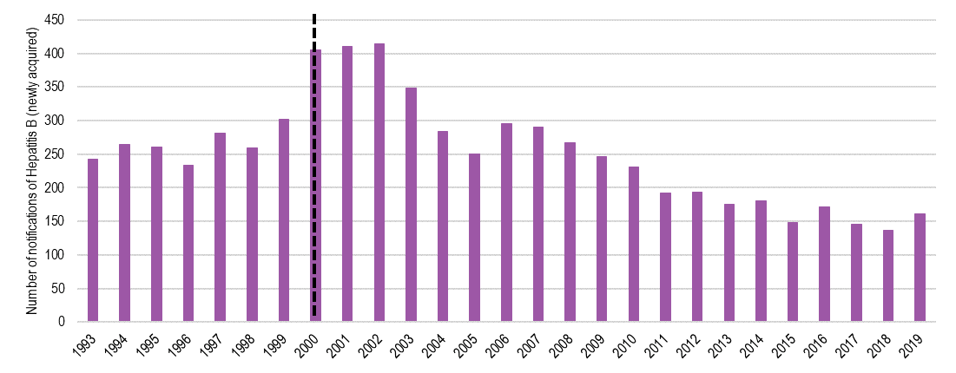
Source: Data is based on the NNDSS database ACCEssed on 25 May 2020.
Notes: as for Figure E.1.
FIGURE E.3 NUMBER OF NOTIFICATIONS OF HAEMOPHILUS INFLUENZAE TYPE B, 1991-2019
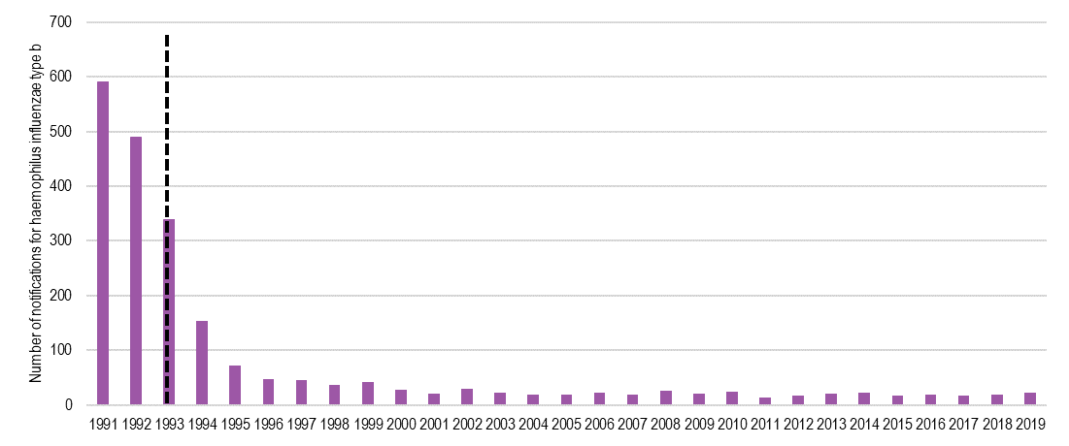
Source: Data is based on the NNDSS database ACCEssed on 25 May 2020.
Notes: as for Figure E.1.
FIGURE E.4 NUMBER OF NOTIFICATIONS OF INFLUENZA (LABORATORY CONFIRMED), 2001-2019
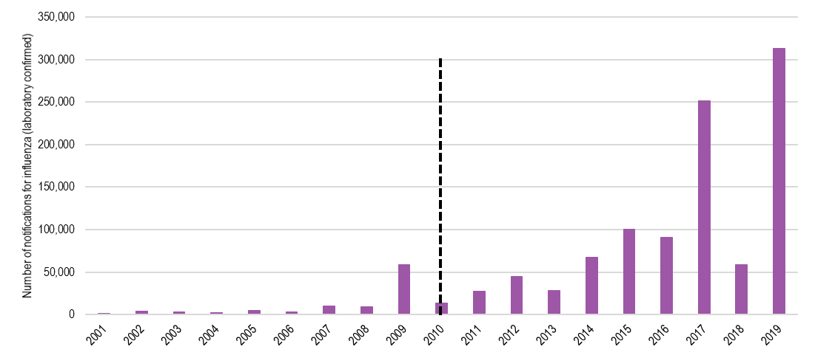
Source: Data is based on the NNDSS database ACCEssed on 25 May 2020.
Notes: as for Figure E.1.
FIGURE E.5 NUMBER OF NOTIFICATIONS OF INVASIVE MENINGOCOCCAL, 1991-2019
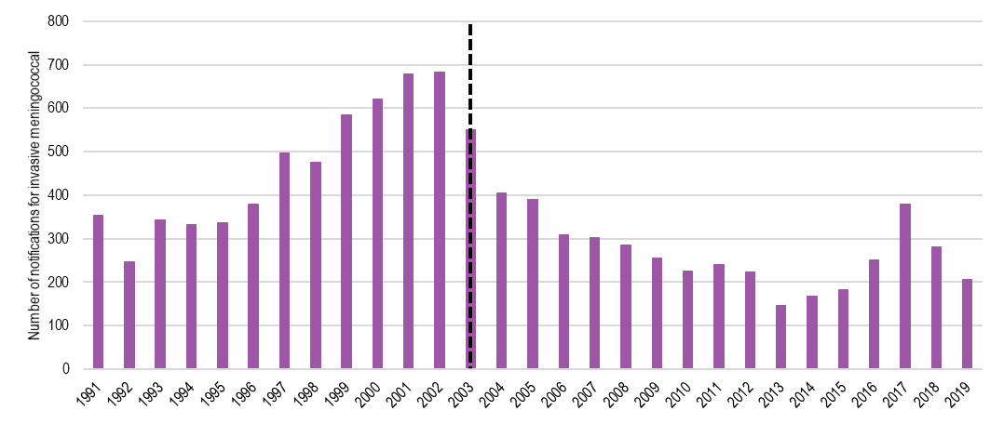
Source: Data is based on the NNDSS database ACCEssed on 25 May 2020.
Notes: as for Figure E.1.
FIGURE E.6 NUMBER OF NOTIFICATIONS OF PNEUMOCOCCAL DISEASE (0-4 YEARS), 2001-2016
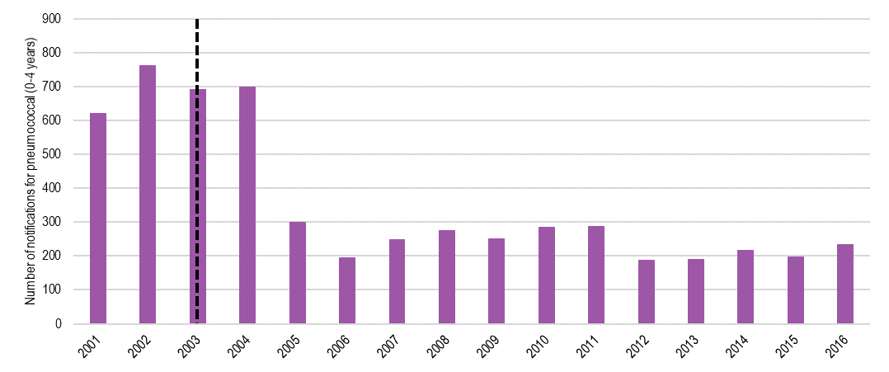
Source: Data is based on the NNDSS database ACCEssed on 25 May 2020.
Notes: as for Figure E.1.
FIGURE E.7 CRUDE HOSPITALISATION RATES (HOSPITALISATIONS PER MILLION POPULATION) OF ROTAVIRUS (0-4 YEARS), 1994-2016
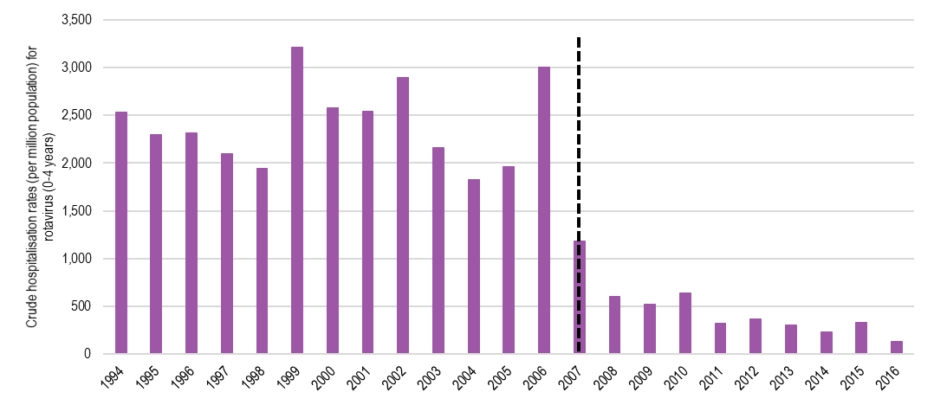
Source: Data is based on the NNDSS database ACCEssed on 25 May 2020.
Notes: as for Figure E.1.

VACCINE-PREVENTABLE DISEASES COVERED BY VACCINES UNDER THE NIP | F
Table F.1 describes the vaccine-preventable diseases under the NIP (child and adolescent). This includes the incidence of disease and a description of the disease, and the history of the disease and vaccine on the NIP.

Table F.1 Incidence of vaccine-preventable Disease for vaccines covered UNder the NIP (child and ADOLESCENT)
Disease | Year added to the NIP | Cases in year before NIP addition | Cases in recent year | Further details
Pertussis (whooping cough) | Early 1940s | Data not available | 12,024 case notifications (2019) | Whooping cough (also called pertussis) is a contagious respiratory infection caused by the bacteria Bordetella pertussis. About half of infants who get whooping cough need care in the hospital.  Whooping cough is widespread in Australia and is one of the least controlled vaccine-preventable diseases. It is highly contagious and affects people of all ages and epidemics in Australia occur every 3 to 4 years.  In 2015, there were an estimated 46,400 cases of whooping cough in Australia, including 302 notifications of whooping cough among infants aged under six months. Between 2014 and 2016, whooping cough caused an average of 415 hospitalisations and three deaths per year.  Whooping cough vaccination began in Australia in the early 1940s, and the vaccine type, number of doses and age at vaccination has varied over time to optimise protection. The NIP schedule provides whooping cough vaccination for infants and young children and is provided through state and territory school vaccination programs for adolescents.
Tetanus | 1953 | Data not available | 6 case notifications (2019) | Tetanus is a bacterial infection caused by a bacterium called Clostridium tetani. The bacteria are found most commonly in soil, dust and manure and can enter the body through breaks in the skin.  Tetanus is uncommon in Australia because of the widespread use of the tetanus vaccine under the NIP. Between 2007 and 2016, there were seven deaths due to tetanus.  Widespread vaccination against tetanus was introduced in Australia from 1953. The NIP schedule currently provides tetanus vaccination for infants and young children, and adolescents through state and territory school vaccination programs.
Measles | Mid-1970s | Data not available | 285 case notifications (2019) | Measles is a highly contagious infection caused by a virus known as Morbillivirus. It causes a skin rash, which usually begins on the face and the spreads down to cover the entire body, and flu-like symptoms. Serious complications are much more common in young children under 5 years of age, in the chronically ill and in adults. Most people recover from measles without complications; however, for some, severe complications may occur, which can be fatal.  Measles caused an average of 64 hospitalisations per year between 2014 and 2016. Between 2007 and 2016, there were only two deaths due to measles.  Measles outbreaks are now rare in Australia due to routine vaccination provided as part of the NIP. The NIP schedule has included a measles vaccination since the mid-1970s. It first included a combined MMR vaccine in 1989, with a second dose of MMR for school-aged children introduced in late 1992.
Diphtheria | 1975 | 32 case notifications (1974) | 18 case notifications (2019) | Diphtheria is a severe inflammation of nose, throat and windpipe caused by the bacterium Corynebacterium diphtheriae.  The disease is rare in most developed countries, including Australia, due to routine vaccination. However, cases of diphtheria do still occur in Australia. There has already been one case reported in January 2020.  Australia generally has high levels of protection against the disease, primarily due to the inclusion of the vaccine on the NIP. However, past outbreaks in other countries have been concentrated in poorly immunised, disadvantaged groups living in crowded conditions and low levels of immunity to diphtheria have been found in Australian adults.  Widespread vaccination against diphtheria began in Australia in 1932. Diphtheria vaccination has been part of the NIP schedule since 1975, providing vaccination for infants and young children, and adolescents through state and territory school vaccination programs.
Polio | 1975 | Data not available | 0 case notifications (2019)  Australia has been classed as polio-free since 2000 | Polio is a disease that attacks the central nervous system and often leaves an infected person partially or fully paralysed. Between 2 to 5 per cent of children and 15 to 30 per cent of adults can die as a result of paralytic polio disease, depending on the severity of the case. Polio is a disease caused by one of three types of viruses called the polioviruses.  Australia has been polio-free since 2000. Following the introduction of polio vaccine in the 1950s, the last case of locally acquired polio in Australia was in 1972. The last case reported in Australia was in 2007, where a traveller contracted the infection in Pakistan.  Widespread vaccination against polio was introduced in Australia in the mid-1950s, and polio vaccination was included on the NIP schedule in 1975. Polio vaccination is available on the NIP for infants and young children.
Mumps | 1989 | Data not available | 171 case notifications (2019) | Mumps is a contagious viral infection which causes swelling of the (parotid) salivary glands on the face.  Mumps was traditionally a common childhood infection. In Australia, the disease is uncommon in children due to routine vaccination. Between 2007 and 2016, there were only three deaths due to mumps in Australia. Most cases of mumps reported in Australia now occur in adolescents and adults.  Mumps vaccination was introduced in Australia in the early 1980s. The NIP schedule first included a combined MMR vaccine in 1989.
Rubella | 1989 | Data not available | 22 case notifications (2019) | Rubella is an infection caused by a virus. It is sometimes called German measles, although it is not related to measles itself. In most people, rubella is a mild disease, but it can have severe consequences for an unborn baby, including a higher risk of severe and permanent birth defects or miscarriage/death.  Rubella is uncommon in Australia due to the routine vaccination program as part of the NIP; however, outbreaks still occur. Between 2007 and 2016, there was a total of 41 hospitalisations and ten deaths due to rubella.  Widespread vaccination against rubella for schoolgirls and non-immune women was introduced in Australia in 1971. The NIP schedule first included a combined MMR vaccine in 1989.
Haemophilus influenzae type b (Hib) | 1993 | 490 case notifications (1992) | 22 case notifications (2019) | Hib disease is a serious illness caused by the bacteria known as Haemophilus influenzae type b. Despite its name, Hib is not related to influenza. Infants and children under 5 years of age are at the greatest risk of serious illness from Hib, which can cause lifelong disability or lead to death.  In Australia, Hib has become a rare disease due to the routine immunisation of infants. Since 1992, reported cases of Hib have fallen from 549 cases to 22 cases in 2019.  Vaccination against Hib was first included on the NIP schedule in 1993. It is available on the NIP for infants and young children.
Pneumococcal (invasive) | 2003 | 2,415 case notifications (2002) | 2,123 case notifications (2019) | Pneumococcal disease refers to the group of illnesses that can be caused by bacteria commonly known as pneumococcus. Pneumococcal disease can cause several different illnesses ranging from pneumonia (infection of the lungs) to meningitis (infection of the lining of the brain) and infections of the blood and bone.  Pneumococcal disease is one of the leading causes of serious illness among Australian children under two years of age and in older adults. Indigenous communities, in particular those from central Australia, are at an increased risk of the disease.  There are at least 90 different strains of the bacteria, but only some of these cause pneumococcal disease. In Australia, vaccinations under the NIP help protect against some of these strains. Between 2014 and 2016, there was an average of 1,576 notifications of invasive pneumococcal disease and 2,219 hospitalisations per year.  Vaccination under the NIP schedule for at-risk Indigenous adults was introduced in 1999, although subsidised vaccinations have been available under the Pharmaceutical Benefits Scheme for all people aged over 65 since February 1997. Vaccination for at-risk infants was first nationally funded under the NIP schedule in 2003, and then extended to all infants and people aged 65 and over in 2005.
Hepatitis B (unspecified) | 2000 | 6,413 case notifications (1999) | 5,698 case notifications (2019) | Hepatitis B is a virus that infects the liver. The virus can be found in blood and bodily fluids, including semen and vaginal fluid. Most adults will fully recover from the infection; however, this is not usually the case in young children.  In 2019 there were 5,855 cases of hepatitis B recorded in Australia, of which 157 cases were “newly acquired,” and 5,698 cases were “unspecified” regarding the time-lapse since first infection. Between 2014 and 2016, there was an average of 158 notifications of newly acquired hepatitis B each year in Australia. During this period, hepatitis B was recorded as the cause of an average of 84 hospitalisations and 26 deaths per year.  Vaccination against hepatitis B in Australia began in the early 1980s. Free infant vaccination started in 1990 in the Northern Territory and was rolled out nationally in 2000. A school-based adolescent ‘catch-up’ program operated from the late 1990s until 2013. The NIP schedule currently provides routine vaccination against hepatitis B at birth and during infancy.
Meningococcal (invasive) | 2003 | 683 case notifications (2002) | 206 case notifications (2019) | Meningococcal disease refers to the group of illnesses that can be caused by bacterium commonly known as meningococcus (or Neisseria meningitidis). It can cause invasive meningococcal disease (IMD), which can result in serious complications or death. IMD includes meningitis (inflammation of the lining of the brain) and septicaemia (blood poisoning). Those at most risk include children under 5 years of age due to their less mature immune system and tendency to put things in their mouth.  Between 2014 and 2016, there was an average of 201 IMD cases per year in Australia. Over the same period, meningococcal disease caused an average of 197 hospitalisations and ten deaths per year.  After the meningococcal serogroup C vaccination was included on the NIP schedule in 2003, the proportion of IMD cases caused by serogroup C decreased from 29 per cent in 2003 to 12 per cent in 2005 and 1 per cent in 2015. From July 2018, the NIP has provided vaccination against meningococcal serogroups A, C, W and Y for all infants. From April 2019, it also provides adolescents with vaccination against these four serogroups.
Hepatitis A | 2005 | 319 case notifications (2004) | 246 case notifications (2019) | Hepatitis A is a virus which infects and causes inflammation the liver. It causes an acute infection from which almost everyone will fully recover.  Although outbreaks of hepatitis A do occur in Australia, the virus is most commonly contracted overseas. Between 2014 and 2016, hepatitis A caused an average of 100 hospitalisations and one death per year.  There is no specific treatment for hepatitis A and vaccination is the best way to protect against this disease. Vaccination against hepatitis A was made available to Indigenous children in North Queensland in 1999. From 2005, the NIP schedule provided hepatitis A vaccination for young Indigenous children living in Queensland, Western Australia, South Australia and the Northern Territory.
Varicella (chickenpox) | 2005 | Data not available | 4,389 case notifications (2019) | Chickenpox is a disease caused by Varicella zoster, which is a virus that comes from the herpes family. It is a very contagious disease that is known by the itchy rash that may first show up on the face, chest, and back then spread to the rest of the body. Chickenpox mostly affects children. In healthy children, the chickenpox disease is generally mild and does not last long, but it can cause serious illness or death in people who have lowered immunity.  The cases of chickenpox in Australia have declined since the introduction of the vaccination program; however, cases are still reported. Between 2014 and 2016, chickenpox caused an average of 379 hospitalisations and five deaths per year.  Vaccination against chickenpox was first included on the NIP schedule in 2005. The NIP schedule currently provides a combined vaccine (measles, mumps, rubella, varicella) vaccine for young children aged 18 months.
Human papillomavirus (HPV) | 2007 for girls, 2013 for boys | Data not available | 898 incidences of cervical cancer (2013)  Estimates indicate that there were over 291,000 new HPV infections in Australia in 2015 | Human papillomavirus, or HPV, is a common virus that affects both males and females in Australia. In most people, HPV is harmless and has no symptoms. Still, in others, the virus may persist and lead to diseases of the genital area, including genital warts and cancers of the cervix, vagina, vulva and anus. Vaccines can help protect against the strains of genital HPV that are most likely to cause genital warts or cervical cancer.  In 2015, there were over 16,000 high-grade cervical abnormalities detected, over 800 diagnoses of cervical cancer and an estimated 230 deaths due to cervical cancer among Australian women.  HPV vaccination for girls was first included on the NIP schedule in 2007, with vaccination for boys added in 2013. The NIP schedule provides vaccination for adolescents aged 12 to 13 years through state and territory school vaccination programs. In 2018, the vaccine covered by the NIP was updated to a new type that protects against 9 strains of HPV, which together cause over 90 per cent of cervical cancers occurring in Australia.
Rotavirus | 2007 | Data not available | 6,171 case notifications (2019) | Rotavirus is a virus that belongs to the Reoviridae family. It causes viral gastroenteritis and is common in children. Rotavirus causes viral gastroenteritis, with symptoms ranging from mild to severe watery diarrhoea and vomiting. Severe cases may lead to fluid loss that requires medical treatment.  Although still relatively common in Australia, routine immunisation has successfully decreased the number of rotavirus cases, and the severity of symptoms and hence the number of hospitalisations due to rotavirus. In 2015, there were an estimated 47,700 cases of rotavirus in Australia. Between 2014 and 2016, rotavirus caused an average of 647 hospitalisations and less than one death per year.  Introduction of routine vaccination for rotavirus in Australia in 2007 has decreased the number of hospitalisations by an estimated 70 per cent. Before the introduction of the rotavirus vaccine, rotavirus caused close to half of all hospitalised cases of gastroenteritis in children, and most children had at least one infection before three years of age.
Influenza | 2010 for expanded eligibility | 59,038 laboratory-confirmed case notifications (2019) | 313,085 laboratory- confirmed case notifications (2019) | Seasonal influenza, also known as the flu, is a contagious respiratory illness. There are three main types of flu virus, the A, B, and C strain. The A and B strains cause most influenza in Australia. Each year the strains circulating are different. In some years, one of the A strains may be more common, while in other years, the B strains may be more common.  Each year, the flu vaccine effectiveness can vary, and it will depend on your age and other conditions and risk factors. It can also depend on the specific strains of influenza circulating in your community.  Each year the World Health Organisation (WHO), along with a specific team of collaborating researchers, makes recommendations on which virus strains the influenza vaccine should cover for the following year. Once the vaccine strains have been decided, WHO then prepare the virus for use in manufacturing the vaccine. Influenza vaccination program for over 65 year olds began in 1997, with an expanded eligibility in 2010 to include pregnant women, Aboriginal and Torres Strait Islander people from 15 years of age and over, peoples aged 65 years and over, and all people from 6 months of age with conditions predisposing to severe influenza.
Varicella zoster (shingles) | 2016 for >70 year olds | 6,366 case notifications (2015) | 15,065 case notifications (2019) | Shingles is caused by the virus varicella zoster (same virus which causes chickenpox), and is characterised by a painful, itchy rash which generally appears on one side of the face or body. Shingles is a viral disease that tends to affect older adults.  In 2019, there were 15,065 cases notifications of shingles (herpes zoster) in Australia. Between 1997 and 2016, shingles caused 438 deaths, 83 per cent (365 deaths) of which occurred in people aged 80 years and over.  A shingles vaccine for people aged 70, with a five-year catch-up program for people aged 71 to 79 years, was added to the NIP schedule in November 2016. The impact of vaccination is expected to become more evident as more vulnerable people are vaccinated.
Source: Victorian Government, Better Health Channel, Accessed on 20 May 2020; The Australian Immunisation Handbook, Accessed on 20 May 2020; Australian Government, Department of Health, National Notifiable Diseases Surveillance System, Australia; Australian Institute of Health and Welfare, National Hospital Morbidity Database, Australia; Australian Government, Department of Health, National Centre for Immunisation Research and Surveillance, Canberra; Australian Institute of Health and Welfare, The burden of vaccine preventable diseases in Australia, canberra, 2019.
NOTE: Cases in recent year indicate the most recent full year of notification data from the NNDSS, with the exception of HPV data, which is based on AIHW Cervical screening in Australia.

Second NPEV Definition of ‘fully immunised’ | G
Vaccination coverage rates measured for performance benchmarks are based on the proportion of children who are ‘fully immunised’ for their age, as defined by the AIR. This definition may change over time with changes to the NIP Schedule. The definitions as of July 2020 are shown in Table G.1.
Table G.1 Definition of ‘fully immunised’ by age cohort
Age cohort | Vaccine
12 to <15 month age cohort
DTP | Diphtheria dose 3 + Tetanus dose 3 + Pertussis dose 3
Polio | Polio dose 3
HIB | Haemophilus type B (Pathway B) dose 2 or Haemophilus type B (Pathway A) dose 3
HepB | Hepatitis dose 3
MMR | Not assessed
Pneumo | Pneumococcal dose 2 or 3
Fully Vaccinated | DTP + Polio + HIB + HepB + Pneumococcal (All previous doses are presumed as given)
24 to <27 month age cohort
DTP | Diphtheria dose 4 + Tetanus dose 4 + Pertussis dose 4
Polio | Polio dose 3
HIB | Haemophilus type B (Pathway B) dose 3, or Haemophilus type B (Pathway B) dose 4, or Haemophilus type B (Pathway A) dose 4, or Haemophilus type B (Pathway A) dose 3 given greater than 11½ months of age
HepB | Hepatitis B dose 3
MMR | Measles dose 2 + Mumps dose 2 + Rubella dose 2
Varicella | Varicella dose 1
MenC | Meningococcal C dose 1
Pneumo | Pneumococcal dose 3
Fully Vaccinated | DTP + Polio + HIB + HepB + MMR+ Varicella + MenC + Pneumococcal (All previous doses are presumed as given)
60 to <63 month age cohort
DTP | Diphtheria dose 4 or 5 + Tetanus dose 4 or 5 + Pertussis dose 4 or 5
Polio | Polio dose 4
HIB | Not assessed
Hep B | Not assessed
MMR* | Not assessed
Fully Vaccinated | DTP + Polio
*From 31 December 2017, the definition of fully immunised changed for the 60-<63 month age cohort, with MMR no longer being assessed from this date.
Source: Australian Immunisation Register

Additional data | H
This Appendix provides additional data to support the findings presented in the body of the report.

Vaccination coverage rates
This Section provides data to support Section 2.1.2.

Vaccination coverage rates for Aboriginal and Torres Strait Islander children
Table H.1 details the number of Aboriginal and Torres Strait Islander 60-<63 month olds in each jurisdiction, and the proportion of 60-<63 month olds who are Aboriginal and / or Torres Strait Islander.
Table H.1 number and proportion of Aboriginal and Torres Strait Islander 60-<63 month olds, by jurisdiction, 2017-18
State or territory | Number of Aboriginal and Torres Strait Islander 60-<63 month olds | Number of non-Aboriginal and Torres Strait Islander 60-<63 month olds | Proportion of 60-<63 month olds who are Aboriginal and/or Torres Strait Islander
ACT | 144 | 5,896 | 2%
NSW | 5,093 | 105,843 | 5%
NT | 1,264 | 3,565 | 35%
Queensland | 5,102 | 67,318 | 8%
SA | 789 | 20,937 | 4%
Tasmania | 492 | 6,131 | 8%
Victoria | 1,021 | 82,437 | 1%
WA | 2,078 | 35,392 | 6%
Source: Australian Immunisation Register

HPV vaccination coverage rates
The figures below provide historical context for HPV vaccination coverage rates for adolescent females (2012-2017) and males (2014-2017) for all states and territories. This data pre-dates the second NPEV, which did not assess HPV vaccination coverages in the Year 1 assessment period.
Figure H.1 HPV VACCINATION COVERAGE RATES: ADOLESCENT females (2012-17) and males (2014-2017
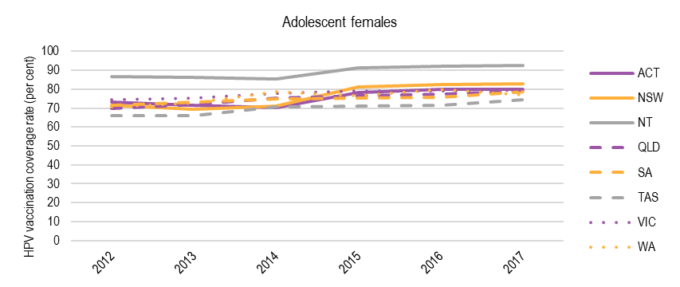
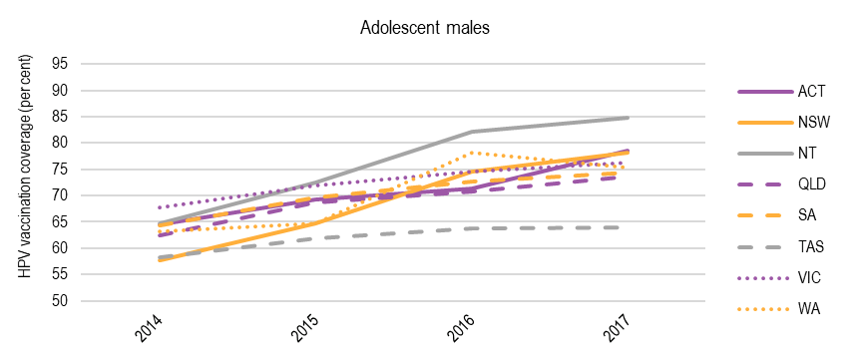
Note: As of July 2020, 'fully immunised' for HPV is defined as a child having a record on the AIR of the number of doses of HPV-containing vaccine as set out in the National Health (Immunisation Program – Designated Vaccines) Determination 2014 by age 15.
2014-2017 data has been sourced from the Department of Health website, previously housed on the National HPV Register.
Source: Commonwealth Department of Health, National HPV Register

Vaccination coverage rates for low coverage SA3 geographical areas
The figures below identify the coverage rates from 2014-2019 for 60 ≤ 63 month olds in four of the ten lowest vaccination coverage SA3 geographical areas in each state, as selected for the AIHW 2017-18 performance report.
Australian Capital Territory
Figure H.2 shows coverage rates for the four SA3 geographical areas for ACT: Belconnen, South Canberra, Tuggeranong and Weston Creek. Coverage rates for all four areas remained consistently high in 2019. As of 2019, Tuggeranong (95.19 per cent) and Weston Creek (95.24 per cent) have coverage rates above 95 per cent, followed closely by Belconnen (94.95 per cent) and South Canberra (91.36 per cent).
FIGURE H.2 VACCINATION COVERAGE RATES FOR 60 ≤ 63 MONTH OLDS IN FOUR LOW-COVERAGE SA3 GEOGRAPHICAL AREAS IN ACT, 2014-2019
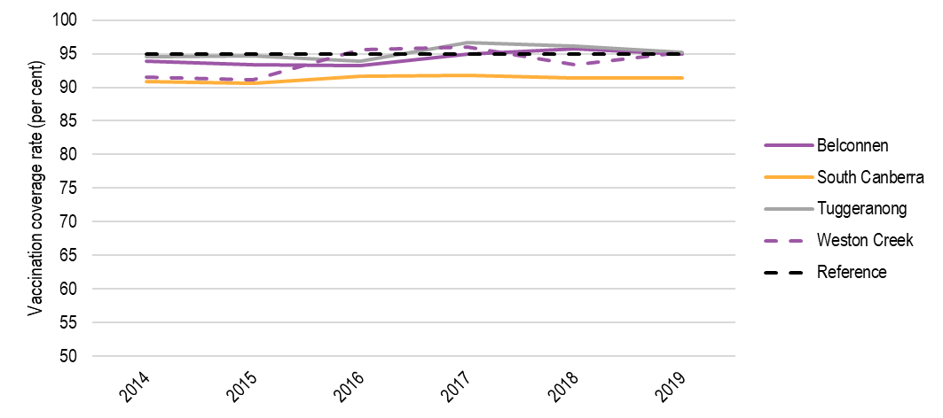
Note: As of July 2020, 'fully immunised' at 60 months of age is defined as a child having a record on the AIR of dose 4 or 5 of a DTP-containing vaccine; and dose 4 of a polio containing vaccine. Note that from 31 December 2017, the definition of ‘fully immunised’ at 60-<63 months of age changed, with MMR no longer being assessed. The reference line (black dashed line) represents a 95 per cent vaccination coverage.
Source: Australian Immunisation Register, May 2020
New South Wales
Figure H.3 shows coverage rates for the four SA3 geographical areas for NSW: Sydney Inner City, Eastern Suburbs - North, North Sydney - Mosman and Manly. Coverage rates for all four areas remained high in 2019.
As at 2019, no selected SA3 geographical areas in NSW were above 95 per cent. Manly had the highest coverage rate at 90.86 per cent, followed by North Sydney - Mosman (89.45 per cent), Sydney Inner City (88.91 per cent) and Eastern Suburbs - North (88.73 per cent).
FIGURE H.3 VACCINATION COVERAGE RATES FOR 60–<63 MONTH OLDS IN FOUR LOW-COVERAGE SA3 GEOGRAPHICAL AREAS IN NSW, 2014-2019
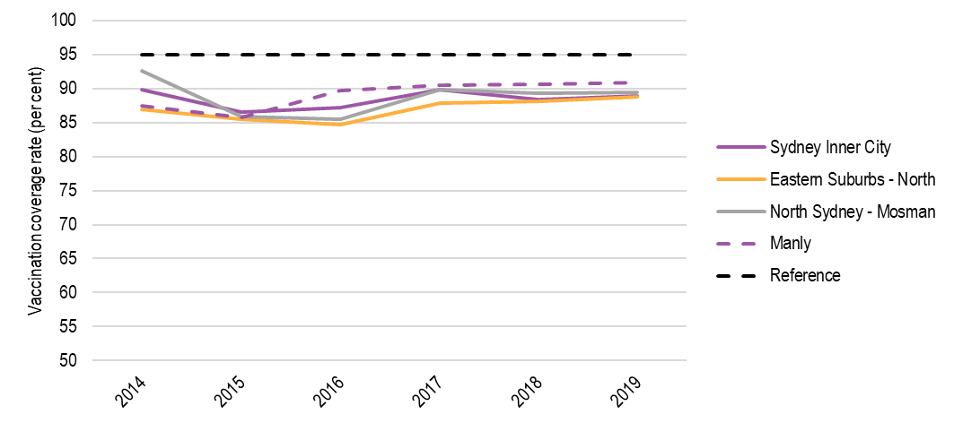
Note: As of July 2020, 'fully immunised' at 60 months of age is defined as a child having a record on the AIR of dose 4 or 5 of a DTP-containing vaccine; and dose 4 of a polio containing vaccine. Note that from 31 December 2017, the definition of ‘fully immunised’ at 60-<63 months of age changed, with MMR no longer being assessed. The reference line (black dashed line) represents a 95 per cent vaccination coverage.
Source: Australian Immunisation Register, May 2020
Northern Territory
Figure H.4 shows coverage rates for the four SA3 geographical areas for NT: Darwin Suburbs, Litchfield, Palmerston and Katherine. Coverage rates for all four areas were high in 2019. Katherine (98.28 per cent) had a coverage rate above 95 per cent, followed Litchfield (94.67 per cent), Palmerston (94.31 per cent) and Darwin Suburbs (92.89 per cent).
FIGURE H.4 VACCINATION COVERAGE RATES FOR 60–<63 MONTH OLDS IN FOUR LOW-COVERAGE SA3 GEOGRAPHICAL AREAS IN NT, 2014-2019
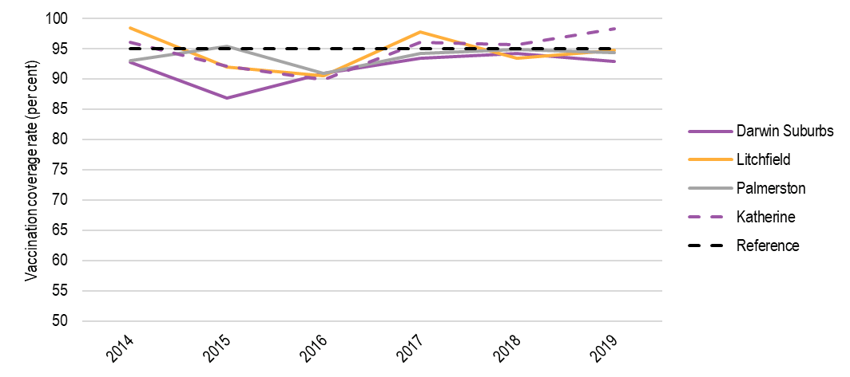
Note: As of July 2020, 'fully immunised' at 60 months of age is defined as a child having a record on the AIR of dose 4 or 5 of a DTP-containing vaccine; and dose 4 of a polio containing vaccine. Note that from 31 December 2017, the definition of ‘fully immunised’ at 60-<63 months of age changed, with MMR no longer being assessed. The reference line (black dashed line) represents a 95 per cent vaccination coverage.
Source: Australian Immunisation Register, May 2020
Queensland
Figure H.5 shows coverage rates for the four SA3 geographical areas for Queensland: Gold Coast Hinterland, Southport, Beaudesert and Bribie Beachmere. Coverage rates between the four areas in Queensland generally had higher variance compared to other states and territories.
As of 2019, no selected SA3 geographical areas in Queensland were above 95 per cent. Bribie Beachmere had the highest coverage rate at 94.89 per cent, followed by Southport (93.29 per cent), Beaudesert (92.66 per cent) and Gold Coast Hinterland (87.88 per cent).
FIGURE H.5 VACCINATION COVERAGE RATES FOR 60–<63 MONTH OLDS IN FOUR LOW-COVERAGE SA3 GEOGRAPHICAL AREAS IN QUEENSLAND, 2014-2019
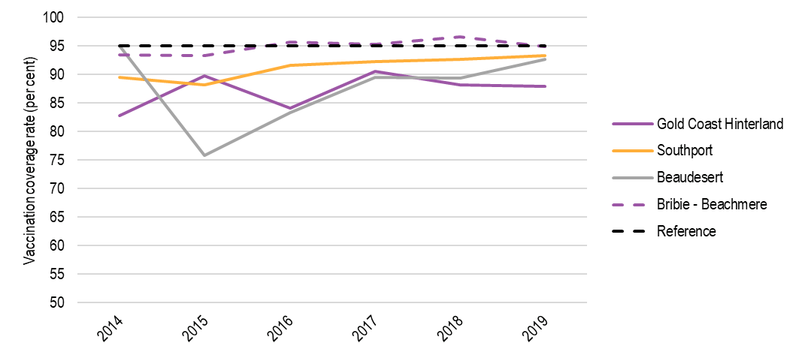
Note: As of July 2020, 'fully immunised' at 60 months of age is defined as a child having a record on the AIR of dose 4 or 5 of a DTP-containing vaccine; and dose 4 of a polio containing vaccine. Note that from 31 December 2017, the definition of ‘fully immunised’ at 60-<63 months of age changed, with MMR no longer being assessed. The reference line (black dashed line) represents a 95 per cent vaccination coverage.
Source: Australian Immunisation Register, May 2020
South Australia
Figure H.6 shows coverage rates for the four SA3 geographical areas for SA: Campbelltown, Norwood Payneham St Peters, Unley and West Torrens. Vaccination coverage rates in the four areas remained consistently high in 2019.
As of 2019, no selected SA3 geographical areas in SA were above 95 per cent; however, all areas were close. West Torrens had the highest coverage rate at 93.96 per cent, followed by Unley (93.78 per cent), Campbelltown (93.70 per cent) and Norwood Payneham St Peters (92.72 per cent).
FIGURE H.6 VACCINATION COVERAGE RATES FOR 60–<63 MONTH OLDS IN FOUR LOW-COVERAGE SA3 GEOGRAPHICAL AREAS IN SA, 2014-2019
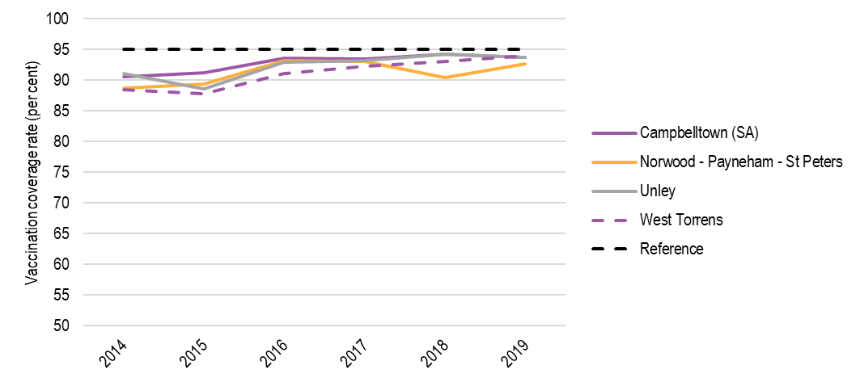
Note: As of July 2020, 'fully immunised' at 60 months of age is defined as a child having a record on the AIR of dose 4 or 5 of a DTP-containing vaccine; and dose 4 of a polio containing vaccine. Note that from 31 December 2017, the definition of ‘fully immunised’ at 60-<63 months of age changed, with MMR no longer being assessed. The reference line (black dashed line) represents a 95 per cent vaccination coverage.
Source: Australian Immunisation Register, May 2020
Tasmania
Figure H.7 shows coverage rates for the four SA3 geographical areas for Tasmania: Hobart North West, North East, Central Highlands, Huon-Bruny Island. Coverage rates in the four areas remained high in 2019. As of 2019, Central Highlands (98.41 per cent) had a coverage rate above 95 per cent. This is followed closely by Hobart - North West (94.98 per cent), North East (94.65 per cent) and Huon Bruny - Island (92.67 per cent).
FIGURE H.7 VACCINATION COVERAGE RATES FOR 60–<63 MONTH OLDS IN FOUR LOW-COVERAGE SA3 GEOGRAPHICAL AREAS IN TASMANIA, 2014-2019
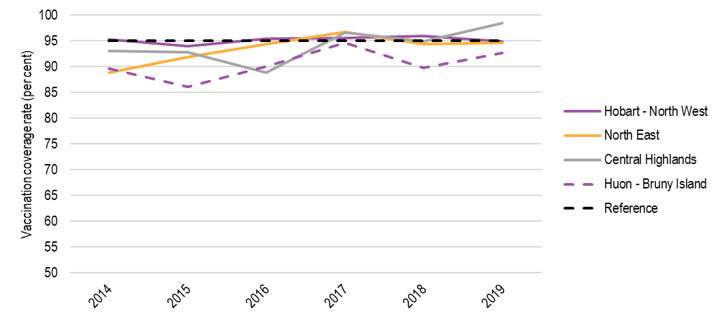
Victoria
Figure H.8 shows coverage rates for the four SA3 geographical areas for Victoria: Melbourne City, Port Phillip, Stonnington West and Maribyrnong. Coverage rates in the four areas remained high in 2019. As of 2019, no selected SA3 geographical area in Victoria had a coverage rate above 95 per cent; however, Maribyrnong is close at 94.09 per cent, followed by Melbourne City (91.59 per cent), Port Phillip (90.28 per cent) and Stonnington West (89.32 per cent).
FIGURE H.8 VACCINATION COVERAGE RATES FOR 60–<63 MONTH OLDS IN FOUR LOW-COVERAGE SA3 GEOGRAPHICAL AREAS IN VICTORIA, 2014-19
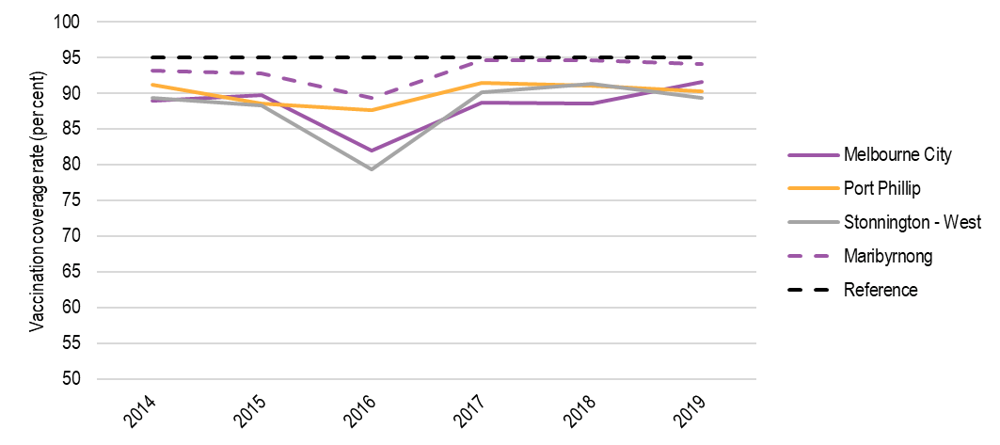
Note: As of July 2020, 'fully immunised' at 60 months of age is defined as a child having a record on the AIR of dose 4 or 5 of a DTP-containing vaccine; and dose 4 of a polio containing vaccine. Note that from 31 December 2017, the definition of ‘fully immunised’ at 60-<63 months of age changed, with MMR no longer being assessed. The reference line (black dashed line) represents a 95 per cent vaccination coverage.
Source: Australian Immunisation Register, May 2020
Western Australia
Figure H.9 shows coverage rates for the four SA3 geographical areas for WA: Manjimup, Cottesloe Claremont, Fremantle and Melville. Coverage rates remained steady in 2019. As of 2019, no selected SA3 geographical area in WA had a coverage rate above 95 per cent. Manjimup is close, at 94.09 per cent, followed closely by Melville (92.91 per cent), Cottesloe Claremont (92.88 per cent) and Fremantle (90.12 per cent).
FIGURE H.9 VACCINATION COVERAGE RATES FOR 60–<63 MONTH OLDS IN FOUR LOW-COVERAGE SA3 GEOGRAPHICAL AREAS IN WA, 2014-19
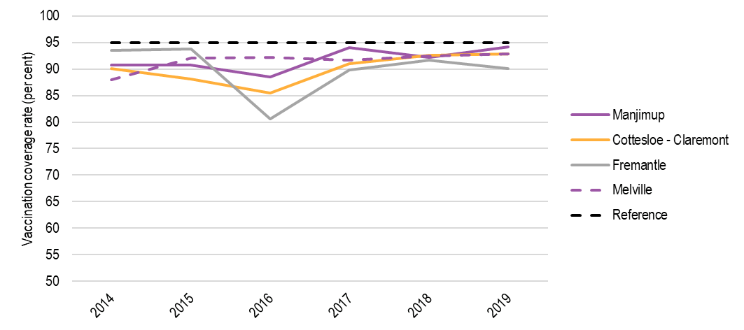
Note: As of July 2020, 'fully immunised' at 60 months of age is defined as a child having a record on the AIR of dose 4 or 5 of a DTP-containing vaccine; and dose 4 of a polio containing vaccine. Note that from 31 December 2017, the definition of ‘fully immunised’ at 60-<63 months of age changed, with MMR no longer being assessed. The reference line (black dashed line) represents a 95 per cent vaccination coverage.
Source: Australian Immunisation Register, May 2020

Wastage and leakage rates
Table H.2 below identifies the wastage and leakage rates for each state and territory for 2013-14 to 2018-19.
Table H.2 WASTAGE AND LEAKAGE RATE FOR AGREED VACCINES, 2013-14 to 2018-19
 | 2013-14 | 2014-15 | 2015-16 | 2016-17 | 2017-18  Year 1 assessment |  | 2018-19  Year 2 assessment
 | - | - | - | - | Previously assessed | Newly assessed | Previously assessed | Newly assessed
ACT | 2.76 | 2.44 | 3.13 | 2.67 | 0.00 | 0.00 | 5.88 | N/A
NSW | 9.28 | 5.39 | 4.61 | 5.52 | 5.51 | 6.69 | 9.12 | N/A
NT | 2.95 | 5.22 | 8.11 | 7.95 | 4.81 | 9.32 | 13.79 | N/A
Queensland | 3.47 | 5.60 | 3.05 | 1.31 | 3.71 | 5.14 | 3.21 | N/A
SA | 5.40 | 4.36 | 4.61 | 2.80 | 3.41 | 4.59 | 5.67 | N/A
Tasmania | 8.10 | 4.46 | 3.76 | 4.74 | 7.27 | 13.53 | 11.83 | N/A
Victoria | 5.98 | 5.13 | 4.14 | 4.19 | 3.34 | 4.30 | 4.58 | N/A
WA | 4.58 | 5.68 | 4.69 | 4.36 | 3.64 | 7.08 | 3.25 | N/A
Note: ‘Previously assessed’ vaccines in 2017-18: Infanrix Hexa (DTPa-hepB-IPV-Hib) and Menitorix (Hib-MenC).
The 2017-18 assessment includes 12 vaccines assessed in Year 1 of the second NPEV (2 ‘previously assessed’ and 10 ‘newly assessed’). ‘Previously assessed’ vaccines in 2017-18 are: Infanrix Hexa (DTPa-hepB-IPV-Hib) and Menitorix (Hib-MenC). ‘Newly assessed’ vaccines in 2017-18 are: Infanrix (DTPa), Tripacel (DTPa), ProQuad (MMRV), Priorix-Tetra (MMRV), Infanrix IPV (DTPa-IPV), Quadracel (DTPa-IPV), Rotarix (Rotavirus), Rotateq (Rotavirus), Prevenar 13 (Pneumococcal), Vaqta Paediatric (HepA).
The 2018-19 assessment includes 10 vaccines assessed in Year 2 of the second NPEV. ‘Previously assessed’ vaccines in 2018-19 are: Infanrix Hexa (DTPa-hepB-IPV-Hib), Infanrix (DTPa), Tripacel (DTPa), ProQuad (MMRV), Priorix-Tetra (MMRV), Infanrix IPV (DTPa-IPV), Quadracel (DTPa-IPV), Rotarix (Rotavirus), Prevenar 13 (Pneumococcal), Vaqta Paediatric (HepA). (10 x previously assessed).
N/A = not applicable. No newly assessed vaccines were included in the assessment for the 2018–19.
Source: AIHW; Wastage and leakage rate supplied by the department of Health.

Vaccine supplier delays
The information below supports the discussion on the efficiency of vaccine suppliers in Section 5.1.2.
As shown in Figure H.10, the national average planned lag (i.e. the duration between the day on which a jurisdiction places an order, and the day on which they request the order be delivered) was 9.9 days, with the shortest planned lag in the NT (5.2 days) and the longest in Queensland (16.7 days).
FIGURE H.10 AVERAGE NUMBER OF DAYS PLANNED LAG IN VACCINE ORDERS, BY STATE, 2019
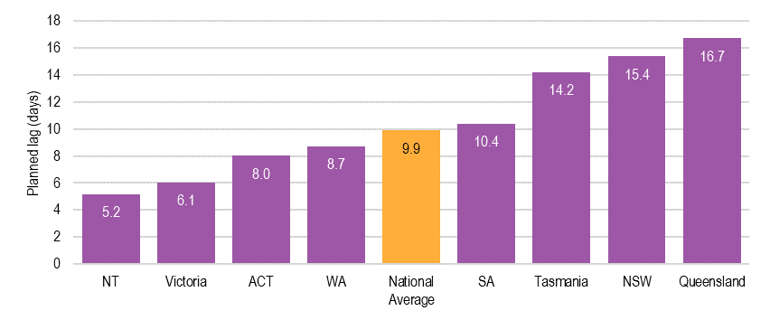
Source: commonwealth department of health 2020
Four vaccine suppliers provide vaccines for the NPEV. In 2019, vaccine Supplier 4 had an average delay of 3.5 days (see Figure H.11). This was largely due to delays in a few orders:
- nine order lines for one vaccine were delivered with an average delay of 27.1 days (two of which were delayed by 85 days)
- 17 order lines for a second vaccine were delivered with an average delay of 15.0 days.
Across the remaining three suppliers, delays ranged between 0.7 and 1.2 days on average.
FIGURE H.11 DELAY BY SUPPLIER, 2019
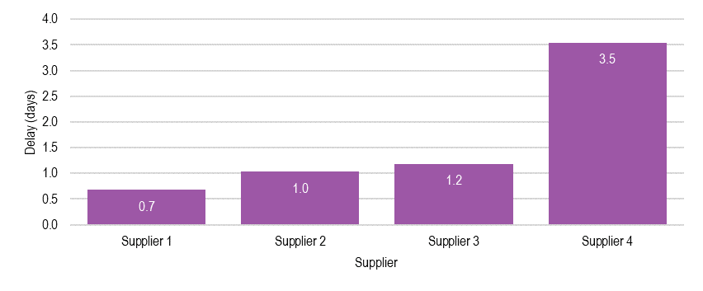
Source: commonwealth department of health 2020
In 2019, approximately six out of ten orders were delivered either early or on time (see Figure H.12). Of the delayed orders, one in five were delayed by more than seven days.
FIGURE H.12 DELAY BY DELAY PERIOD, 2019
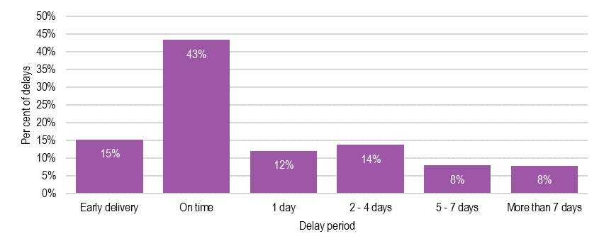
SOURCE: COMMONWEALTH DEPARTMENT OF HEALTH 2020

ACIL ALLEN CONSULTING PTY LTD
ABN 68 102 652 148
acilallen.com.au

About ACIL Allen consulting
ACIL ALLEN CONSULTING IS THE LARGEST INDEPENDENT, AUSTRALIAN OWNED ECONOMIC AND PUBLIC POLICY CONSULTANCY.
WE SPECIALISE IN THE USE OF APPLIED ECONOMICS AND ECONOMETRICS WITH EMPHASIS ON THE ANALYSIS, DEVELOPMENT AND EVALUATION OF POLICY, STRATEGY AND PROGRAMS.
OUR REPUTATION FOR QUALITY RESEARCH, CREDIBLE ANALYSIS AND INNOVATIVE ADVICE HAS BEEN DEVELOPED OVER A PERIOD OF MORE THAN THIRTY YEARS.

AIHW (2016). Australia’s health 2018 Cat. No: AUS 221. Canberra: AIHW.
Australian Government (2009). National Partnership on Essential Vaccines. Canberra: Australian Government.
The leading practice principles identified for the assessment of the NPEV are described in Section 1.3.5.
Intergovernmental Agreement on Federal Financial Relation (2015). A Short Guide to Reviewing National Partnerships. Canberra: Australian Government.
Department of the Prime Minister and Cabinet (2020). Effective Commonwealth-State Relations. Accessed 9 July 2020: https://www.pmc.gov.au/domestic-policy/effective-commonwealth-state-relations.
Department of Health (2019). The Australian health system. Accessed 10 May 2020: https://www.health.gov.au/about-us/the-australian-health-system.
AIHW (2016). Australia’s health 2018 Cat. No: AUS 221. Canberra: AIHW.
Department of Health (2018). National Immunisation Strategy for Australia 2019–2024. Canberra: Australian Government.
Australian Government Department of Health (2020). National Immunisation Program Schedule. Accessed 10 May 2020: https://www.health.gov.au/initiatives-and-programs/national-immunisation-program.
Department of Health (2018). Immunisation policy and governance. Accessed 10 May 2020: https://www.health.gov.au/health-topics/immunisation/about-immunisation/immunisation-policy-and-governance.
Australian Technical Advisory Group on Immunisation (2018). Australian Immunisation Handbook. Canberra: Australian Government.
Australian Government (2009). National Partnership on Essential Vaccines. Canberra: Australian Government.
Australian Government (2017). National Partnership on Essential Vaccines. Canberra: Australian Government.
World Health Organisation (n.d.). Immunization supply chain and logistics. Accessed 25 May 2020.
ProPolicy Consulting (2016). The National Partnership on Essential Vaccines: the changing landscape over 2009-2016 and implications for future arrangements for the Commonwealth Department of Health.
Department of Health and Ageing (2010). Vaccine preventable diseases in Australia, 2005 to 2007. Canberra: Australian Government.
Department of Health (2018). Using the Australian Immunisation Register. Accessed 3 August 2020: https://www.health.gov.au/health-topics/immunisation/health-professionals/using-the-australian-immunisation-register.
COAG (2009). National Partnership Agreement on Essential Vaccines. Canberra: Australian Government.
AIHW (2019) The burden of vaccine preventable diseases in Australia. Canberra: AIHW.
Sapere Research Group and Sironis Health (2014). Review of the National Partnership Agreement on Essential Vaccines for the Commonwealth Department of Health.
ProPolicy Consulting (2016). The National Partnership on Essential Vaccines: the changing landscape over 2009-2016 and implications for future arrangements for the Commonwealth Department of Health.
Australian National Audit Office (2018). Effectiveness of Monitoring and Payment Arrangements under National Partnership Agreements. Canberra: Commonwealth of Australia.
Australian Institute of Health and Welfare (2019). National Partnership on Essential Vaccines: performance report 2017–18. Cat. no. IHW 204. Canberra: AIHW.
Other data and information including year 1 and 2 assessment data and methodology for performance benchmarks, National Essential Vaccines Procurement Framework 2019-22, and the National Vaccine Storage Guidelines ‘Strive for 5’.
The calculation subtracts the number of vaccines reported as given to children (including an adjustment factor of 3 per cent to account for under-reporting) and the number of vaccines reported as wasted due to unavoidable circumstances from the number of vaccines distributed.
Council on Federal Financial Relations (n.d.). Intergovernmental Agreement on Federal Financial Relations. Canberra: Australian Government.
Australian Government, Department of Finance, 2019, Guide to classifying payments to other levels of government for specific purposes and Commonwealth own-purpose expenses
Scores from highest to lowest are: Meets, Partially Meets and Does Not Meet.
Council on Federal Financial Relations website Accessed 9 July 2020 http://www.federalfinancialrelations.gov.au/content/npa/default.aspx
Australian Government Department of Health (2020). National Immunisation Program Schedule. Accessed 10 May 2020: https://www.health.gov.au/initiatives-and-programs/national-immunisation-program.
Australian Bureau of Statistics (2019). 3301.0 - Births, Australia, 2018. Accessed 8 July 2020: https://www.abs.gov.au/ausstats/abs@.nsf/mf/3301.0.
Australian Government Department of Health (2020). Current coverage data tables for all children. Accessed 8 July, 2020: https://www.health.gov.au/health-topics/immunisation/childhood-immunisation-coverage/current-coverage-data-tables-for-all-children.
Australian Immunisation Register
This is the only performance benchmark that uses the calendar year as the reference period (1 January to 31 December).
Australian Government (2017). National Partnership on Essential Vaccines. Canberra: Australian Government.
Ibid.
All vaccines on the NIP provided to children and excluding those provided to other at-risk groups, unless otherwise agreed with the Commonwealth.
‘Previously assessed’ vaccines in 2017-18: Infanrix Hexa (DTPa-hepB-IPV-Hib) and Menitorix (Hib-MenC).
‘Newly assessed’ vaccines in 2017-18: Infanrix (DTPa), Tripacel (DTPa), ProQuad (MMRV), Priorix-Tetra (MMRV), Infanrix IPV (DTPa-IPV), Quadracel (DTPa-IPV), Rotarix (Rotavirus), Rotateq (Rotavirus), Prevenar 13 (Pneumococcal), Vaqta Paediatric (HepA).
‘Previously assessed’ vaccines in 2018-19: Infanrix Hexa (DTPa-hepB-IPV-Hib), Infanrix (DTPa), Tripacel (DTPa), ProQuad (MMRV), Priorix-Tetra (MMRV), Infanrix IPV (DTPa-IPV), Quadracel (DTPa-IPV), Rotarix (Rotavirus), Prevenar 13 (Pneumococcal), Vaqta Paediatric (HepA).
Mazumdar, T. (2020). Stalled vaccine programmes 'putting children's lives at risk'. June 4 2020 for the BBC. Accessed 30 June 2020: bbc.com/news/health-52911972.
The Healthy Start for School program is a check for all 4-year-old children to ensure that every child has a basic health check prior to starting school, which includes immunisation status reviews by a health professional during a health check.
COAG (2017). National Partnership Agreement on Essential Vaccines. Canberra: Australian Government.
For performance benchmark 5 (wastage and leakage), for newly introduced vaccines, a baseline of 10% is applied.
Current coverage data tables for Aboriginal and Torres Strait Islander children and Current coverage data tables for all children March 2020 annualised data from the AIR. Accessed from: https://www.health.gov.au/health-topics/immunisation/childhood-immunisation-coverage/current-coverage-data-tables-for-all-children, 25 May 2020 https://www.health.gov.au/health-topics/immunisation/childhood-immunisation-coverage/current-coverage-data-tables-for-aboriginal-and-torres-strait-islander-children, 25 May 2020.
Australian Government (2017). National Partnership on Essential Vaccines. Canberra: Australian Government.
Data for 2017-18 was provided but not usable due poor quality data transaction. The Department is planning to cleanse this data for the 2019 analysis.
Average estimates are based total vaccine orders and are not weighted according to vaccine volumes – therefore individual outlier orders can have a significant impact on the calculated estimates.
The Nationally Negotiated Price and contract prices are Commercial in Confidence.
The Year 2 performance assessment (2018-19 reference period) managed by the AIR Policy team is still currently being finalised. Final performance results and associated payments are yet to be considered and approved by the Commonwealth delegate. The Year 3 performance assessment (2018-19 reference period) is due to commence from July 2020.
Commonwealth Department of Health, Immunisation Strategies.
Queensland Health (2019). Immunisation records. Queensland: Queensland Government.
Department for Education (2020). School immunisation program. South Australia: Government of South Australia.
Medicare Health Assessment for Aboriginal and Torres Strait Islander People (MBS Item 715).
Performance benchmark payments are equal to: 0.75% of the funded 4.5% of each States total vaccine costs, as per clause 26 of this agreement. Milestone payment is equal to: 0.75% of the funded 4.5% of total vaccine costs, distributed equally to each State as per clause 26 of this agreement.
Department of Health (2020). Current coverage data tables for all children. Accessed 11 August 2020: https://www.health.gov.au/health-topics/immunisation/childhood-immunisation-coverage/current-coverage-data-tables-for-all-children.

