The National Health Reform Agreement Long Term Reforms Roadmap was endorsed by all Australian Health Ministers at the Health Ministers’ Meeting on 17 September 2021.
The Strategy may be downloaded from Federal Financial Relations website or the Australian Department of Health website.
Inquiries about the content of the Strategy should be directed to LTR.Inbox@health.gov.au.
Copyright
© 2021 Australian Health Ministers
This work is copyright. You may copy, print, download, display and reproduce the whole or part of this work in unaltered form for your own personal use or, if you are part of an organisation, for internal use within your organisation, but only if you or your organisation:
- do not use the copy or reproduction for any commercial purpose; and
- retain this copyright notice and all disclaimer notices as part of that copy or reproduction.
Apart from rights as permitted by the Copyright Act 1968 (Cth) or allowed by this copyright notice, all other rights are reserved, including (but not limited to) all commercial rights.

Contents
Contents 3
National Health Reform Agreement (NHRA) – Long-term Health Reforms – Roadmap 4
The National Health Reform Agreement 4
Purpose of the reform roadmap 4
Key areas of reform 4
COVID-19 impact 5
Governance 5
Key partners 5
Interdependencies 5
Review and evaluation 6
Long term reforms 7
Nationally cohesive Health Technology Assessment 7
Paying for value and outcomes 10
Joint planning and funding at the local level 14
Empowering people through health literacy 18
Prevention and wellbeing 21
Enhanced health data 25
Interfaces between health, disability and aged care systems 28
Appendix A 30

National Health Reform Agreement (NHRA) – Long-term Health Reforms – Roadmap

The National Health Reform Agreement
The 2020–25 Addendum to National Health Reform Agreement (NHRA) aims to improve health outcomes for all Australians and ensure our health system is sustainable. Commonwealth, state and territory governments, as parties to the NHRA, are committed to a shared long-term vision for health reform. They will work together to achieve the agreed critical priorities of:
- improving efficiency and ensuring financial sustainability
- delivering safe, high-quality care in the right place at the right time
- prioritising prevention and helping people manage their health throughout their lifetime
- driving best practice and performance using data and research.

Purpose of the reform roadmap
This reform roadmap is attached to the Addendum to the National Health Reform Agreement 2020-2025 (NHRA). Commonwealth, state and territory governments are committed to this reform roadmap and its implementation.
This roadmap provides a flexible approach to achieving the priorities outlined above. It allows programs to evolve and shift direction to incorporate learnings or changes in the health landscape. Implementation of the long-term reform activities set out here will take into account each jurisdiction’s circumstances. States and territories will have the flexibility to identify priority reforms and determine the scope and timing of activities to best suit local needs and support local health system diversity, readiness and funder and provider capabilities.

Key areas of reform
The roadmap includes a vision statement, aim, case for change, links to other reforms, intended outcomes, key concepts and COVID related developments for each reform area. The roadmap identifies actions, deliverables and timeframes for these key areas of reform:
- nationally cohesive Health Technology Assessment
- paying for value and outcomes
- joint planning and funding at a local level
- empowering people through health literacy
- prevention and wellbeing
- enhanced health data
- interfaces between health, disability and aged care systems

COVID-19 impact
This program of reform has commenced at a time of unprecedented change due to the impacts
of the COVID-19 pandemic. The response to COVID-19 included many novel approaches to providing health services and support and will inform the implementation of these reforms.
The reforms will support the COVID-19 recovery by enabling flexible, innovative and
data-informed approaches to delivering health care.

Governance
Health Ministers and Chief Executive Officers of Commonwealth, state and territory health departments are responsible for implementing these reforms. A governance diagram is
at Appendix A.

Key partners
Key partners in implementing these reforms will include, but not be limited to, Local Hospital Networks, Primary Health Networks, Aboriginal Community Controlled Health Organisations and national bodies such as the Independent Hospital Pricing Authority, the Administrator of the National Health Funding Pool, the Australian Institute of Health and Welfare, and the Australian Commission on Safety and Quality in Health Care. Other partners will be engaged in specific implementation activities.
To implement this program of reform, the Commonwealth and states will work in partnership with Aboriginal and Torres Strait Islander communities to co-design approaches tailored to their needs. This commitment recognises and will enable Aboriginal and Torres Strait Islander leadership, local decision-making processes, co-delivery of culturally safe and secure health services, and Aboriginal and Torres Strait Islander-led evaluation.

Interdependencies
The long-term reforms build on many initiatives aimed at improving patient outcomes and experiences within the health system. These include initiatives delivered by all jurisdictions at national, state, regional and local levels. This set of health reforms takes a system-wide approach and there are critical interdependencies between the streams of reform.
The Enhanced health data reform is an enabler for all the long-term system wide reforms and is the first priority. Access to joined-up data that provides an end-to-end view of patient pathways will enable policymakers and governments to develop a more accurate model of the health system, to inform system design, funding and improved patient access and experiences.
The Paying for value and outcomes and Joint planning and funding at a local level reforms are intrinsically linked and complementary. The first aims to deliver system-level payment reform and will create an enabling environment for trials of flexible models of care. The Joint planning and funding reform will strengthen governance, funding and accountability arrangements to support better collaboration at the local level. The Enhanced health data reform will develop supporting data collections, overarching governance arrangements and enhance linkage capabilities to support these reforms.
The Prevention and wellbeing and Empowering people through health literacy reforms will help reorient the health system around individuals and communities and reduce the prevalence of disease, supported by the structural reforms above.
The goal of the Nationally cohesive Health Technology Assessment (HTA) reform is to increase the consistency, timeliness, efficiency and value of HTA processes nationally. This will contribute to the Paying for value and outcomes reform.
The Interfaces between health, disability and aged care systems reform will develop performance interface indicators to monitor and report on new and existing interface issues and improve governance mechanisms to resolve issues. This reform is linked to the Enhanced health data reform given the need to link data across systems.

Review and evaluation
Evaluation and knowledge sharing are key commitments within each reform stream. A common evaluation framework will be developed to outline expectations and methods to review reform implementation. More specific evaluation questions or scope may be required for individual activities within each individual reform as needed.

Long term reforms
Reform stream | Nationally cohesive Health Technology Assessment
Vision | Improved health technology decision-making will deliver safe, effective, efficient care that is financially viable and improves population health.
Aim | Health technology assessment (HTA) is guided by a systematic, cohesive, efficient and responsive national framework for decision making across all levels of the health system.
Case for change | The Commonwealth, states and territories acknowledge that, within the constraints of limited budgets, robust and transparent prioritisation of spending on health technologies is critical for coordinated, equitable and efficient service delivery.  The current approach to HTA to inform policy investment and disinvestment decisions in Australia is fragmented. It does not support coordinated and timely responses to rapidly changing, emerging, and disruptive technologies, including high-cost and highly specialised therapies and services. Separate HTA processes exist across all levels of the health system, and across levels of government. This duplicates effort, creates inefficiencies and inconsistent advice, and delays access to innovative and emerging technologies. Current HTA processes often focus on new or emerging technologies before they are put into practice. Processes to compare benefits and cost-effectiveness with existing technologies, and processes for disinvesting in low value care, are under-developed.  This reform will support ongoing policy and process development for HTA, implementation, monitoring and evaluation of new technologies, including a process for decisions about disinvesting where appropriate.
Links to other reforms | Increased impact of HTA on funding (investment and disinvestment) and consideration of value in decision-making will contribute to the Paying for value and outcomes reform.
Intended outcomes | During the term of this Addendum, all parties will strive to achieve:  nationally consistent, appropriate and evidence-based investment and disinvestment decisions  improved patient access to cost effective health technologies  improved transparency and reduced duplication of effort between HTA bodies  coordinated and timely responses to rapidly changing technologies  effective sharing of information and recommendations between jurisdictions and the Commonwealth, including consistent outputs and standardised advice  improved stakeholder engagement, understanding and public trust in the HTA process
Key concepts | HTA is the systemic evaluation of the properties and effects of a health technology. HTA addresses direct and intended effects, as well as indirect and unintended consequences. It is used primarily to inform decision making. Health technologies include tests, devices, medicines, vaccines, procedures, programs and systems.
COVID-19 related  developments | The COVID response resulted in expedited assessments and approvals. This reform will explore what changes to processes supported this and what lessons may be learned to inform nationally consistent HTA practice.

Key components
National health reform agreement commitments | NHRA clause | Deliverable | Timeframes
 |  |  | 21-22 | 22-23 | 23-24 | 24-25
Agree consistent process for assessing and funding highly specialised therapies under the NHRA | C.11, C.12, Apx. B | Endorsed process
Establish process to facilitate a cohesive approach to HTA nationally | C.13.a | National Committee
Develop a national HTA framework, including processes to inform implementation, investment and disinvestment opportunities at Commonwealth and state levels | C.13.b | National framework
Establish an information sharing platform | C.13.c | Information sharing platform
Produce public and stakeholder guidance | C.13.d | Guidance materials
Identify HTA workforce requirements and develop workforce framework | C.13.e | Workforce action plan
Identify and prioritise technologies that will benefit from national level HTA | C.13.a | Agreed priority list

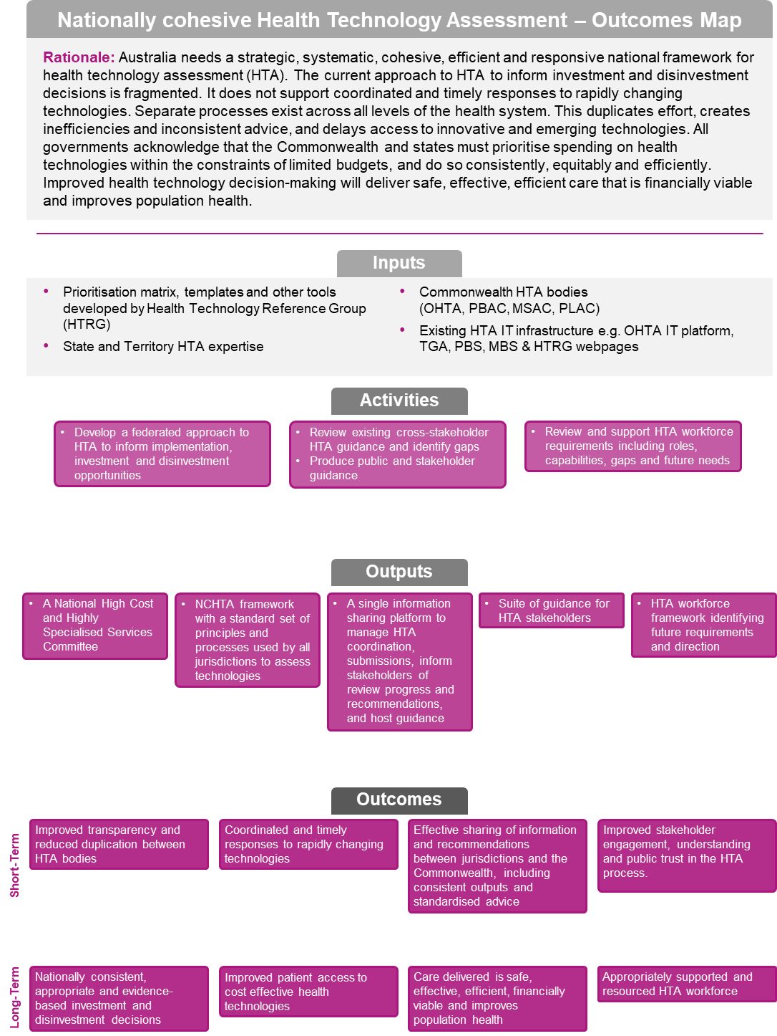

Reform stream | Paying for value and outcomes
Vision | The health financing system is proactive, responsive, supportive of contemporary models of care, value-based and focused on individual and community needs. Future funding models will give providers the flexibility to provide care in the right place, at the right time, by the right workforce.
Aim | State, territory and Commonwealth funding will support value and reduce duplication and fragmentation of health services, which is caused in part by multiple funding sources and programs. Providers will be rewarded for coordinating and delivering care pathways that have the best outcomes for patients in the most efficient way. A stronger focus on preventive health, early intervention, and care that is integrated across a treatment journey will lead to improved quality of care and the health outcomes that matter most to patients.
Case for change | The Commonwealth, states and territories recognise current health funding models do not adequately support and incentivise improvements in clinical care to address current and future population health challenges. The system does not provide the necessary funding flexibility and governance arrangements to address these challenges – such as managing chronic disease and an ageing population – or the responsiveness to support changing models of care. Under this reform, trials of funding and payment reform options will test how innovative funding models can best support contemporary care that leads to better patient outcomes and support.
Links to other reforms | To fully realise its benefits, this reform is critically interdependent with other long-term health reforms, in particular the Joint planning and funding at a local level reform.  The Enhanced health data reform will develop supporting data collections and overarching governance arrangements, including a primary and community care national minimum data set and patient reported outcome and experience measures. This will leverage evidence from the Atlas of Healthcare Variation, the National Clinical Quality Registry and Virtual Registry Strategy 2020-2030 and state-based programs.  This reform will build on earlier work by the Independent Hospital Pricing Authority (IHPA) on bundled payments for specific conditions and cohorts. It will consider trials currently underway which relate to integrated care in out-of-hospital settings, pooled Commonwealth and state/territory funds, and bundled payments across a pathway of care.
Intended outcomes | During the term of this Addendum, all parties will strive to achieve:  - core principles for consistent outcome-focused, value-based health care measures across the health system  - increased flexibility in national funding arrangements which supports more effective and efficient resource allocation and focuses on the outcomes that matter to patients  - increased number of trials of innovative, flexible funding models across Australia (at state and federal level)  - robust evaluations of trials and systematic sharing of the evidence  - increased number of successful contemporary care models scaled up, systematised and funded recurrently to ensure benefits are realised and ongoing  - improved patient-reported health outcomes and care experiences, and health care provider experiences  - a reduction in inefficient health care practices (e.g. avoidable hospitalisations) and improved sustainability of health care funding
Key concepts | ‘Value’ is achieving the health outcomes that matter most to patients, relative to the cost of delivering those outcomes. Value encompasses and integrates many goals already sought in the delivery of health care, such as health outcomes, quality, safety, patient-centred care, efficiency in terms of cost and eliminating low value practices, and clinical process improvements. Cost is considered in terms of the full cost incurred across the course of care for a patient’s condition.  ‘Outcomes’ are the results people care about most when seeking treatment, including functional improvement and the ability to live fulfilling and productive lives. This should cover all services or activities required to successfully meet a patient’s health care needs. The outcomes that matter to patients are broad, multi-faceted and cannot be measured by a single, all-encompassing clinical or personal indicator (e.g. self-assessed quality of life, trust, comfort). Comprehensive health outcome and cost data is required to support measurement, including Patient Reported Measures (PRMs).  The ‘Quadruple Aim’ in health care has four goals: improved health outcomes, improved patient experiences, improved provider experiences, and improved effectiveness and efficiency.
COVID-19 related  developments | In response to the COVID-19 pandemic, many jurisdictions expanded their use of flexibly funded models of care, such as Hospital in the Home, and innovative models of care, such as virtual care and secondary triage for residential aged care facilities, which were supported by the expanded application of MBS telehealth items. This reform will also consider the potential benefits and risks of embedding such initiatives in standard care.  The COVID-19 National Partnership Agreement is supporting a collaborative, cross-sectoral approach to implementing responses to COVID-19 within jurisdictions.

Key components
National health reform agreement commitments | NHRA clause | Deliverable | Timeframes
 |  |  | 21-22 | 22-23 | 23-24 | 24-25
Identify and support removal of legislative, regulatory and technical barriers to implementing innovative funding and payment approaches | C.21.b | Action plan
Develop a funding methodology that incorporates flexible funding options within the public hospital funding model that support innovative models of care | A.101.a | Endorsed methodology
Develop a national health funding and payments framework | C.21.a | Framework
Trial funding and payment reforms at a program level and progress system level changes | C.21.c | Bilateral and multilateral trials
Implement a common approach to evaluation of trials and knowledge sharing to inform further decisions about scaling of trials and future reform directions. | C21.d | Evaluation reports

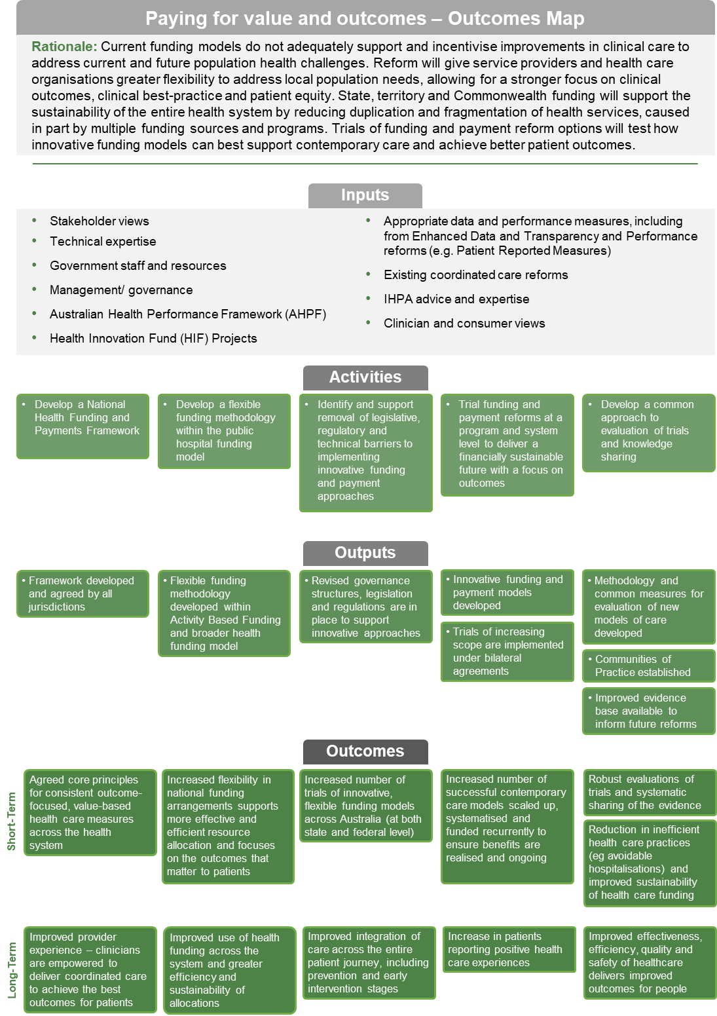
Reform stream | Joint planning and funding at the local level
Vision | Better-integrated, patient-centred care will improve people’s experiences and health outcomes and support equitable access to care. Integrated planning and funding of health services at a local level will support providers to plan, resource, work together, and coordinate care for patients across their treatment journey.
Aim | Local planning and service commissioning is driven by collaboration, integration and better investment decisions across care settings based on population and patient needs, with clear and shared accountability for outcomes and quality. Innovative governance models will increase flexibility and support providers to deliver value-based care according to the Quadruple Aim in health care - improved health outcomes, improved patient experience, improved provider experience, and improved effectiveness and efficiency.
Case for change | The current health system in Australia is fragmented, making it difficult for people to get  well-coordinated care and leading to poorer health outcomes. The system is not well-placed to meet the needs of people with chronic or complex health and social care needs, and older, frailer people who often use a wide range of health services. Poor coordination between providers can cause confusion and duplication and make services hard to navigate.  Despite best efforts, providers often work in isolation rather than together. Investment decisions are far removed from service delivery and there is potential for blame and cost shifting between service providers, commissioners, health sectors and levels of government.  The Commonwealth, states and territories recognise there is a need for greater collaboration across care settings, support for clinicians to adopt new practices, and a joint commitment across all agencies and governments to ensure better planning and co-ordination of health services at the local level. This reform complements the Paying for value and outcomes reform, which supports more flexible funding arrangements.
Links to other reforms | This reform is critically interdependent with other long-term health reforms, particularly the Paying for value and outcomes reform, which will deliver system-level payment reforms to create a supportive environment to trial effective commissioning arrangements.  The Enhanced health data reform will develop new and improved data sets (including primary and community health) and enhance linkage capabilities to support integration and local commissioning.  This reform offers a mechanism to address the findings in the Productivity Commission’s report on Innovations in Care for Chronic Health Conditions (2021), and the recommendations and outcomes of the Royal Commission into Aged Care Quality and Safety (2021) and the Royal Commission into Violence, Abuse, Neglect and Exploitation of People with Disability (2023). It will leverage COVID-19 responses, existing jurisdiction initiatives and align with Commonwealth reforms to primary care.
Intended outcomes | During the term of this Addendum, all parties will strive to achieve:  - national principles for local level commissioning to support an increase in effective collaboration between primary, community and acute health care organisations  - increased number of sustainable joint planning and funding initiatives to deliver improved experiences for patients and better health outcomes at the local level  - increase in patients reporting positive health care experiences, using appropriate care settings and accessing integrated care pathways  - increase in provider satisfaction and engagement, and increased participation in training to improve commissioning capability  - trials that demonstrate reduction in service duplication and improved efficiency
Key concepts | ‘Joint planning’ involves various organisations collaborating to assess needs, for geographic regions and for specific populations, make decisions on what health services and health literacy and prevention measures are provided, and share accountability for outcomes.  ‘Joint funding’ involves using existing and new funding to support integrated care pathways, including pooled models where various funding sources may be combined.  ‘Commissioning’ is a continual cycle to develop and implement services based on needs assessment, planning, co-design, funding, monitoring and evaluation.
COVID-19 related  developments | This reform may build on relevant COVID developments including the Aboriginal and Torres Strait Islander Advisory Group on COVID-19, co-chaired by NACCHO and Commonwealth Health with all states involved, and local level PHN activities (e.g. emergency responses in Victoria and NSW).

Key components
National health reform agreement commitments | NHRA clause | Deliverable | Timeframes
 |  |  | 21-22 | 22-23 | 23-24 | 24-25
Identify and support reform of barriers to joint governance, needs assessment, service integration, evaluation and funding, at a national, state and territory level | C28.b | Action plan
Agree national principles for commissioning at the local level | C28.a | National principles
Trial, evaluate, refine and scale up joint planning and funding arrangements | C28.c | Bilateral and multilateral trials
Address workforce matters, including capability gaps for health services commissioning | C28.d | Action plan
Explore innovative workforce models and potential new roles for care coordination | C28.d | Defined models and roles
Develop outcome measures, reporting and accountability arrangements shared between local organisations | C28.e | New measures

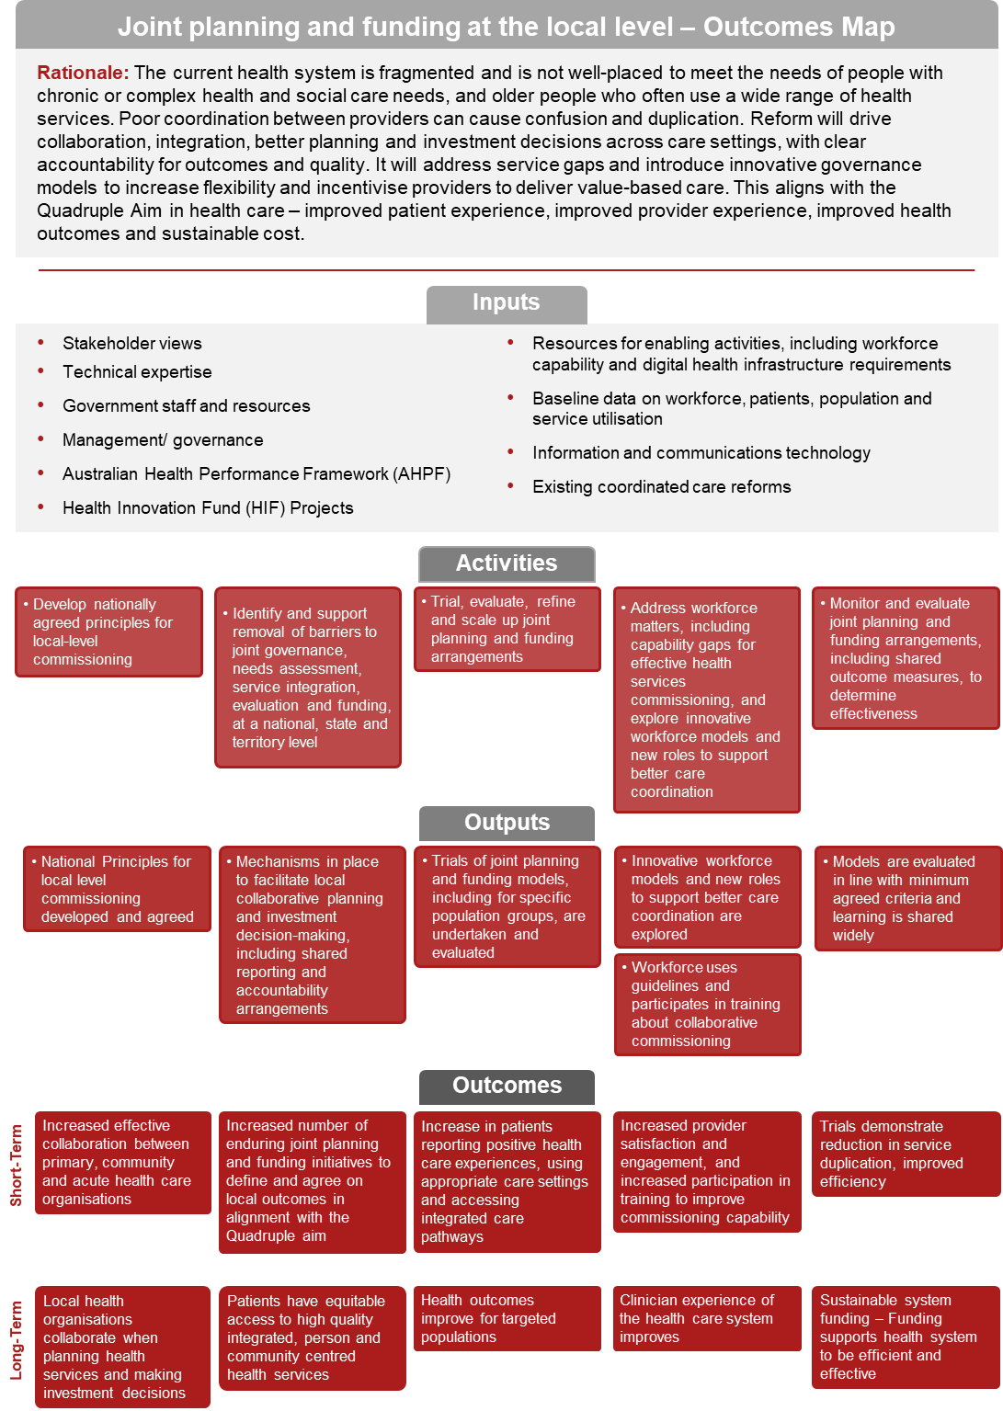
Reform stream | Empowering people through health literacy
Vision | Australians will be empowered to manage their own health, avoid illness, make informed health choices, engage effectively with health services, and achieve better health outcomes.
Aim | Service providers and policy makers will better support people’s health literacy needs, including through strategic leadership for the health sector. The whole health system will be more responsive to individuals’ health literacy needs, delivering person-centred health information, support and services to all Australians.
Case for change | The Commonwealth, states and territories recognise all Australians have a right to safe, high quality care. This is enhanced when people are informed about services, treatment options and costs in a clear and open way and are active participants in decisions and choices about their care. Health literacy is crucial to effective self-care. People with poor health literacy are less able to understand the consequences of poor health, take action to prevent or manage disease, navigate the health system or participate in their own health care decision-making. Poor health literacy can lead to higher rates of overweight and obesity, chronic conditions, hospitalisation, emergency care and adverse outcomes and disproportionately affects people from disadvantaged backgrounds.
Links to other reforms | The Enhanced health data reform will develop quality information for consumers on health system performance, including the development and implementation of Patient Reported Measures.  This reform will support Closing the Gap in disadvantage for Aboriginal and Torres Strait Islander people, and other vulnerable groups.  Work to align government-funded information resources and digital platforms will align with My Health Record and Healthdirect initiatives.
Intended outcomes | During the term of this Addendum, all parties will strive to:  - embed health literacy standards and requirements into health care training and qualifications  - increase innovation and cooperation on health literacy initiatives between governments, the health workforce, researchers, and the community  - ensure people can easily access reliable, user-friendly, culturally and linguistically appropriate information and support  - support patients and families to partner with their health care teams to make joint decisions about care options  - promote the use of Patient Reported Measures to understand what patients value and improve patient experiences and outcomes
Key concepts | The Empowering people through health literacy reform is focused on creating a health system that promotes health literacy, including cultural change at the organisational and individual levels.  It will take a universal approach to promoting health literacy responsiveness by recognising everyone benefits from clear, understandable, motivational (including non-stigmatising) and actionable information and that health workers are not expected to identify who has low levels  of health literacy.
COVID-19 related  developments | Relevant COVID developments include improved communications campaigns and the increased profile of government information resources and advice services, particularly in quality language materials and accessible formats.

Key components
National health reform agreement commitments | NHRA clause | Deliverable | Timeframes
 |  |  | 21-22 | 22-23 | 23-24 | 24-25
Better align government-funded information resources and digital platforms, ensuring they are culturally and linguistically appropriate, accessible, credible and evidence-based | C.33 | Reviewed health digital platforms and information resources
Systematically measure patient reported health outcomes and care experiences | C.32 | Patient reported measures framework (linked to Enhanced health data)
Build workforce capability to meet health literacy needs | C.32 | Workforce engagement strategy
Make information on the performance of the health system and services more accessible | C.33 | Accessible performance data
Share evidence of the effectiveness of health literacy initiatives across governments, the health workforce, researchers and the community | C.34 | Information sharing strategies and mechanisms utilised/developed

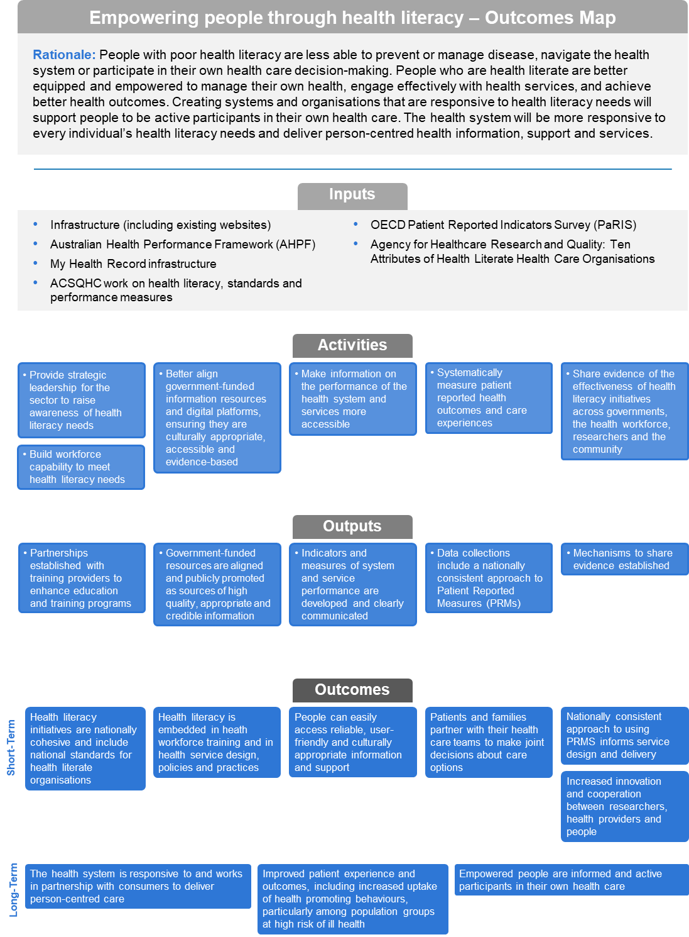

Reform stream | Prevention and wellbeing
Vision | Australians will live healthier lives. This reform will promote and maintain good physical and mental health and wellbeing and reduce the proportion of people living with preventable chronic conditions and delay the onset of these conditions. It will address the underlying drivers of preventable ill health – including social, economic and environmental factors – and will focus on those with greatest need. This reform will make our health system more equitable and more sustainable.
Aim | Primary prevention investment will be increased and invested in scalable, high-value,  evidence-based innovations so Australia’s health system can promote good health and wellbeing and better address preventable chronic disease.
Case for change | Australia is a world leader in many areas of prevention, such as reducing levels of smoking, but despite ongoing action in other areas like tackling obesity, rates of chronic disease have not reduced.  Almost 40 per cent of the total burden of disease could be prevented by reducing exposure to the top five risk factors – tobacco use, overweight and obesity, dietary risks, high blood pressure and high blood sugar. And approximately 40 per cent of preventable hospitalisations are due to chronic disease, placing a significant burden on the health system.  Funding for preventive health is low and varies across jurisdictions, with public health in Australia accounting for just 1.5 per cent of total health expenditure. There are ongoing difficulties in measuring impacts, outcomes, and returns on investment for preventive health activities. There are limited mechanisms to generate investment or support cross sector collaboration.  The Commonwealth, states and territories recognise that effective prevention requires  cross-portfolio action and engagement to complement existing activities. Through the NHRA, all governments have committed to increase investment in primary prevention over time in  evidence-based initiatives.
Links to other reforms | This reform will build on the National Strategic Framework on Chronic Conditions, as well as the full range of evidence-based primary prevention activities undertaken nationally and within jurisdictions. It will support the implementation of existing commitments in development – such as the National Obesity Strategy, the National Preventive Health Strategy and the National Mental Health and Suicide Prevention Agreement.
Intended outcomes | During the term of this Addendum, all parties will strive to achieve:  - a shared approach to the prevention of chronic conditions, their risk factors, and their underlying drivers  - removal of barriers and disincentives for prevention activities across the healthcare system to promote a better balance between prevention and treatment within the health system  - increased investment (by all sources) in prevention activities, and a sustainable national prevention funding mechanism with appropriate incentives  - a strengthened evidence base for primary prevention initiatives, including improved collection, linkage, analysis, access, use of prevention related data and evaluation of initiatives
Key concepts | The Commonwealth, states and territories will work together to explore innovative ways to finance evidence-based primary prevention activities, including through cross sector and non-government sources. This reform will lay the foundations for increased, sustained investment in preventing disease and promoting wellbeing, including addressing the wider determinants of health.  Cohort-specific and risk-based approaches to planning and prioritisation will be explored.  A national prevention and monitoring performance framework will include outcomes measures and indicators to show progress. It will develop targets and outcomes specifically relating to the health and wellbeing of Aboriginal and Torres Strait Islander populations. It will also develop a consistent way to measure the cost-effectiveness of prevention investment.
COVID-19 related  developments | Key risk factors for illness and fatalities from COVID-19 included obesity and chronic disease, highlighting the risk to our population and the urgent need for action on non-communicable disease.  The COVID-19 response included a number of preventive approaches, including: pro-active outreach programs to support people at high risk for COVID-19, including people with disabilities; mental health and wellbeing support programs; increased support for infectious disease emergency response research; and increased telephone and online access to support and information.  This reform will explore the potential benefits and risks of embedding initiatives such as these  in ongoing programs.

Key components
National health reform agreement commitments | NHRA clause | Deliverable | Timeframes
 |  |  | 21-22 | 22-23 | 23-24 | 24-25
Review health system barriers to prevention | C.40.e | Action plan
Agree a national monitoring and reporting framework, including outcomes and progress measures to inform priorities for prevention investment | C.40.a | Framework
Develop innovative fit-for-purpose financing mechanisms for scaling primary prevention initiatives | C.40.c  C.40.b | Bilateral trials
Explore evidence-based regulatory prevention measures | C.40.d | Recommendations

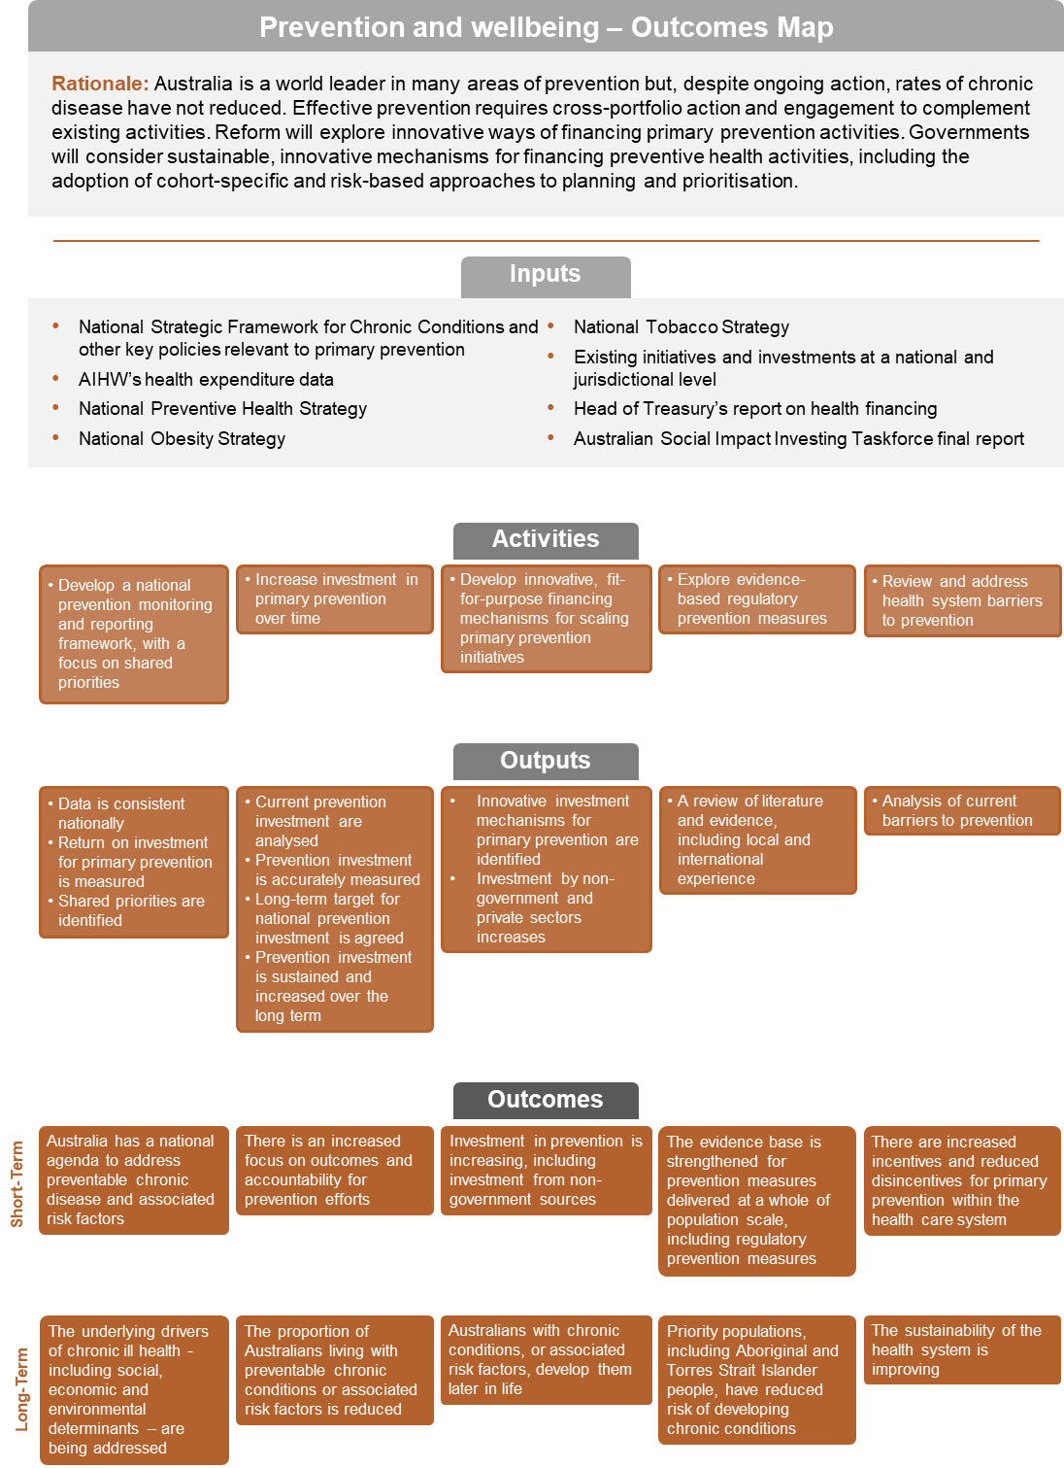
Reform stream | Enhanced health data
Vision | Integrated data supports better decisions which improve health outcomes and save lives. Governments, clinicians, consumers and researchers will be able to access and link richer sources of information to help deliver better care which is more targeted, person-centred and value-based.
Aim | This reform aims to ensure the data generated by Australia’s health system drives better health outcomes and delivers effective, safe and efficient health care for all Australians.
Case for change | Australia’s data resources represent substantial investments, but there are technical and other barriers which limit realisation of the full benefits of this resource.  The Commonwealth, states and territories recognise that integrating data across patient journeys by using various health data sets will support better planning and decision-making by governments, health services, clinicians, consumers, researchers and communities. Data linked at the  person-level helps policymakers and program designers provide more consumer-focused care to drive system improvements and break down siloes. Robust health data is also essential to understanding the wider determinants of health and wellbeing.
Links to other reforms | The Enhanced health data reform is key to fully realise other long-term health reforms, including Paying for value and outcomes, Joint planning and funding at a local level, Interfaces between health, disability and aged care systems, and support trials of innovative models of care under the Addendum Schedule A.  Initiatives developed under this reform will be mindful of the need for better data to accurately measure outcomes for Aboriginal and Torres Strait Islander peoples and progress toward Closing the Gap.
Intended outcomes | During the term of this Addendum, all parties will strive to:  - establish a national standard and risk-based approach to govern the creation, access and sharing of data across all Australian governments  - remove legislative and regulatory barriers to health data linkage, access and use, while maintaining appropriate privacy standards  - increase access to regularly updated linked data, including multilateral linked data, across health care settings and patient journeys  - increase use of best practice health data and analytics, including linked data and patient reported measures, to better understand health service use and inform planning and service delivery  - increase health workforce capability to use health data and analytics effectively  - ensure appropriate data is captured and used meaningfully to support other NHRA reform activities
Key concepts | The Parties are committed to achieving comprehensive health data access, usage and sharing, while at the same time maintaining data security and preserving individuals’ privacy.
COVID-19 related  developments | This reform may be able to leverage COVID-19 responses to support rapid data collection for  up-to-date monitoring and response, including the Australian Data and Digital Council (ADDC) Data Sharing to Support COVID-19 Recovery, the Critical Health Resource Information System (CHRIS), and changes to legislation during the pandemic to allow data sharing between agencies.

Key components
National health reform agreement commitments | NHRA clause | Deliverable | Timeframes
 |  |  | 21-22 | 22-23 | 23-24 | 24-25
Review data linkage and privacy legislation and regulations across Australia | C.46.f | Report
Share information about current data systems, processes and guidelines to help inform solutions for data sharing | C.47.a
Pilot projects for local implementation and feedback to all participants | C.47.b
Scale up a national approach to data governance arrangements, structures and processes | C.46.a | Approach document and implementation plan | Dependent on C.46.f
Develop a risk-based framework and standards for collection, sharing, and security of data | C.46.d | Framework and standards
Establish Commonwealth-state patient-level primary and community health care datasets | C.46.b | Datasets
Develop and implement a consistent approach to the collection and use of Patient Reported Measures | C.46.e | Approach document and implementation plan
Develop a health data workforce capability framework to define roles and standards, and identify necessary skills and capabilities | C.46.c | Framework and implementation plan

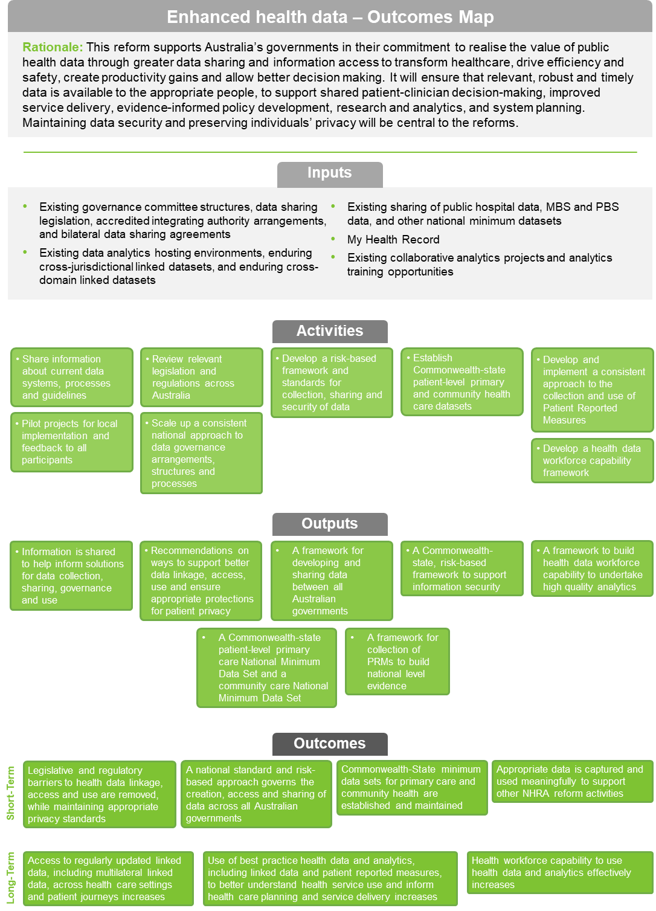
Reform stream | Interfaces between health, disability and aged care systems
Vision | Better coordination between the health, primary care, aged care and disability systems will  ensure people can access the services they need, when they need them and improve care outcomes for people.
Aim | People’s experiences of transferring and navigating between health and social service systems will be timely, well-coordinated and streamlined, particularly for people with complex and chronic conditions and disabilities.
Case for change | The care needs of many Australians are becoming increasingly complex. Many people access multiple services across the health, primary care, disability and aged care systems. The Commonwealth, states and territories recognise they have a shared responsibility to better coordinate their services, particularly for people with chronic conditions and disability.
Links to other reforms | This reform supports the success of other NHRA long-term reforms, aligning with and expanding data projects underway by jurisdictions and the Commonwealth.
Intended Outcomes | During the term of this Addendum, all parties will strive to:  resolve interface issues quickly, consistently and sustainably  identify and address service gaps within agreed timeframes  ensure better coordination between the health, primary care, disability and aged care systems with improved consumer access and care outcomes  provide better access to the clinical and social care older people and people with disability need from the appropriate system at the appropriate time  make it easier for consumers, carers and their families to navigate the health, primary care, aged care and disability support systems to receive optimal care and support  reduce avoidable hospital presentations, time spent in hospital and discharge delays
Key concepts | The parties are committed to reducing barriers, inefficiencies and issues that impact patients who use both health and social service systems. The parties will address legislative, funding and policy issues that impede interface performance.
COVID-19 related  developments | This reform will build on COVID developments, including: National Disability Insurance Agency/state data sharing Memorandums of Understanding; continuing telehealth services;  in-reach support services, accessible communications and improved engagement and collaboration with disability and aged care sectors.

Key components
National health reform agreement commitments | NHRA clause | Deliverable | Timeframes
 |  |  | 21-22 | 22-23 | 23-24 | 24-25
Establish health, primary care, aged care and disability interface performance indicators and associated data collection and reporting | F.12 | New indicators and data collection
Monitor and analyse interface performance and effectiveness of system and interface improvement strategies | F.13.e | Framework and regular reporting
Monitor, report on and address services gaps and the effect of policy or service changes across systems | F.13.a-d | Regular reporting  Action plan
Clarify joint governance arrangements for monitoring and resolving issues between health, aged care and disability systems | F.14 | Paper
Explore the impact of housing security, provision and assistance on people’s health outcomes | F.15 | Report
Work towards consistent application/interpretation of data across systems to assist understanding of linkages between data sets, establish sharing practices, explore viability of disability identifier in health data | F.16.c | Framework and regular reporting
Improve data sharing for serious incident/missed care across systems to provide early warning flags for  all regulators | F.16.d | Framework and regular reporting
Work towards sustainability and improved coordination of health, primary health, aged care and disability services particularly in regional, rural and remote communities | F.16.e | Regular reporting

Appendix A - Governance
