Better and Fairer Schools Agreement – Full and Fair Funding 2025-2034

Table of Contents
PRELIMINARIES 3
PART 1 – PARTIES, OPERATION, ROLES AND RESPONSIBILITIES 6
Parties 6
Term 6
Variations 6
Withdrawal of Parties 7
Dispute resolution 7
Progress reviews 7
Shared responsibilities of the Commonwealth and the states and territories 8
Responsibilities of the Commonwealth 8
Responsibilities of the states and territories 10
Aboriginal and Torres Strait Islander Peoples 11
Responsibilities of the non-government school sector 11
Enforceability 12
PART 2 – PURPOSE, OBJECTIVES, OUTCOMES AND IMPROVEMENT MEASURES 13
Purpose 13
Objectives 13
Outcomes 14
Improvement Measures 14
PART 3 – FUNDING ARRANGEMENTS 18
PART 4 – NATIONAL REFORMS 19
National Reform Directions 19
National Enabling Initiatives 21
PART 5 – REPORTING AND PUBLIC TRANSPARENCY 23
National and state and territory reporting 23
Non-government school sector reporting 24
PART 6 – SIGNATURES 25
PART 7 – SCHEDULES 33

Better and Fairer Schools Agreement – Full and Fair Funding 2025-2034

PRELIMINARIES
- The Parties acknowledge the Traditional Owners of the lands and waters on which Australians live, learn and work, and pay respects to their Elders past, present and emerging.
- Aboriginal and Torres Strait Islander cultures and knowledge are fundamental to shaping and improving education systems and outcomes for Aboriginal and Torres Strait Islander children and students. The Parties to this Better and Fairer Schools Agreement – Full and Fair Funding 2025-2034 (Agreement) will encourage and support self-determination of Aboriginal and Torres Strait Islander peoples and communities, to significantly improve Aboriginal and Torres Strait Islander education.
- All Parties have committed to working in genuine partnership with Aboriginal and Torres Strait Islander stakeholders as part of the National Agreement on Closing the Gap (Closing the Gap Agreement). The Parties express their thanks to the National Aboriginal and Torres Strait Islander Education Corporation (NATSIEC) and the Coalition of Peaks for their significant engagement and work in partnership on the development of this Agreement. Working in partnership will lead to a better and fairer education system, including for Aboriginal and Torres Strait Islander students.
- The Parties acknowledge the contribution of Aboriginal and Torres Strait Islander peoples and ways of learning to Australia’s education system. The Parties commit to supporting the education of Aboriginal and Torres Strait Islander students, and to work in partnership with Aboriginal and Torres Strait Islander peoples to design and deliver reforms to increase education equity for Aboriginal and Torres Strait Islander students.
- Australia has a strong education system, but it can be better and fairer. To do that, governments and school systems, in partnership with families, will support every student to succeed so that no one is held back or left behind.
- All Australian governments have agreed to uphold the vision for Australian schooling outlined in the Alice Springs (Mparntwe) Education Declaration (the Mparntwe Education Declaration) for a world class education system that encourages and supports every student to be the very best they can be, no matter where they live or what kind of learning challenges they may face.
- Specifically, this Agreement will support the Mparntwe Education Declaration’s 2 interrelated goals - that the Australian education system promotes excellence and equity and that all young Australians become confident and creative individuals, successful lifelong learners, and active and informed members of the community. An equitable system also needs to build on and include local, regional and national cultural knowledge of Aboriginal and Torres Strait Islander peoples.
- All Parties recognise teachers, educators, support staff and school leaders are vital to achieving these education goals for young Australians. All Parties commit to working together to foster high-quality teaching and leadership, including through developing well-prepared pre-service teachers, and building a diverse educator workforce that is reflective of the contemporary Australian population.
- A high-quality, equitable and inclusive school education system has the power to transform lives and support young people to realise their full potential by providing the skills they need to participate in society and the economy.
- The Parties acknowledge that learning is a partnership with parents, carers and others in the community, all of whom have a role to play in nurturing students’ success at school and in life.
- The Parties also recognise the importance of agency in empowering students to be active and engaged in their learning.
- The Parties also affirm their continued commitment to the implementation of Australia’s Disability Strategy 2021-31.
- This Agreement sets out the shared intention of the Parties to work in partnership to improve education outcomes for all Australian students and build on the capability and capacity of the education workforce. The Bilateral Agreements between the Commonwealth and individual state and territory governments set out the specific intentions for the relevant state or territory and the Commonwealth, building on the shared intention in this Agreement, and the strategies and initiatives that will be pursued to deliver them.
- This Agreement operates in the context of, and gives effect to, requirements under the Australian Education Act 2013 (the Act). The Act sets out conditions on states and territories for grants of financial assistance based on the Schooling Resource Standard (SRS). The SRS is made up of a base funding amount for every student plus additional loadings for schools and students with greater needs. This Agreement and its schedules satisfy the requirements of paragraphs 22(2)(a) and (b) of the Act.
- The Parties recognise that the constitutional responsibility for school education lies with states and territories. States and territories have in place their own regulatory frameworks, local policies and priorities intended to maximise students’ educational outcomes. Non-government approved authorities and approved system authorities have their own policies and priorities intended to maximise students’ educational outcomes.
- Subsection 78(3) of the Act requires approved system authorities to distribute all Australian Government recurrent funding in accordance with a needs-based funding arrangement that is compliant with subsection 78(5) of the Act. This approach recognises that approved system authorities are best placed to understand the individual needs of their schools and students.
- The Parties acknowledge the significant ongoing reform, investment and effort already underway or occurring outside this Agreement, both at a national level and in individual states and territories and systems. This includes substantial work being undertaken by all governments and schooling sectors through the response to Strong Beginnings: Report of the Teacher Education Expert Panel and the National Teacher Workforce Action Plan.
- This Agreement and all schedules to this Agreement are not intended to limit the operation of the Act and the Australian Education Regulations 2023 (the Regulations), including decisions made under that legislation.
- This Agreement replaces the Better and Fairer Schools Agreement 2025-2034 and the Interim School Funding Agreement 2025. All Parties acknowledge the Act may be amended to reflect the changes required as a result of this Agreement and its schedules.
- Reflecting the long-standing practice of collaboration between all Australian governments to deliver school education reform, the Education Ministers Meeting is responsible for overseeing the implementation of this Agreement.
- The Parties recognise the important role of the non-government school sector in school education, including non-government approved authorities, approved system authorities and non-government representative bodies, and commit to working with the non-government school sector to implement this Agreement.

PART 1 – PARTIES, OPERATION, ROLES AND RESPONSIBILITIES

Parties
- The Parties to this Agreement (the Parties) are:
  - the Commonwealth of Australia (the Commonwealth)
  - the states and territories, being:
    - the State of New South Wales
    - the State of Victoria
    - the State of Queensland
    - the State of Western Australia
    - the State of South Australia
    - the State of Tasmania
    - the Australian Capital Territory
    - the Northern Territory
- A state or territory that is a Party to this Agreement is taken to have terminated its participation in the Better and Fairer Schools Agreement 2025-2034 or the Interim School Funding Agreement 2025 as of the date that it became a Party to this Agreement.

Term
- This Agreement and any schedules (except Schedule D) will commence from the date of signature of the first Party at clause 22(b) and expire on 31 December 2034.
- The Bilateral Agreements between the Commonwealth and a state or territory (which will be included at Schedule D) will commence from the date of signature of the first Party at clause 22(b) to this Agreement and expire on 31 December 2034, unless otherwise agreed.

Variations
- In accordance with the Council on Federal Financial Relations’ processes for oversight of federal financial arrangements, this Agreement may be varied or extended at any time with the agreement in writing of the Education Ministers of all the Parties, or by First Ministers where appropriate.
- Unless otherwise specified, the schedules to this Agreement (except Schedule D) may be varied or revoked, and new schedules may be added, at any time with the agreement of the Education Ministers of all Parties. Any new schedules will be developed and included with the agreement of the Education Ministers of all Parties.
- Bilateral Agreements between the Commonwealth and a state or territory (included at Schedule D) may be varied, or added to Schedule D, with the written agreement of the Education Ministers of the Commonwealth and the state or territory to which the Bilateral Agreement relates.
- Where variations materially impact the non-government school sector, the relevant Parties agree to consult with relevant non-government representative bodies on proposed variations on a national or state level, as appropriate.

Withdrawal of Parties
- A Party to this Agreement may terminate its participation in this Agreement at any time by notifying all the other Parties in writing. If a Party intends to withdraw, it should provide as much notice as possible before withdrawing and a minimum of 3 months.

Dispute resolution
- Any Party may give notice to the other Parties of a dispute under this Agreement or any schedule to this Agreement, except Schedule D.
- Officials of relevant Parties will attempt to resolve any dispute under this Agreement in the first instance. If a dispute cannot be resolved by officials, it may be escalated to the relevant Education Ministers and, if necessary, to the Education Ministers Meeting. If a dispute cannot be resolved by the relevant Education Ministers, it may be referred to the relevant First Ministers and, if necessary, to the Council on Federal Financial Relations or National Cabinet for consideration.
- In the case of a dispute related to a Bilateral Agreement between the Commonwealth and a state or territory, officials of relevant Parties will attempt to resolve any dispute relating to the Bilateral Agreement in the first instance. If a dispute cannot be resolved by officials, it may be escalated to the relevant Education Ministers and, if necessary, to relevant First Ministers or the relevant Council on Federal Financial Relations Ministers.
- A dispute does not, of itself, constitute failure to implement this Agreement.

Progress reviews
- The Commonwealth will commission an independent progress review of this Agreement, excluding implementation of National Reform Directions set out in Bilateral Agreements at Schedule D, on behalf of Education Ministers, with the reviewer(s) and the terms of reference to be agreed by Education Ministers. The reviewer(s) will provide its final report to all Ministers no later than 31 December 2028. Following consideration of the progress review, updates or modifications could be made to this Agreement, including Schedule D, in accordance with the processes at clauses 26 to 29.
- The Commonwealth will commission a second independent review of this Agreement, excluding implementation of National Reform Directions set out in Bilateral Agreements at Schedule D, on behalf of Education Ministers, with reviewer(s) and the terms of reference to be agreed by Education Ministers. The reviewer(s) will provide its final report to all Ministers no later than 31 December 2033. The review will inform the next national agreement.
- The reviews at clauses 35 and 36 will consider the impact and effectiveness of the National Reform Directions and National Enabling Initiatives in achieving the overall objectives and outcomes of this Agreement. The reviews will take into consideration the levels of school funding investment across systems and sectors when assessing impact and effectiveness. The reviews will not include any assessment of compliance with sections 22A and 78 of the Act, which have discrete review provisions under section 128 of the Act.
- The reviews at clauses 35 and 36 will have regard to the specific scope of this Agreement, which is supplementary to efforts by Parties that occur outside of this Agreement.
- The reviews at clauses 35 and 36 will be conducted in consultation with Aboriginal and Torres Strait Islander peoples, organisations and communities, including NATSIEC and the Coalition of Peaks.

Shared responsibilities of the Commonwealth and the states and territories
- The Commonwealth and the states and territories commit to:
- continue to work together through the Education Ministers Meeting, recognising their complementary roles in the federation
- commission the national education agencies and bodies to support the delivery of work consistent with the Objectives and Outcomes articulated in this Agreement and the priority of Education Ministers, noting that states and territories will not be held accountable for a failure of a national agency to deliver agreed actions
- establish and maintain formal partnerships with Aboriginal and Torres Strait Islander peoples, organisations and communities, consistent with the Parties’ Closing the Gap Agreement Implementation Plans
- work collaboratively with education stakeholders in the development and implementation of national reforms, including in partnership with Aboriginal and Torres Strait Islander representative organisations, consistent with the intent of the Closing the Gap Agreement and with the non-government sector
- work together to improve the quality and timeliness of the data that supports the achievement of the Outcomes and Objectives of this Agreement
- share best practice and school improvement strategies, including evaluations of programs, where appropriate, to support school and school system improvement
- provide public leadership by promoting the excellent work of teachers and school leaders, the value of their contribution to society and the critical role they play in realising the national school reform agenda and improving outcomes for Australia’s children and young people.
- The Parties acknowledge there are a range of factors and services outside the scope of this Agreement and education settings more generally that may impact a student and their learning. The Parties recognise that reform processes in other portfolios may impact the education system and have the potential to influence student outcomes in education settings, including progress and achievement of Improvement Measures.

Responsibilities of the Commonwealth
- The Commonwealth will:
- maintain and administer the Act and associated legislative instruments
- consult, collaborate and seek agreement from the Education Ministers Meeting, as the key body for making decisions and in recognition of the significant impact of changed Commonwealth funding arrangements on state and territory investment, about:
    - amendments to the Act, Regulations and policy guidelines that underpin the operation of the Regulations and Act
    - terms of reference for reviews by the National School Resourcing Board (the Board) established under section 128 of the Act
    - any changes that impact the operation and calculation methodology of the SRS
- provide assistance as required to support the operation of the Board
- provide timely access to Commonwealth funding and SRS data to assist states and territories to meet the requirements of section 22A of the Act, and consider what arrangements might provide for greater certainty for states and territories to support jurisdictional budget management, including consideration of the timing of SRS indexation rates
- develop a First Nations education policy in partnership with Aboriginal and Torres Strait Islander education stakeholders and state and territory governments
- work with states and territories to facilitate the non-government school sector to implement relevant aspects of this Agreement (see clause 57)
- monitor the non-government school sector’s compliance with the Act and the Regulations and support the achievement of the outcomes and objectives of the Agreement
- facilitate Australia’s international engagement on educational matters, including the international assessment programs of the Organisation for Economic Co-operation and Development
- lead and meet milestones of the National Enabling Initiatives for which the Commonwealth has primary responsibility, in collaboration with states and territories
- implement significant national initiatives, including those announced in the 2024-25 Budget such as the Commonwealth Prac Payment for teachers undertaking supervised mandatory placements and the establishment of a National Teacher Resource Hub.
- Where the Commonwealth proposes to take a compliance response in relation to a state or territory under the Act, the Commonwealth will ensure that the terms of that proposed response are provided to the state or territory concerned and the views of that state or territory are sought and taken into consideration prior to any final decision.
- In the event of a change to any of the following components of the SRS arising as a direct result of amendments to the Act or the Regulations that commence from 1 January 2024 until 31 December 2034, the Commonwealth will ensure a state or territory contribution amount as set out as a share of the SRS under section 22A of the Act, or in this Agreement or a Bilateral Agreement at Schedule D, will not be impacted by the following, unless otherwise agreed by the Education Minister of that state or territory:
- the SRS indexation factor (see section 11A of the Act)
- the SRS base and funding amounts (see section 33 and 34 of the Act)
- the Commonwealth’s and states and territories’ annual shares (see section 35A and 22A of the Act)
- the student with disability loading (see section 36 of the Act)
- the Aboriginal and Torres Strait Islander loading (see section 37 of the Act)
- the socio-educational disadvantage loading (see section 38 of the Act)
- the low English proficiency loading (see section 39 of the Act)
- the location loading (see sections 40 and 41 of the Act)
- the size loading (see sections 42 to 51 of the Act)
- the methodology for calculation of SES scores and capacity to contribute settings (see section 23 of the Regulation and section 54 of the Act).
- Parties note that in the operation of clause 44, the amended contribution share should be consistent with the expected value of the original contribution share agreed under the SRS settings as set out under section 22A of the Act, or in this Agreement or a Bilateral Agreement at Schedule D, that were in operation at the time that shares at Schedule D were agreed, unless otherwise agreed.
- Parties note that a state or territory would not exercise clauses 44 and 45 if a change to a component of the SRS was a result of the review of the SRS base and loadings and the change is agreed by the Education Minister of that state or territory.
- The Board provides independent oversight of Commonwealth school funding, including undertaking independent reviews under section 128 of the Act. Given the significance to all jurisdictions of the advice provided by the Board, the Board will consult with Education Ministers, in addition to requirements for consultation with the states and territories in undertaking each review.

Responsibilities of the states and territories
- States and territories are responsible for schooling in their state or territory, including the regulatory framework for all schools. States and territories are responsible for developing policy, delivering services, monitoring and reporting on performance and employment of school staff in the government school sector.
- In this context, states and territories will:
- deliver state-specific reforms against National Reform Directions and report as set out in their respective Bilateral Agreement
- work with the Commonwealth to facilitate the non-government school sector’s implementation of relevant aspects of this Agreement (see clause 57)
- engage with the non-government school sector to facilitate their implementation of relevant aspects of this Agreement (consistent with subsection 77(2A) of the Act), noting that states and territories will not be held accountable in the event that an approved authority does not meet its obligations under subsection 77(2A) of the Act
- provide financial and student data where appropriate from government systems to the relevant national education body as agreed by the Education Ministers Meeting
- distribute Commonwealth funding to schools according to state and territory needs-based funding arrangements as provided for under subsection 78(5) of the Act
- work together with the Commonwealth in the development and implementation of the National Enabling Initiatives.

Aboriginal and Torres Strait Islander Peoples
- Through the Closing the Gap Agreement, all Australian Governments and the Coalition of Peaks have agreed a fundamentally new way of developing and implementing policies and programs that impact the lives of Aboriginal and Torres Strait Islander people.
- This Agreement acknowledges the rich histories and continuing cultures of Australia's Aboriginal and Torres Strait Islander peoples and commits the Parties to work in genuine partnership with Aboriginal and Torres Strait Islander peoples, organisations and communities.
- The Parties commit to work in partnership with Aboriginal and Torres Strait Islander education stakeholders including NATSIEC and relevant state and territory Aboriginal and Torres Strait Islander representative bodies, consistent with the partnership agreement to be agreed by Education Ministers.
- The Parties also acknowledge the importance of data sovereignty and undertake that reporting of data under this Agreement should be shared with Aboriginal and Torres Strait Islander peoples, organisations and communities where appropriate, and align with the targets agreed under the Closing the Gap Agreement.
- Consistent with the Parties’ shared commitment under the Closing the Gap Agreement to increased transparency of funding allocations, approved system authorities and approved authorities will continue to prioritise funding towards supporting Aboriginal and Torres Strait Islander students through the operation and publication of needs-based funding arrangements consistent with the Act.
- Consistent with the Priority Reforms under the Closing the Gap Agreement, the Parties also undertake to support and develop the Community Controlled Sector to deliver culturally safe and appropriate services to support Aboriginal and Torres Strait Islander students and the education workforce.

Responsibilities of the non-government school sector
- The Act establishes ongoing requirements for all approved authorities. These include requirements to implement the Australian Curriculum, ensure schools participate in the National Assessment Program and provide information in accordance with the Regulations (under subsection 77(2) of the Act).
- Under subsection 77(2A) of the Act, non-government approved authorities are required to cooperate with their local state or territory government in the implementation of this Agreement, including the National Enabling Initiatives and the relevant Bilateral Agreement, which includes implementing the National Reforms.
- Reporting for the non-government school sector is outlined in Part 5 of this Agreement.

Enforceability
- The Parties do not intend any of the provisions of this Agreement to be legally enforceable; however, this does not lessen the Parties’ commitment to the Agreement.

PART 2 – PURPOSE, OBJECTIVES, OUTCOMES AND IMPROVEMENT MEASURES

Purpose
- The Parties commit to actions that will support full and fair funding for schools, build a world class education system for all students, and encourage and support every student to be the very best they can be, no matter where they live or what kind of learning challenges they face.
- To guide implementation and evaluation of the Agreement, the Parties agree to a set of Objectives, Outcomes and Improvement Measures against each of the 3 priority areas identified at clause 62. The Objectives articulate the broader goal for the education system; the Outcomes summarise the expected benefits that will be realised through the successful implementation of the reform agenda; and the Improvement Measures identify progress against outcomes.
- Education Ministers have agreed that the following 3 national priority areas form the basis for the Agreement, which are consistent with the goals of the Mparntwe Education Declaration:
- equity and excellence
- wellbeing for learning and engagement
- a strong and sustainable workforce.
- The Objectives and Outcomes of this Agreement are a shared responsibility of the Commonwealth, states and territories and the non-government school sector. In conjunction with the goals and visions of the Mparntwe Education Declaration, they articulate a shared aspiration for Australia’s education system.
- All Parties are responsible for working together to achieve the Objectives, Outcomes and Improvement Measures of this Agreement. While the Parties are collectively committed to this, Commonwealth funding to states and territories under the Act is not conditional on the achievement of these Objectives, Outcomes and Improvement Measures.

Objectives
- The Parties commit that, in pursuing the National Reforms at Part 4, they seek to deliver upon the following Objectives:
- Equity and excellence – schools and education systems are equipped to provide all students with highly effective evidence-based teaching and equitable learning opportunities and support them to maximise their learning.
- Wellbeing for learning and engagement – schools take a structured approach to wellbeing for learning in a way which reflects their school and learning environment, and students have a sense of belonging, safety and engagement with their learning.
- A strong and sustainable workforce – the workforce is respected and continues to grow, and teachers and non-teaching school staff are supported to innovate and be at their best to ensure young Australians thrive in their education. A sustainable workforce means that the Australian community recognises the value teachers and school leaders bring to students, communities and the economy.

Outcomes
- The Parties agree that the Agreement will contribute to the following Outcomes:
- Equity and excellence – all students are provided access to high-quality evidence-based teaching that is inclusive, where young Australians of all backgrounds and levels of need are supported to achieve their full educational potential.
- Wellbeing for learning and engagement – students are provided with appropriate support, experiences, teaching and resources to positively and confidently engage in learning.
- A strong and sustainable workforce – all staff are supported to innovate, consistent with evidence-based teaching, and be at their best to ensure young Australians thrive in their education. Teaching is valued and more Australians consider a career in education, and there is a high teacher retention rate.

Improvement Measures
- The Parties agree that national Improvement Measures, including national level targets, are essential to articulating the joint ambition of all Parties for the national education system, in line with the goals of the Mparntwe Education Declaration and the national priorities for reform.
- The Parties agree to focus on measures that, both individually and collectively, promote a greater understanding of how the joint effort of governments, school systems and approved authorities are leading to better outcomes for students and educators. Parties aim to contribute to these national targets through continuous (i.e. year-on-year) improvement.
- The Parties and non-government representative bodies will track progress against the Improvement Measures and report against these where the Commonwealth does not separately have access to the data, consistent with their reporting obligations (see Part 5).
- Where appropriate and relevant jurisdiction-specific targets exist, Bilateral Agreements may specify jurisdiction-specific targets which clarify how an individual state or territory will contribute to the national target within the unique context of that state or territory. Where a state or territory has negotiated a jurisdiction-specific target, this will be included in their Annual Implementation Report where the Commonwealth does not separately have access to the data. A state or territory’s data will be included in the measurement of the national target.
- Where a Bilateral Agreement does not specify a jurisdiction-specific target and where the Commonwealth does not separately have access to the data, the relevant state or territory will report its progress towards the national target in its Annual Implementation Report to the Commonwealth.
- Parties note that progress on Improvement Measures and targets may be impacted by the point at which Parties deliver full and fair funding for schools in their respective jurisdiction.
- For the purpose of this Agreement, priority equity cohorts are Aboriginal and Torres Strait Islander students, students living in regional, rural and remote locations, students with disability and students from educationally disadvantaged backgrounds.
- All Parties agree that Improvement Measures will be disaggregated by priority equity cohorts where data is available and where disaggregation does not materially reduce the reliability of the data or inappropriately identify individuals or schools. Where data is not available, Parties will look to make improvements over time to enable that to occur.
- The Parties agree that the Improvement Measures outlined below:
- supersede the education targets from the National School Reform Agreement 2019-2024
- build on but do not replace or supersede any targets from the Closing the Gap Agreement or any other active national agreements between states and territories and the Commonwealth during the life of the Agreement.
- Should National Cabinet endorse updated targets relevant to school education during the life of the Agreement, these may be adopted as part of the Agreement, subject to agreement by the Education Ministers Meeting.
Priority Area | Improvement Measure
Equity and excellence | Year 12 certification:  Recognising that finishing school education is key to ensuring students have the skills and confidence they need to become successful lifelong learners, confident and creative individuals and active and informed citizens, the Parties agree to the following improvement measure:  - By 2030, increase the proportion of students with Year 12 (or equivalent) certification by 7.5 percentage points, compared with 2022 results, nationally (for all students);  - and trend upwards compared with 2022, for the following priority equity cohorts (nationally):  - regional and remote locations including:  - outer regional; and  - remote and very remote (combined as per the National Report on Schooling in Australia and the Report on Government Services); and  - low socio-economic status (SES) backgrounds.  Note: Certification rates are estimated by calculating the number of students who meet the requirements of a Senior Secondary Certificate or equivalent expressed as a percentage of the potential Year 12 population. The potential Year 12 population is an estimate of a single year age group which could have attended Year 12 that year, calculated as the estimated resident population (ERP) aged 15 to 19 divided by 5.  Where statistically possible, we will seek to report annually on the number of Aboriginal and Torres Strait Islander students with a Year 12 (or equivalent) certification.  The Parties will seek to progressively develop a sub measure that captures the alternative pathways available to young people (including Vocational Education and Training (VET), traineeships and apprenticeships, at the Australian Qualifications Framework (AQF) Certificate III and above level) over the course of the Agreement.
Equity and excellence | Pathways for success:  Recognising that schools play an essential role in supporting students to complete both in-school senior secondary qualification and non-school VET qualifications, the Parties agree to the following improvement measure, which aligns with the ambition articulated in the Closing the Gap Agreement:  - By 2031, increase the proportion of people (age 20-24) attaining Year 12 or equivalent qualification to 96 per cent; and  - By 2031, increase the proportion of Aboriginal and Torres Strait Islander people (age 20-24) attaining Year 12 or equivalent qualification to 96 per cent.  Note: As per the Closing the Gap Agreement, Year 12 or equivalent refers to a school qualification of Year 12 or equivalent, or a non-school qualification at Certificate level III or above based on the AQF. This is a Closing the Gap target and will be updated to adopt any changes to the target in the Closing the Gap Agreement.  Education Ministers will support the efforts and work with Skills Ministers to achieve the outcomes for young people outlined in this improvement measure.
Learning equity:
To ensure that schooling delivers learning to all students, the Parties agree to the following improvement measure focused on increasing proficiency in the skills needed to engage across the curriculum and striving for success for priority equity cohorts:

- By 2030, in the National Assessment Program–Literacy and Numeracy (NAPLAN) Reading and Numeracy, of Years 3, 5, 7 and 9:
  - reduce the proportion of all students in the Needs Additional Support proficiency level by 10 per cent; and
  - increase the proportion of all students in the Strong and Exceeding proficiency levels by 10 per cent.
- and trend upwards in the proportion of priority equity cohort students (including, Aboriginal and Torres Strait Islanders, outer regional, remote and very remote, and parental education (Year 11 or below)) in the Strong and Exceeding proficiency levels.

Parties will monitor NAPLAN participation and exemption rates, to ensure these do not impact efforts to measure and improve proficiency levels of all students and for students from priority equity groups.
Wellbeing for learning and engagement | Student attendance:  Recognising that reform efforts to lift learning outcomes and improve wellbeing can be effective only if students are attending schools, the Parties agree to the following improvement measure:  - By 2030, increase the Student Attendance Rate, nationally (for all students), to 91.4% (2019 level):  - and return to 2019 levels for the following priority equity cohorts, nationally:  - Aboriginal and Torres Strait Islander students;  - students from regional and remote locations including:  - outer regional;  - remote;  - very remote; and  - students from low socio-educational advantage (SEA) schools*.  - By 2035, the Student Attendance Rate for priority equity cohorts is the same as the overall student population.  Note: Student Attendance Rate is the number of full-time equivalent student-days attended by full time students in Years 1 to 10 as a percentage of the total number of possible student-days.  * Low SEA is defined as the student attendance rate in the first ICSEA Quarter – as currently reported in the National Report on Schooling in Australia.
A strong and sustainable workforce | Building the workforce:  Recognising the importance of building the Australian teacher workforce by focusing on building a pipeline of teachers and supporting them to develop rewarding and long-standing careers, the Parties commit to the following improvement measures:  - By 2035, increase the engagement rate (completed or still enrolled)* for domestic students enrolled in initial teacher education by 10 percentage points; and  - The Parties will seek to develop by 31 December 2027, an early career retention measure that captures the number and proportion of teachers who remain engaged as teachers after 3/5 years.^  Note: these will be reported nationally only.  *The engagement rate captures initial teacher education students who have either completed their qualification or still ongoing (at the 6 year point for undergraduates and at the 4 year point for postgraduates).  ^Through the National Enabling Initiative at clause 88(d), the Parties will develop methodology, baseline and future targets by 31 December 2027.
A strong and sustainable workforce | Strengthening the Aboriginal and Torres Strait Islander workforce:  Recognising the importance of developing a workforce that better reflects the Australian community, the Parties commit to the following improvement measure:  - By 2035, increase the engagement rate (completed or still enrolled)* for domestic students enrolled in initial teacher education who identify as Aboriginal and/or Torres Strait Islander by 10 percentage points.  *As per the previous initial teacher education target, the engagement rate captures initial teacher education students who have either completed their qualification or still ongoing (at the 6 year point for undergraduates and at the 4 year point for postgraduates).

PART 3 – FUNDING ARRANGEMENTS
- Parties recognise that states and territories provide the majority of public funding for school education in the government sector and the Commonwealth provides the majority of public funding for school education in the non-government school sector.
- To support all public schools on a path to 100 per cent of the SRS, the Commonwealth will increase its share of the SRS from 20 per cent to up to 25 per cent for all government schools by no later than 2034 (or the year specified in each state and territory Bilateral Agreement in Schedule D), subject to states and territories:
- implementing National Reform Directions as set out in this Agreement and the Bilateral Agreements
- contributing at least 75 per cent of the SRS for government schools in their jurisdiction by no later than 2034
- reducing the 4 per cent indirect school expenditure attributed to their total SRS share for the government sector to zero, and replacing it with recurrent funding on eligible expenditure by 2034. Each state and territory will outline their approach to meet this requirement in their Bilateral Agreement at Schedule D.
- directing the increase in Commonwealth funding provided as part of this Agreement to schools with the highest levels of need according to their needs-based funding arrangements. For the avoidance of doubt, this may include but is not limited to, allocation of funding or resources, or central or regional services or supports or resources provided to schools by a state or territory as part of its local needs-based funding arrangements consistent with the Act.
- Exceptions to clause 78 will be set out in the Bilateral Agreements in Schedule D.
- The Commonwealth will continue to provide at least 80 per cent of the SRS for all non-government schools. For most non-government schools, the base per student SRS amount is reduced by the anticipated capacity of their school community to financially contribute towards the school’s operating costs.
- Details of state and territory funding contributions are outlined in their relevant Bilateral Agreements at Schedule D.

PART 4 – NATIONAL REFORMS
- Parties acknowledge the significant existing national, state, territory, and sectoral effort and investment in Australia’s education system. All governments and schooling sectors are committed to improvement and to building on the significant strengths of Australia’s education system and the progress already made.
- In considering national reform activities in the context of this Agreement, the following taxonomy is applied:
Activity | Explanation
National Reform Directions | National Reform Directions capture activities committed to by Parties to the Agreement which will contribute to the Objectives and Outcomes in Part 2.  National Reform Directions are commitments to areas of action by all Parties, with flexibility in delivery provided to reflect existing state and territory reform agendas, local needs and the diverse context in which schooling is delivered across Australia.  Implementation details for the National Reform Directions will be outlined in Bilateral Agreements for each state and territory.
National Enabling Initiatives | National Enabling Initiatives are specific activities that require collaboration between all Parties to be achieved.  National Enabling Initiatives will enable Parties to effectively implement future reform efforts and system-level improvements. Implementation milestones for National Enabling Initiatives are outlined in Schedule B.

National Reform Directions
- Parties commit to continue and/or build on existing efforts in the areas of equity and excellence, wellbeing for learning and engagement, and a strong and sustainable workforce for all students and particularly those in priority equity cohorts through:
- Equity and excellence
- Whole-of-system and/or whole-of-school approaches that identify student learning needs early and provide tiered and targeted, intensive supports, in line with evidence-based teaching and a ‘multi-tiered systems of support’ approach
- A Year 1 phonics check and an early years of schooling numeracy check (once available) is made available to schools in Australia to support teachers and school leaders to identify student learning needs early
- Initiatives that encourage student uptake of high-quality science, technology, engineering and mathematics (STEM) education opportunities
- Wellbeing for learning and engagement
- Initiatives that support connections between schools and other non-school services to support students to come to school ready to learn, for example through full-service school models where appropriate
- Structured initiatives that support wellbeing for learning and engagement, for example in-school wellbeing coordinators or access to School Counsellors, psychologists, mental health workers and/or youth health nurses
- Initiatives which support student engagement in learning, for example through greater student participation, attendance, inclusion and/or enhanced school-family engagement
- A strong and sustainable workforce
- Initiatives to develop, recognise, reward and/or deploy highly expert teachers, particularly in schools which need additional support, for example Highly Accomplished or Lead Teachers or equivalents
- Access to high-quality and evidence-based professional learning for teachers and school leaders and the provision of quality-assured curriculum resources that have been developed in partnership with the teaching profession
- Initiatives to strengthen teacher and school leader wellbeing, for example actions to support safe and respectful schools, strengthen Aboriginal and Torres Strait Islander cultural safety, and reduce teacher and school leader workload
- Initiatives to increase teacher attraction and retention including those that encourage students to take up a career in teaching and increase the diversity of the teacher workforce, for example initiatives focused on increasing the number of Aboriginal and Torres Strait Islander educators, or through implementing actions under the National Teacher Workforce Action Plan and/or recommendations of Strong Beginnings: Report of the Teacher Education Expert Panel
- Parties acknowledge that states and territories will have flexibility to determine the appropriate level of activity in delivery of each National Reform Direction to reflect their individual contexts and existing efforts. The detail regarding the specific activities to be undertaken in respect of the National Reform Directions will be outlined in the Bilateral Agreements at Schedule D.
- Parties will co-operate with the non-government school sector in the implementation of National Reform Directions where appropriate, reflecting that the non-government school sector will have flexibility in delivery of each National Reform Direction to reflect their individual contexts and existing efforts, and noting that states and territories will not be responsible should a non-government approved authority not meet its obligations under the Act.
- The implementation of Bilateral Agreements is a condition of Commonwealth funding to states and territories under subsection 22(2) of the Act. States and territories will not be held accountable for non-government approved authorities not meeting its obligations under the Act. Nor will the non-government school sector be held accountable for a state or territory not meeting its obligations under this Agreement.

National Enabling Initiatives
- The Parties agree to the following National Enabling Initiatives:
- Review of the SRS base and loadings calculation methodology. The review should include a cost neutral option.
- Implementation of the Unique Student Identifier for school students.
- Undertake collective work to better understand and provide advice to Education Ministers on:
- socioeconomic diversity, its impact on schools and student learning and approaches to addressing these impacts
- school attendance, its impact on learning and mechanisms to advance evidence-based approaches to addressing non-attendance, including school refusal.
- Review of the Measurement Framework for Schooling in Australia to ensure it remains a relevant tool, including by considering the range of student level outcome data captured, appropriate disaggregation of data, and possible new and updated measures. This Review will include consideration of the costs and benefits (with primacy given to any impact on teacher workload) of:
- a new measure of student engagement
- a new equity in learning gain measure, to enable measurement of student learning growth
- national measures of access, participation and outcomes for students with disability to establish a better understanding of the education experiences and outcomes of schooling for students with disability
- extending the Australian Teacher Workforce Dataset to ensure that comprehensive data, based on teacher registration, is collected to better understand workforce trends, including on early career retention and diversity, and extending the Australian Teacher Workforce Survey to capture data on out-of-field teaching.
- Development of an early years of schooling numeracy check to support teachers to assess their students’ numeracy skills and identify and respond to students who need tailored support.
- Each National Enabling Initiative project will have a Project Plan, endorsed by Education Ministers, which will appropriately scope the project, set out the Parties’ joint commitment to coordination of effort, specific actions to be taken by Parties and a timeline for implementation (see the milestones outlined in Schedule B).
- Consistent with Action 20 of the National Teacher Workforce Action Plan, a Teacher Workload Impact Assessment will be prepared, in consultation with states and territories, the non-government school sector and unions, as part of the development of the Project Plan which is presented to Education Ministers Meeting on each National Enabling Initiative. Ministers will have regard to this assessment when considering each Project Plan.
- The implementation of the National Enabling Initiatives as outlined in Schedule B is a condition of Commonwealth funding to states and territories under section 22 of the Act. Education Ministers Meeting may vary Schedule B over time.
- The cost of National Enabling Initiatives will be met by Parties according to the cost sharing principles outlined in Schedule C, or as otherwise agreed by Education Ministers Meeting, including alternate cost sharing arrangements for specific National Enabling Initiatives, where agreed.
- Parties will co-operate with the non-government school sector in the implementation of National Enabling Initiatives, noting that states and territories will not be responsible for the non-government school sector or a non-government approved authority not implementing National Enabling Initiatives.
- If the Education Ministers Meeting agrees in future to any new National Enabling Initiatives as related to sections 22(1)(a) and 77(2A) of the Act, these will be separately progressed through Education Ministers Meeting processes.
- The Commonwealth, in consultation with states and territories and through the Australian Education Senior Officials Committee, will annually report to the Education Ministers Meeting on the progress of action on the National Enabling Initiatives.

PART 5 – REPORTING AND PUBLIC TRANSPARENCY
- Reporting and public transparency are key mechanisms to give the community confidence that outcomes are being achieved and that reforms to improve the quality and equity of school education in Australia are being implemented by all Parties.
- Parties acknowledge that states and territories have an existing level of accountability through their respective Parliaments for delivery of education in government schools.
- Parties agree that, as far as practical, reporting requirements under this Agreement will leverage existing reporting processes and data sources. Unless explicitly stated otherwise, reporting under the Agreement will not impose any additional burden on schools. Requests to provide data and information to support public reporting will provide reasonable timeframes to respond and ensure the accuracy and integrity of data provided.
- Parties agree this Agreement and its schedules, including Bilateral Agreements at
Schedule D, will be made publicly available.

- Parties reiterate their commitment to funding transparency and to building public understanding of how funding is distributed to schools for the benefit of students, especially students from priority equity cohorts. All approved system authorities will ensure full and accessible information on their needs-based funding arrangements are publicly available. In line with the intent of subsection 78(5) of the Act, this could include but is not limited to:
- providing a clear rationale and explanation of the methodology and the calculation of funding, including the period of coverage, base amount, eligibility, and centralised costs and levies. This includes providing a clear explanation for how the local loadings are calculated
- providing meaningful and understandable information on how the needs-based funding arrangements support schools and students, particularly how funding for students with greater educational needs flows to schools
- publishing this information in a timely and accessible manner.

National and state and territory reporting

- Parties agree the following reporting and transparency arrangements are critical to community confidence in the schooling system, and to provide clarity about the use of Commonwealth funds, noting that these arrangements will leverage existing data sources:
- an Annual Implementation Report from states and territories, as the approved system authorities for government schools, on progress on National Reform Directions and Improvement Measures (where the Commonwealth does not separately have access to this data), as outlined in the Bilateral Agreements and as part of assessing compliance with paragraph 22(2)(c) of the Act
- an annual report from the Commonwealth to the Education Ministers Meeting regarding the implementation of National Enabling Initiatives (per clause 95)
- public reporting on progress against this Agreement through an education reporting dashboard, with the Commonwealth to seek agreement on the format and content of the dashboard from state and territory Education Ministers
- an annual report from the Commonwealth to the Australian Parliament on Commonwealth funding for government and non-government approved authorities, as required under section 127 of the Act
- annual funding reporting from states and territories to the Commonwealth on state and territory funding for government and non-government schools for the purposes of assessing compliance with section 22A of the Act, as set out in the Bilateral Agreements
- publication of the 2 independent reviews set out at clauses 35 and 36, following agreement of the Education Ministers Meeting.

Non-government school sector reporting
- Parties recognise that the participation of the non-government school sector will be important in achieving progress against the reform directions outlined in this Agreement.
- Non-government representative bodies are approved by the Commonwealth Education Minister as the bodies that represent non-government schools under subsection 91(1) of the Act.
- Non-government representative bodies will provide an Annual Implementation Report to the Commonwealth each calendar year.
- A template for completing the Annual Implementation Report for non-government representative bodies is provided at Schedule E. The Annual Implementation Report should include:
- activity against the National Reform Directions
- progress towards specified Improvement Measures, where the Commonwealth does not separately have access to the data.
- Education Ministers may, from time to time, ask non-government representative bodies to provide information on other matters relevant to the Objectives and Outcomes of this Agreement, where appropriate.

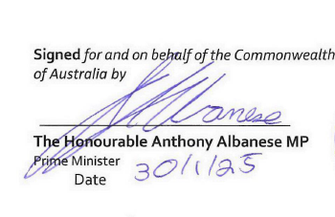
PART 6 – SIGNATURES
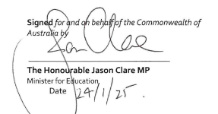

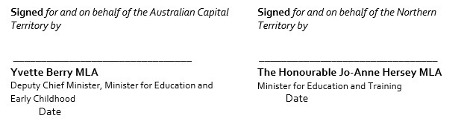




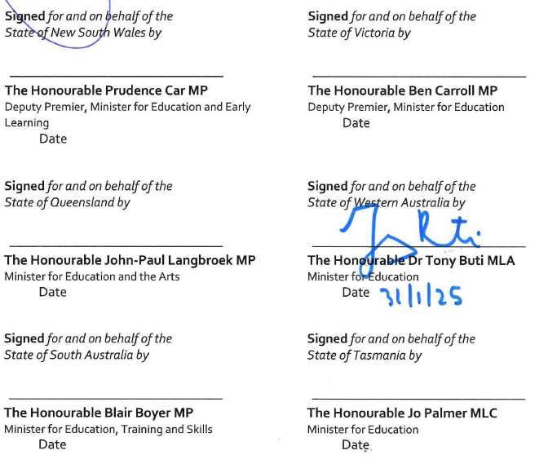

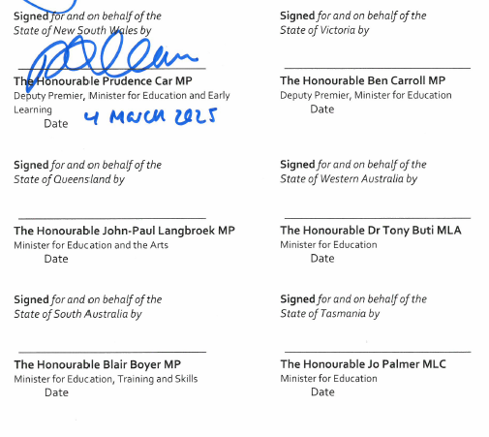

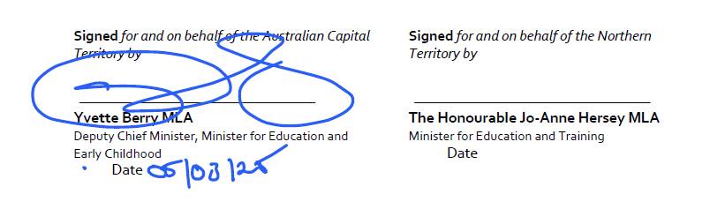
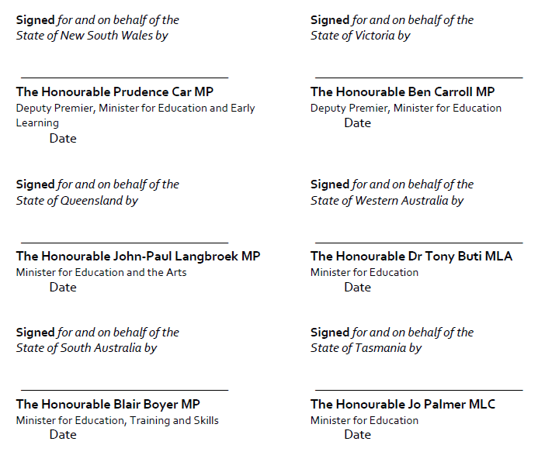

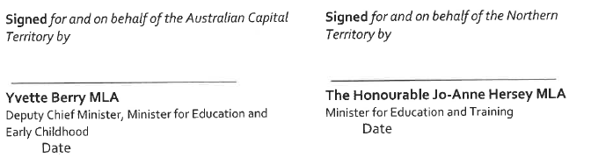
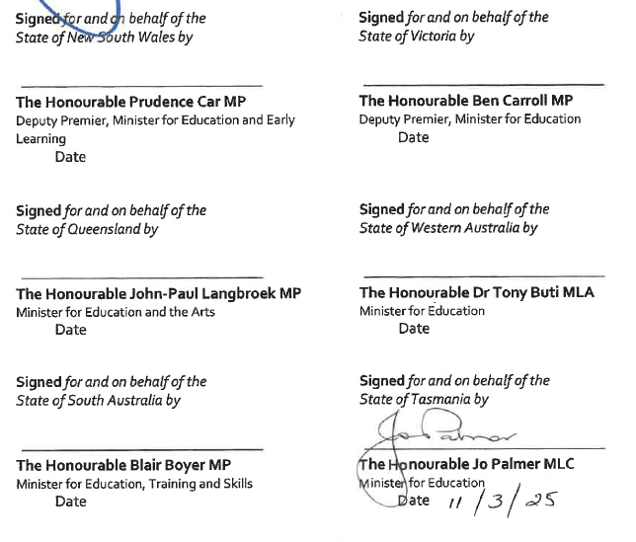

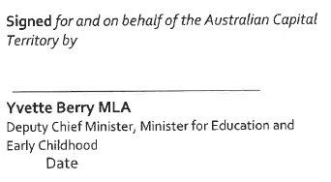
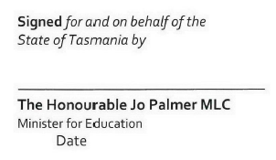
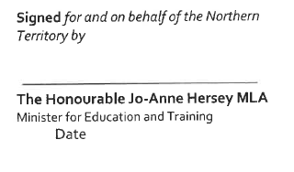
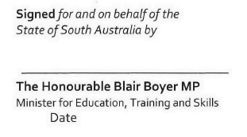
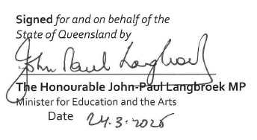
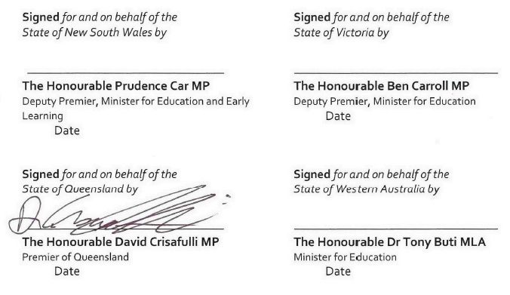

PART 7 – SCHEDULES
Schedule A – Definitions
Schedule B – National Enabling Initiatives
Schedule C – Cost sharing principles
Schedule D – Bilateral Agreements
Schedule E – Annual Implementation Report for non-government representative bodies

Schedule A:
Definitions

Approved authority | An approved authority is a legal entity that the Commonwealth has approved to receive and administer Commonwealth funding for one or more schools. The approved authority for a government school is its relevant state or territory government. The approved authority for a non-government school is the body corporate for that school, as approved by the Commonwealth Minister.
Approved system authority | An approved authority for more than one school that distributes Commonwealth recurrent funding to its member schools using its own needs-based funding arrangement.
Australian Curriculum, Assessment and Reporting Authority (ACARA) | ACARA is the independent authority responsible for the development of a national curriculum (Kindergarten to Year 12) and a national assessment program, including managing the National Assessment Program Literacy and Numeracy (NAPLAN). ACARA also manages the My School website (www.myschool.edu.au).
Australian Education Research Organisation (AERO) | AERO is a ministerial-owned company governed by a board and jointly funded by the Commonwealth, state and territory governments. AERO conducts research and shares knowledge to promote better educational outcomes for Australian children and young people.
Coalition of Peaks | Coalition of Peaks consists of national, state and territory non-government Aboriginal and Torres Strait Islander peak bodies and independent statutory authorities that have responsibility for policies, programs and services related to Closing the Gap.
Council on Federal Financial Relations | Comprises the Commonwealth Treasurer and all state and territory treasurers and is responsible for overseeing the financial relationship between the Commonwealth and state and territory governments.
Education Ministers | Australian Government and state and territory government ministers responsible for school education.
Education Ministers Meeting (EMM) | The Education Ministers Meeting is a forum for collaboration and decision-making on early childhood education and care, school education, higher education and international education. Australian Government and state and territory government ministers responsible for education attend the meeting. The Commonwealth Minister for Education is the Chair of the Education Ministers Meeting.
First Ministers | The Prime Minister, the Premiers of each Australian state, and the Chief Ministers of the Northern Territory and the Australian Capital Territory.
National Aboriginal and Torres Strait Islander Education Corporation (NATSIEC) | NATSIEC is the community-controlled education peak body. NATSIEC will provide national collective Aboriginal and Torres Strait Islander education engagement, cultural and pedagogical expertise and strategic advice in order to ensure Aboriginal and Torres Strait Islander communities' educational aspirations are heard, acted upon and reviewed.
National Cabinet | National Cabinet is a forum for the Prime Minister, Premiers and Chief Ministers to meet and work collaboratively. National Cabinet was established on 13 March 2020 and is chaired by the Prime Minister. The Commonwealth and state and territory governments individually have flexibility to determine the best way to achieve any agreed outcomes made by National Cabinet in their jurisdiction. A representative of Local Government is invited to meet with National Cabinet once each year.
National Enabling Initiative | A matter set out in the Better and Fairer Schools Agreement 2025-2034 (the Agreement) for which the Education Ministers Meeting agrees an approach and timetable for national implementation and is overseeing its implementation. Implementation of National Enabling Initiatives in the Agreement is a condition of funding under subsections 22(2) and 77(2A) of the Australian Education Act 2013 (the Act).
National School Resourcing Board | The National School Resourcing Board (the Board) provides independent oversight of different parts of the Commonwealth recurrent public funding model. The Board reviews different parts of the funding model under the Act and the Australian Education Regulations 2023.
Non-government representative body | A non-government representative body is a body that represents approved authorities for non-government schools, as approved according to section 91 of the Act.

Schedule B:
National Enabling Initiatives
Under clause 88 of the Better and Fairer Schools Agreement – Full and Fair Funding 2025-2034, Parties commit to undertaking the following activities. These National Enabling Initiatives complement the extensive local and national reform efforts underway across states and territories. Project Plans will be developed to guide implementation, under clause 89.
The National Enabling Initiatives will be scoped in collaboration with government and non-government school sectors and broader education stakeholders. A number of National Enabling Initiatives involve a review of existing arrangements. For the avoidance of doubt, agreement to undertake a review does not constitute agreement to any subsequent recommendations of the review.
Parties note that, under clause 27 of the Agreement, schedules to the Agreement may be varied or revoked, and new schedules may be added, at any time with the agreement of the Education Ministers of all Parties. Variations to Schedule B will include the addition or amendment of milestones as National Enabling Initiatives are further developed and considered and decisions are made through Education Ministers Meeting.

Implementation milestones
Implementation and timing of milestones is subject to Education Ministers Meeting considering and agreeing the cost and cost sharing arrangements, scope and governance of each National Enabling Initiative, acknowledging the different local contexts and starting points of each jurisdiction.
National Enabling Initiative | Milestone | Timing
Review of the Schooling Resource Standard (SRS) base and loadings calculation methodology. The review should include a cost neutral option. | - Education Ministers Meeting (EMM) agree a Project Plan, including terms of reference, for a review of the SRS base and all loadings, and commission the review to be completed by mid-2029. The terms of reference should include a requirement to consider at least one cost neutral option. | No later than mid-2027
 | - EMM to receive the review. | No later than mid- 2029
Implementation of the Unique Student Identifier for school students. | - Parties provide an implementation plan for their jurisdiction to inform a national Project Plan, setting out actions and deliverables in the following areas:  - legislation and regulation  - information privacy  - data management  - communication and stakeholder engagement  - technical and business readiness. | Mid 2025
 | - EMM agree a national Project Plan for implementation of the Unique Student Identifier, reflecting implementation plans in each jurisdiction. | Mid 2025
 | - EMM to consider an annual status report from each Party against their implementation plans. | Mid 2026 and mid- 2027
 | - All school students have a Unique Student Identifier. | End 2027
Undertake collective work to better understand and provide advice to Education Ministers on:  - socioeconomic diversity, its impact on schools and student learning and approaches to addressing these impacts  - school attendance, its impact on learning and mechanisms to advance evidence-based approaches to addressing non-attendance, including school refusal. | - EMM agree national Project Plans for 2 projects:  - Socioeconomic diversity, its impact on schools and student learning and approaches to addressing these impacts.  - School attendance: Its impact on learning and on different cohorts, and mechanisms to advance evidence-based approaches to addressing non-attendance, including school refusal. | i) Late 2025  ii) Mid 2025
 | - EMM to task Parties and the non-government school sector with providing quantitative and qualitative information to contribute to each of the projects at a)i) and a)ii) above, with this information reported to EMM. | i) Mid 2026  ii) Late 2025
 | - EMM to receive a findings report on each of the projects at a)i) and a)ii) above. | i) No later than end 2027  ii) Early 2027
Review of the Measurement Framework for Schooling in Australia to ensure it remains a relevant tool, including by considering the range of student level outcome data captured, appropriate disaggregation of data, and possible new and updated measures. This Review will include consideration of the costs and benefits (with primacy given to any impact on teacher workload) of:  - a new measure of student engagement  - a new equity in learning gain measure, to enable measurement of student learning growth  - national measures of access, participation and outcomes for students with disability to establish a better understanding of the education experiences and outcomes of students with disability | - EMM agree a national Project Plan and commission a review of the Measurement Framework for Schooling in Australia (MFSA). The review should consider the range of student level outcome data captured, appropriate disaggregation of data, and the costs and benefits of possible new and updated measures set out at clause 88(d). | Early 2025
- extending the Australian Teacher Workforce Dataset to ensure that comprehensive data, based on teacher registration, is collected to better understand workforce trends, including on early career retention and diversity, and extending the Australian Teacher Workforce Survey to capture data on out-of-field teaching. | - EMM to receive the final report | No later than early 2027
 | - EMM to consider findings from the review and revisions to the MFSA. | No later than mid- 2027
Development of an early years of schooling numeracy check to support teachers to assess their students’ numeracy skills and identify and respond to students who need tailored support. | - EMM agree a national Project Plan for the development of an early years of schooling numeracy check, including consideration of existing checks, timelines and estimated costs. | Mid 2025
 | - EMM to commission the development of an early years of schooling numeracy check. | Early 2027
 | - Once developed, the early years of schooling numeracy check is trialled in all jurisdictions with findings presented to EMM for consideration. | From 2027
 | - The early years of schooling numeracy check is available to be rolled out to schools across Australia. | From 2028

Schedule C:
Cost sharing principles
- The Parties recognise that the agreed National Enabling Initiatives will likely require investment by the Parties to meet our reform ambitions. Parties will consider the fully costed initiatives when finalised, along with anticipated benefits, before implementation.
- The Parties also recognise that existing investments in national infrastructure will be utilised wherever possible to most efficiently implement the initiatives.
- The Parties acknowledge that final costs incurred by Parties will include ongoing funding for implementation and possible future work arising from the National Enabling Initiatives, which cannot yet be determined.
- The cost of the National Enabling Initiatives borne by the state or territory count towards the state or territory contribution to school funding, for the purpose of section 22A of the Australian Education Act 2013.
- The cost sharing arrangements for each of the National Enabling Initiatives will be considered and agreed by the Education Ministers Meeting as part of the initial milestone for each initiative. Parties will consider the final cost sharing arrangements before implementation.
- Cost sharing arrangements will consider previous precedents for investment in national initiatives, including the existing Education Ministers Meeting cost sharing formulae.
- The Parties recognise that costs for implementation and ongoing costs will differ significantly between jurisdictions (for example costs of some reforms could be higher in rural and regional areas).

Schedule D:
Bilateral Agreements

APPENDICES
The following bilateral agreements have been agreed:
Appendix 1 – Australian Capital Territory agreed 6 March 2025
Appendix 2 – New South Wales agreed 11 March 2025
Appendix 3 – South Australia agreed 11 March 2025
Appendix 4 – Tasmania agreed 13 March 2025
Appendix 5 – Queensland agreed 24 March 2025
Appendix 6 – Western Australia agreed 27 June 2025
Appendix 7 – Victoria agreed 8 December 2025

Schedule E:
Annual Implementation Report for non-government representative bodies

Purpose of this reporting template
This reporting template, the Annual Implementation Report for non-government representative bodies, contributes to achieving the transparency and accountability commitments under the Better and Fairer Schools Agreement – Full and Fair Funding 2025-2034 (Agreement), as outlined in Part 5. Non-government representative bodies are required to fill in the Annual Implementation Report for non-government representative bodies annually and report it to the Australian Government Department of Education.
Non-government representative bodies will report for each calendar year, and the report will be due by 30 November following the end of the calendar year, or a later date as agreed by the Commonwealth and the relevant non-government representative body.

National Reform Directions
Non-government representative bodies are required to fill in the below table outlining their implementation of the National Reform Directions.
National Reform Direction | Description of local implementation | Outline the focus on priority equity cohorts and schools needing additional support (where applicable) | Details of qualitative or quantitative impact
[National Reform Direction]
[For example]  Structured initiatives that support wellbeing for learning and engagement, for example in-school wellbeing coordinators or access to School Counsellors, psychologists, mental health workers and/or youth health nurses. |  |  | For example - Ratio of wellbeing functions to students, where applicable.

Specific National Reform Direction implementation
National Reform Direction | 20xx Update | Evidence/Caveats/Background information
Phonics and early years of schooling numeracy check participation rates, including for priority equity cohorts (where data is available) |  | [Please note overarching commitment in the Agreement that there is no requirement for more data collection by schools – this table will report data non-government representative bodies already collect with no requirement for more data collection by schools.]
Number of Highly Accomplished and Lead Teachers or equivalent |  | For e.g. certain percentage being deployed in schools which need additional support.

Improvement Measures
Non-government representative bodies are required to fill in the following table outlining their progress against identified agreed Improvement Measures, only where data is not available at the Commonwealth level:
Improvement Measure | 20xx Update | Evidence/Caveats/Background information
[Identified Improvement Measure]

